Administrator Guide
Performance Manager
Effective 2/14/2022

Contents
System Administration 5
Administration areas 6
Development Plans Administration 8
Impersonate 10
All Employees 11
Appraisals 11
Checklists 11
Documents 11
Employee List 12
Feedback 12
Goals 14
Job Description 14
Personal Information 15
Task Administration 16
Tasks 19
Checklists administration 20
Checklist Forms 20
Adding checklist forms 22
Checklist form skills 22
Position Checklists 23
Adding checklist forms to positions 24
Skills Master List 24
Skills form 25
Client Settings 28
Custom Lists 28
Add/Edit Custom Lists 29
360 Review Settings 39
Appraisal Options 40
Data Maintenance 43
Groups 44
Language Checker 45
Manager Override 46
Message Center 47
Routing Users 48
Performance Vitals Configuration 52
Settings 61
Recognition and Remarks Administration 67
User Maintenance 74
Adding a user 74
Assigning a manager 75
Employee Profile 76
Permission groups 77
Compensation administration 78
Compensation cycles 78
Adding compensation cycles 83
Guideline configuration 83
Worksheet configuration 84
Merit matrix 85
Feed files 86
Compensation employee groups 86
Compensation managers 87
Document Library 89
Adding documents 89
Goals administration 91
Assessment lists 91
Adding assessment lists 92
Editing assessment lists 93
Pillars 94
Adding Pillars 94
Goal forms 95
Adding goal forms 96
Adding goals to job description forms 97
Job Description 99
About the Job Descriptions page 99
Building a Job Description 100
Changing the Template for a Job Description 101
Copying a Job Description 103
Editing a Job Description 105
Job Description History 106
Import List 106
Special Forms 107
Adding a template 109
Copying a Template 114
Job Description Weights 114
Recognition and Remarks Administration 115
Recognition lists 121
Schedule 123
Schedule Details 123
Schedule Assignments 141
Schedule Date Types 144
Adding Schedules 145
Copying Schedules 146
Editing Schedules 147
Date Calculator 147
360 Review Schedule Administration 148
Appraisal Schedule Administration 149
Checklist Schedule Administration 150
Document Schedule Administration 152
Reports 154
Custom Reports 154
Exporting Reports 154
Available Reports 155
Viewing reports 157

System Administration
System-wide settings in Performance Manager are controlled from the pages accessible from the Admin item in the navigation bar and, in some cases, other areas within Performance Manager. Options found in these areas allow global configuration of the system to meet organizational needs.
Warning: Changes made to system-wide settings impact all users, so always take caution when updating these options.
The two areas that contain system-wide settings for administrators are:
- Admin. The Admin area in the navigation bar contains most of the areas for system-wide configuration settings. It contains several categories, each with a set of sub-pages for the different features of Performance Manager.
- Job Description. The Job Description area in the navigation bar provides access to job descriptions and templates used to create them.

Administration areas
The Admin area in the navigation bar contains most of the areas for system-wide configuration settings. Several categories reside under Admin, each with a set of sub-pages:
All Employees
The All Employees page provides access to pages found under the My Folder area for a selected employee. Once an employee is selected, any of the available My Folder pages can opened for reviewing and/or editing as needed.
Checklists
- Checklist Forms. Checklist forms are the forms that contain the actual skills/competencies that employees are evaluated on. This page provides an area to build both template and specific position forms with all the necessary associated skills.
- Position Checklists. The Position Checklists page is where checklist forms are assigned to specific positions in Performance Manager.
- Skills Master List. The Skills Master List contains all the available skills for checklists. This page allows users to manage the available skills, including adding, deleting, and editing.
Client Settings
- Custom Lists. Custom lists are used for maintaining instructions, radio buttons, and drop-down lists throughout Performance Manager.
- Data Maintenance. The Data Maintenance page allows administrators to update Facility, Department, and Position information in Performance Manager.
- Groups. Groups are used during scheduling of appraisals, training, and competency checklists. They are used to group together positions/departments that have the same scheduling demographic.
- Language Checker. Language checker is a library of words and/or phrases that are marked as "questionable" when used on an appraisal form. It is used to assist managers (helping them to avoid using harsh or offensive language) when completing appraisals.
- Manager Override. Manager override is used to create a temporary override if the employee’s manager is on leave or cannot perform a scheduled evaluation.
- Message Center. The Message Center is where email reminders for tasks are configured.
- Routing Users. The Routing Users page allows you to control which users in Performance Manager can be used for routing various forms in the system. Users can be assigned as routing users for multiple forms.
- Settings. The Settings page contains several display customization options for Performance Manager.
- User Maintenance. The User Maintenance page allows administrators to add users into the system, change user statuses for active or terminated employees, and update user demographic data. This page is also used to assign managers to user groups directly within Performance Manager.
Compensation
- Cycle management. The Cycle management page provides an area to create and manage compensation cycles and their specific settings. These cycles are available in the drop-down menu on worksheet.
- Worksheet configuration. The Worksheet configuration page determines which fields appear on the worksheet for users. It also allows the customization of field names.
- Guideline configuration. Guideline configuration is where specific rules for compensation merit increase recommendations are defined.
Documents
The Document Library page provides a place to manage documents used with the Document Sign Off feature in Performance Manager.
Goals
- Assessment Lists. Assessment lists provide a scale that is used to rank user performance against a goal. They help determine overall performance over a review period.
- Performance Goal Forms. Goal forms are where corporate, facility, and department goals are created in the system. These forms are used to define goals for individual employee goals to align to.
- Pillars. Pillars are the starting point for all goals in Performance Manager. They represent the basic ideals and overarching values your company strives towards. All goal forms, whether on the level of corporate, facility, or department, are tied back to a pillar.
Schedules
- Appraisal Schedule. Appraisals are employee reviews by their managers and peers that drive merit increases.
- Checklist Schedule. Checklists are designed to test employee knowledge and skills in specific areas related to their job descriptions.
- Document Schedule. Document schedules assign tasks for employees to review and sign off on documents.
- 360 Review Schedule. 360 reviews provide an opportunity to collect feedback about an employee from coworkers. These reviews assist managers during appraisals.

Development Plans Administration
Settings for Development Plans allows you to enable the feature and determine who is able to create and send new plans.
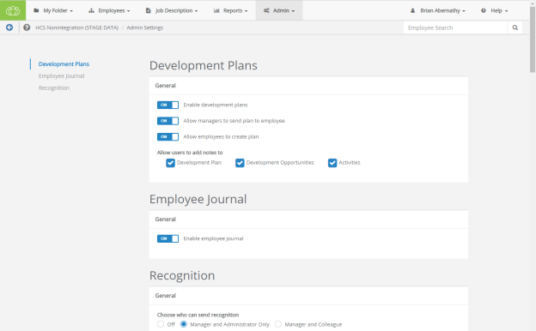
The settings page for Development Plans can be opened from the Feature Settings area of the Settings page under Admin. Clicking the Please click here link at the bottom of the section opens a new page with all applicable settings for Development Plans.
- Enable development plans. Turns the Development Plans feature on for all users.
- Allow managers to send plan to employee. Managers can create new plans and send them to employees for review.
- Allow employees to create plan. Employees can create new development plans for themselves.
- Allow users to add notes to. Enables or disables the ability for users to add their own notes to Development Plans, Development Opportunities, or Activities.
Additional settings
Development Plans allow you to customize the list of competencies that can be added as Development Opportunities in a plan.
The page for customizing this list can be reached by clicking the Click here to add and edit Custom Lists link on the Custom Lists page.
Employee Journal settings
- Enable Employee Journal. Turns the Employee Journal feature on (or off) for all users.
Recognition settings
Settings for the Recognition and Remarks feature are also found on this page. For more information on these settings, please refer to the Recognition and Remarks Administration page.

Impersonate
Administrators have the ability to impersonate any other user in Performance Manager. Impersonating means you are able to view and interact with the system as if you were that selected user: you have access to the same areas they do, can view and perform their assigned tasks, etc.
Now, this may sound like too much power for one person to wield, but there's good reasons to offer this feature - mainly as a way to deal with wayward tasks left untouched by former or vacationing employees. Used in moderation only when needed, impersonation is a useful tool.
There's a couple different ways to impersonate a user:
- User menu. The user menu in the navigation bar - the one with your name on it - contains an Impersonate link. Clicking that opens an employee picker page where you locate the desired employee and begin impersonation.
- Employee Search. When an administrator uses the Employee Search field in the navigation bar, the list of matching results contains an impersonate icon (look for this guy right here: ). Clicking this icon for the desired employee begins your impersonation.
When you are impersonating a user, there are two visual cues that alert you to your deception. First, the user menu in the navigation bar is now blue and displays the name of the user you're impersonating.
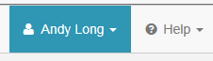
The other cue is at the bottom of the page in the form of a little pop-up message.
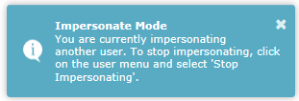
All finished pretending to be someone else? Just head back up to that user menu and select the Stop Impersonating option from the drop-down list to return to your regularly scheduled programming.

All Employees
The All Employees area under Admin allows system administrators to manage both active and terminated employees.
Once an employee is selected from the Select Employee page, you can access any of the pages available under the My Folder area for the selected employee. These pages allow you to manage tasks, training and assessments, appraisals, goals, etc.
When selecting an employee, the Tasks page is opened by default. Other employee profile pages can be opened using the available links.
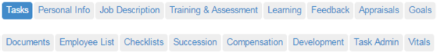
There's also a Task Administration link that allows you to edit due dates and delete tasks as necessary, and Vitals that displays the employee's Performance Vitals page.

Appraisals
The Appraisals page provides an area for administrators to review manager, 360, self and multi-rater appraisals that have been conducted on the employee.
Clicking the link for an appraisal opens a new page that displays the PDF, as well as a link to download the file.
Clicking the Return link reopens the selected appraisal and reassigns the appraisal task to the employee.

Checklists
The Checklists page lists the competency checklists for the selected user. There are tables for checklists completed by managers and/or validators, as well as self-assessment checklists completed by the employee.
The tables includes an Action column that allows you to edit the checklist or download a PDF of the completed checklist.

Documents
The Documents page lists reference materials related to the selected employee, such as certifications and training files, as well as any documents that were signed off on by the employee (as part of the Document Sign Off feature).
Clicking the link for a document opens a new page that displays the PDF, as well as a link to download the file. Reference documents can be deleted by clicking the checkbox for the desired item and clicking the Remove Selected button.

Employee List
The Employee List page displays a table of employees that report to the selected user. The table contains links for each of the pages found under the My Folder area for the employees.
Clicking a link for one of the available pages opens the administrator view of that page for the selected employee. This also takes you out of the employee record you were originally viewing.

Feedback
There are a few different methods of viewing or logging feedback, issuing recognition, and keeping track of personal events for particular employees as an Administrator within Performance Manager, and they can all be viewed from the three tabbed sections on this page. The Feedbackpage allows users to review Feedback that has been given to the employee by their manager, as well as review any Recognition and Remarks sent by colleagues. Additionally, to add or review a written record of something that occurred, the Journal tab allows access to the user's Employee Journal.
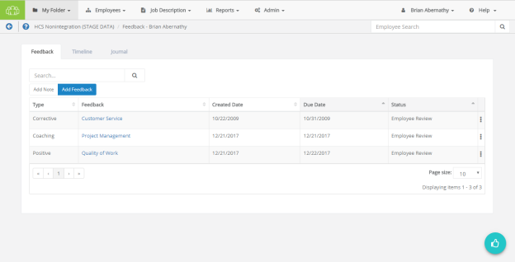
Feedback
On this page, the area found under the Feedback tab allows the administrator to view and manage feedback for the selected employee. Whether it's positive reinforcement, coaching to foster improvement, or issuing corrective feedback, such occurrences may be issued and reviewed from here.
Any existing feedback can be viewed by clicking the link in the available tables. Alternately, it can also be printed or deleted via the options found in the Actions drop-down menu in the right-most column of the feedback table.
New feedback (and notes) can be created as well by using the Add Note and Add Feedback buttons. For additional details about these options, please refer to the Notes and Adding Feedback pages.
Recognition
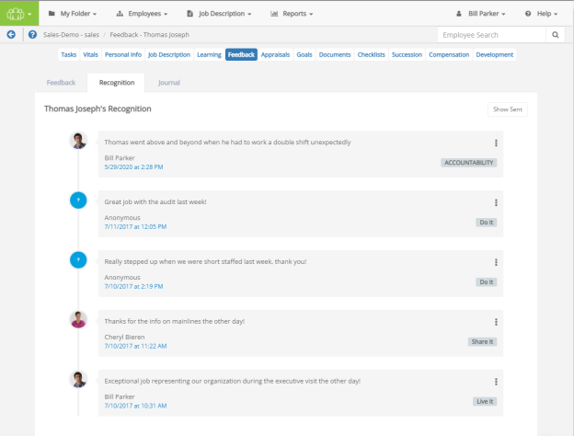
The Recognition tab on this page shows a list of feedback received via the Recognition and Remarks form, presented in chronological order.
Clicking Show Sent in the upper-right corner of the tab displays a list of all recognition sent to other employees. When clicked, this button changes to Show Received. Clicking this button again reverts the page back to its original display.
Additional options to Print or Delete items from the recognition timeline are found by clicking the Actions menu, which is shown as three vertically-aligned dots on the right-hand side of an entry.
Journal
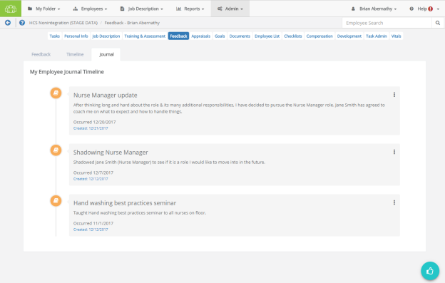
The Journal tab displays the employee's record of events and accomplishments that were entered using the Journal form. Entries in this page are presented in chronological order, based on the date the entry was created. In the Admin's view of this page, the Actions menu presents the option to Delete an entry from the timeline.

Goals
The Goals page allows administrators to review and delete goals (Individual, Departmental and Organization) that have been assigned to and completed by the employee. Development and Performance goals are displayed in separate tables.
The Development Goals table contains an Actions column that provides the ability the Edit, Delete, and Print goals.
Clicking a link in the Performance Goals table opens the goal detail form where further edits can be made to the goals.

Job Description
The Job Description page provides links to view job descriptions that were signed off on by the selected employee. Clicking the link for a job title opens a new page that displays the PDF, as well as a link to download the file.

Personal Information
The Personal Info page provides access to employee demographic information supplied by the HRIS feed. Personal information here can simply be reviewed and not edited.
The personal info link also allows you to add and edit license and certification information for the selected employee.
Note: Only users holding Admin permissions may add, edit, or delete information from the Licenses and Certifications table. When employees need to update their license or certification details, they'll need to reach out to Performance Manager system administrators for their assistance with the task.
Adding a license or certification
To add a new license or certification:
- Select Add.
- Complete the necessary fields for the new license or certification.
- Select Save. The newly added item now appears in the tables on the Personal Info page.
Editing an existing license or certification
To edit an existing license or certification:
- Select Edit from the menu option in the right-most column in the table. This displays the form used to modify license or certification details.
- Make the changes as needed.
- Select Save to retain your changes.
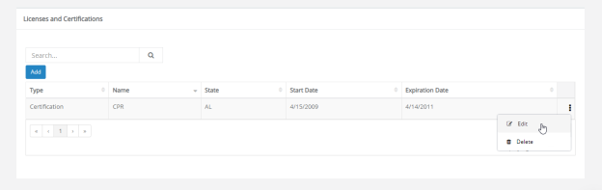
Warning: If license/certification is being sent over on an HRIS feed, any edits made in Performance Manager will be overwritten by the feed data.
Deleting a license or certification
To delete an existing license or certification:
- Select Delete from the menu option in the right-most column in the table.
- Select OK in the popup that displays to confirm you want to delete the item. After deletion, it disappears and the page displays a green success message.
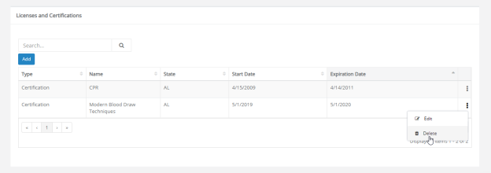
Warning: Deleted licenses and certifications cannot be recovered, so click carefully!

Task Administration
The Task Administration page provides an area to make edits to tasks assigned to the selected employee in Performance Manager.
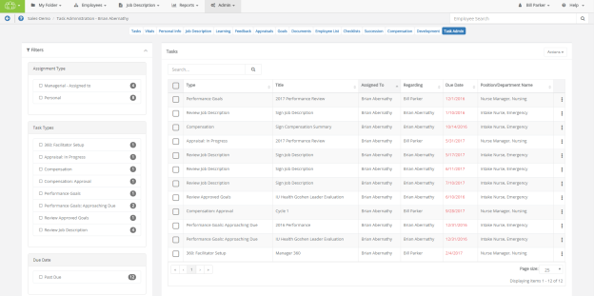
Sort columns in either ascending or descending order by clicking each column's heading.
Searching is also handled via the Search bar in the upper-left corner. The search runs in real-time, meaning as soon as a single character is entered, any applicable results are instantly shown.
The final column of the table contains drop-down menus ( ) on the right-hand side of each row, which expand to show the following actions:
- Edit Due Date (). Allows the Due Date for a selected task to be updated as needed.
- Delete (). Deletes the selected task from the employee's task list.
The upper-right corner of the table holds the Actions drop-down menu, which expand to show the following batch actions:
- Batch Edit (). Allows the Due Date for all selected tasks to be updated as needed.
- Batch Reassign(). Initiates the reassignment process for all selected tasks.
- Batch Delete (). Deletes all selected tasks from the employee's task list.
Changing a due date
To change a due date for a task:
- Click the Actions icon ( ) to show the actions menu for the task you wish to update.
- Click the Edit icon () to display the Edit Task Date modal. The Due Date field here is editable.
- Make the necessary changes to the due date. You can type in a date using the standard format (MM/DD/YYYY) or use the available calendar picker by clicking the date field and using the calendar drop-down.
- Click Update when finished. This displays a confirmation at the bottom of the page to let you know the date has been updated successfully.
Reassigning a task
To reassign a task to another employee:
- Click the check box for any tasks you'd like to assign.
- Click the Actions drop-down menu in the upper-right corner of the table.
- Click Batch Reassign () to display the Reassign Tasks modal containing an Employee Search field.
- Begin typing an employee's name to display matching results in real-time. After locating the desired task recipient, click their name to select it from the list, then click Next.
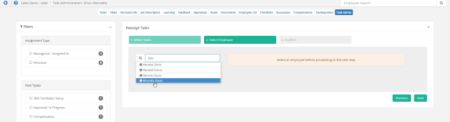
- Click Reassign to complete the process. This displays a confirmation at the bottom of the page to let you know the tasks have been successfully reassigned.
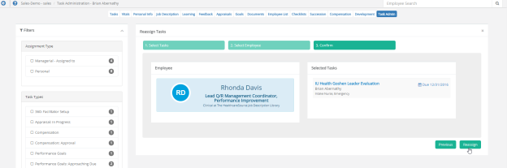
Deleting a task
To delete a task:
- Click the Actions icon ( ) to show the actions menu for the task you wish to update.
- Click the delete icon () for the task you wish to delete. A confirmation dialog opens.
- Click OK to confirm the deletion.
Clicking OK reloads the Task Admin page, and the selected task no longer appears in the table. The task is also removed from the Tasks table for the employee.

Tasks
The Tasks page for an employee is the first page that opens once you have made a selection from the Select Employee page. It displays both Personal and Managerial tasks assigned to the user.
Administrators have the ability to reassign managerial tasks (such as appraisals and competency checklists) from one user to another.
Note: Personal tasks should not be reassigned. For example, a Review Job Description task assigned to an employee should not be reassigned to another employee as its specific to the employee to whom it’s assigned.
Reassigning a task
To reassign a task:
- Check the box in the row for the task(s) you wish to reassign.
- Click the Reassign Tasks button.
- Search for and select the user to whom you wish to reassign the task(s).
- Click the Assign button.
The selected task(s) are reassigned to the desired user. The tasks show up in the new user's task list, and are removed from the originals user's list.
Deleting a task
To delete a task:
- Check the box in the row for the task(s) you wish to reassign.
- Click the Remove Selected button.
- Click OK to confirm.
The selected task(s) are removed from the employee's task list.

Checklists administration
Performance Manager systems that utilize Checklists contain a Checklists section under the Admin area in the navigation bar where options and features for checklists are configured. This area is only accessible to users that have the necessary system privileges.
While the majority of work performed in this administration area takes place upon initial setup of the Checklists module, many options can be edited or added at any time.
The available configuration pages for checklists are:
- Checklist Forms. Checklist forms are the forms that contain the actual skills/competencies that employees are evaluated on. This page provides an area to build both template and specific position forms with all the necessary associated skills.
- Position Checklists. The Position Checklists page is where checklist forms are assigned to specific positions in Performance Manager.
- Skills Master List. The Skills Master List contains all the available skills for checklists. This page allows users to manage the available skills, including adding, deleting, and editing.
Checklists administrative workflow
The basic workflow for configuring checklists is as follows:
- Create necessary skills on the Skills Master List page.
- Create a template or position checklist form and add necessary skills to the form on the Checklist Forms page.
- Publish the form.
- Assign the form to positions on the Position Checklists page.

Checklist Forms
Checklist forms are the actual forms that are used when completing checklists for employees. These forms contain all the skills that have been assigned to their position for evaluation.
There are two types of checklist forms:
- Template Forms. Template forms are used as templates to populate position forms. Templates can be used as a convenient way to manage content that is the same across multiple checklists. Templates can be nested, meaning they can inherit from other templates.
- Position Forms. Position forms are used to build skill lists for specific positions in Performance Manager. Employees assigned to a position are evaluated on the skills contained within the associated position form. Position Forms can inherit from templates, but cannot be inherited by other forms.
The Checklist Forms page contains a table that lists Template and Position Forms on two separate tabs. The table can be filtered in order to easily locate desired forms.
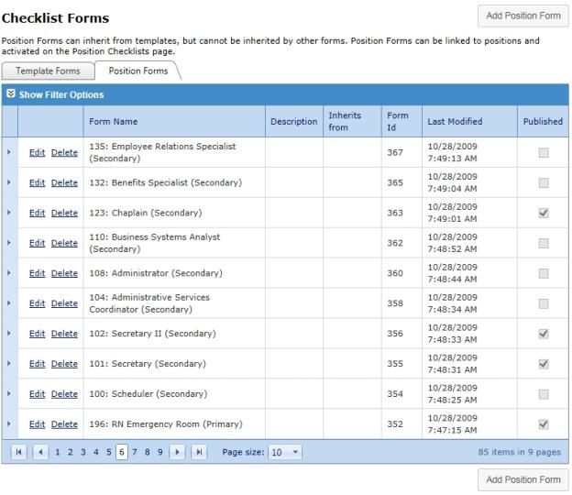
Table columns
(arrow column) | The first column contains arrows that expand each row of the table to display any previous versions of the selected form. Only Published versions of the form are listed here.
(actions column) | The next column contains the available actions for each form (Edit and Delete).
Form Name | The name of the form. These should be descriptive enough to identify by name only - avoid using form numbers or acronyms.
Description | A description of the checklist form.
Inherits from | Displays which template the form inherits its content from. Both Template and Position Forms can inherit from templates. However, Position Forms cannot inherit from other Position Forms.
Form ID | Internal database ID for the form. This is mainly for HealthcareSource use.
Last Modified | Displays the date for the last time the form was published.
Published | This checkbox is used to publish forms. A checkmark indicates the form is published and available for use.

Adding checklist forms
Both Template and Position Forms can be added from the Checklist Forms page.
- Select the tab for the type of form you wish to create and click the Add Form button above the table. The button text indicates which type of form you are creating (Add Template Form or Add Position Form). This opens the Add Form page.
- Enter a Name and Description for the form.
- Select a template from the table if you wish to populate the new form with template data. Only one template can be selected. You can also check the Do Not Inherit option if you want to manually add skills to the new form.
Note: The form can be edited in the next step regardless if a template is selected or not, including removing Items inherited from a template and adding other categories/skills.
- Click Save. This opens the Form Preview page where you can manage the skills that appear on the form.
- Add or remove skills as needed on the form.
- When finished adding skills, click the Publish button to finalize the checklist form and make it available to assign to positions. If you don't wish to publish the form at this time, you can navigate to another page and your form will be saved.
Published forms can be found on the Checklist Forms page and when assigning forms to positions. Unpublished forms are only listed on the Checklist Forms page, but are not available to use for positions until the form is published.

Checklist form skills
When adding or editing checklist forms, you have the option to add new skills and remove any skills currently appearing on the form.
When adding or removing a category, all the skills that fall under that category are also removed.
Adding skills
To add a skill or category/group of skills to a form:
- Locate the desired skill or category in the list.
- Check the box next to the desired skill/category.
- Click the Update Preview button above the skills list on the left.
The page reloads and displays the updated form with the new skills added.
Removing skills
To remove a skill or category from the form:
- Locate the desired skill or category on the form.
- Right-click the name/title of the skill/category. This opens a drop-down menu.
- Click Delete.
Clicking Delete removed the selected skill/category from the form.

Position Checklists
The Position Checklists page is where checklist forms are assigned to specific positions in Performance Manager. Every position in your organization is listed in the table along with any assigned checklists for each. The table is grouped by Department, and can be filtered to help quickly locate desired positions.
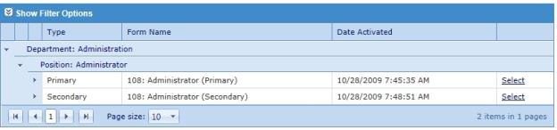
Each position can be assigned a Primary and Secondary form. Primary forms can be thought of as preliminary skills that need to be evaluated during introductory periods for employees (e.g. within the first 90 days of employment). Secondary forms can then be used to assign skills that require more position-specific abilities (e.g. assessment of neurological symptoms).
Expanding the rows for the Primary and Secondary forms displays a history of the forms that have been assigned and the date they were activated. There's also a view link for each that allows you to view the previous forms.
The Select link in the table opens a pop-up window that shows the current active form for the selected position, and allows the selection of a different form if necessary.

Adding checklist forms to positions
Checklist forms need to be assigned to positions in Performance Manager in order to schedule checklist tasks. This is performed on the Position Checklists page under the Admin area.
- Locate the desired position in the table.
- Click the Select link in the desired slot (Primary or Secondary) for the position. This opens the Select Checklist Form pop-up window.
- In the available table in the pop-up window, locate the desired checklist form to assign to the position. The table can be filtered to help find the desired checklist, and the View link can be used to view a preview of the checklist form.
- Check the box next to the desired checklist to assign. Only one selection can be made in the table.
- Click the Activate button.
Clicking Activate reloads the pop-up window. The selected checklist now appears in the Active Form table, along with the current date and time under Date Activated.
Click the Close button or the X in the upper right-hand corner to close the pop-up window. The selected checklist form is now listed in the table on the Position Checklists page.

Skills Master List
The Skills Master List page displays all the skills available for adding to checklist forms. This page is used to manage available skills, including adding, deleting, and editing skills.
Skills are displayed in list form on the left side of the page. Items in bold text are categories, or groups of skills. Items in normal text are actual skills. It is recommended that categories are used to define Departments and Positions within your organization, under which sets of skills can then be added. This makes it easy to locate desired skills in the list when adding them to checklists. It also speeds up the checklist process since both categories and individual skills can be added to checklist forms.
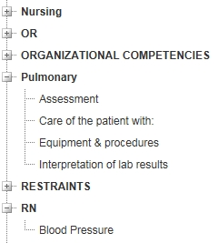
Right-clicking any item from the list opens an actions menu, which includes the ability to Add, Edit, and Delete the selected item.

Skills form
A skills form opens in a pop-up window when adding new skill to the Skills Master List. The fields found on this form determine how employees are evaluated and what criteria must be achieved in order to pass.
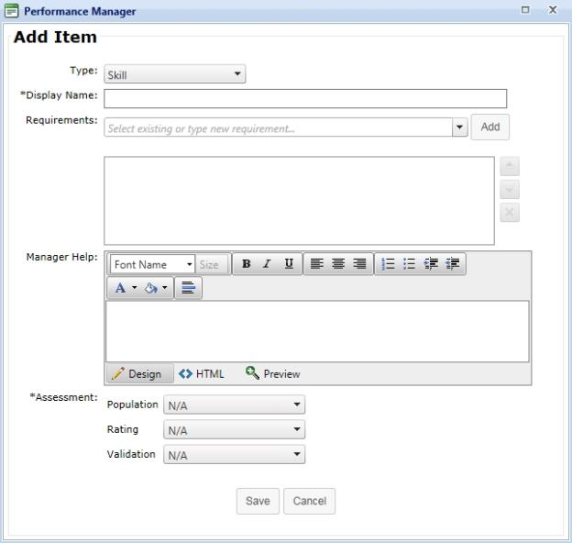
Type | Type of item to add to the master list. This can be Category or Skill.
Display Name | The name of the category or skill. This is displayed in the Skills Master List when building checklist forms.
Requirements | Drop-down list of available requirements that can be added to the skill.
(blank text box) | This field displays any Requirements that have been added to the skill. These can be re-ordered or removed using the button options to the right of the field.
Manager Help | Text box for providing instructions to managers or validators assessing employees on the skill.
Population | Determines the population that was used to evaluate the skill.
Rating | Rating scale used to evaluate the employee's performance of the selected skill.
Validation | Determines how the skill was evaluated.

Note: Only one field under the Assessments section needs to be completed (Population, Rating, Validation). It is not necessary to complete each field for each skill.

Client Settings

Custom Lists
Custom lists are used for maintaining instructions, radio buttons, and drop-down lists throughout Performance Manager.
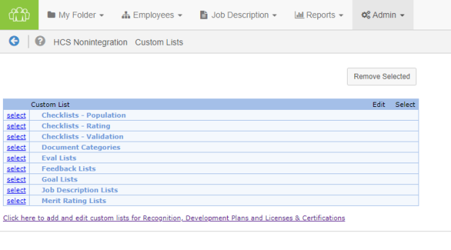
- Competency Population. Competency Population lists determine organization's population served or age-specific options on competency checklists. Multiple lists can be added as needed.
- Competency Rating. Rating lists determine your organization's rating scales on competency checklists. Multiple lists can be added as needed.
- Competency Validation. Validation lists determine your organization's validation methods on competency checklists. Multiple lists can be added as needed.
- Document Categories. Document Categories provide a means for cataloging reference documents attached to employee electronic folders. Only one list of categories is allowed, but the list may contain multiple categories as needed.
- Eval Lists. Eval lists appear as radio buttons on appraisal/evaluations forms when evaluating employee performance. Multiple lists can be added as needed.
- Feedback Lists. Feedback lists are used to customize sections on the feedback form.
- Goal Lists. Goal lists are used to customize sections on the goal form.
- Job Description Lists. Job description lists appear as drop-down lists on job description forms when they are being edited. These lists help standardize job description data entry.
Job description lists are usually set up by your Account Manager during implementation. Multiple lists can be added as needed.
- Merit Rating Lists. Merit rating lists are used to auto-calculate overall performance or merit increases based on the evaluation score/weight. One list can be added for each template in the system, provided the template is not inherited.
Merit rating lists are usually set up by your Account Manager during implementation. It is recommended that you reach out to your Account Manager for assistance when working with merit rating lists.
The Click here to add and edit Custom Lists link underneath the table opens a new page for customizing lists used in Recognition and Remarks, Professional Development Plans, and Licenses & Certifications.

Add/Edit Custom Lists
All custom lists in Performance Manager can be edited to meet individual customer needs. Though the process for adding and editing lists is similar across all lists, there are slight differences in some instances.
There are two pages where custom lists are managed: the main Custom Lists page, and another Lists page that's reachable by clicking the link under the table on the main Custom Lists page.
Managing lists on the main Custom Lists page
The table on the main Custom Lists page contains several lists for various features throughout Performance Manager. While overall management is similar, some of these lists contain slight differences regarding what information is displayed.
Competency Population
Multiple Competency Population lists can be added to the system. These can be edited at any time.
To set up a new Competency Population list:
- Click the Select link next to the Competency Population listing on the Custom Lists page.
- Enter the title of the list in the available text box (example: Facility wide Population Served) and click the Add link. This adds the new list to the table.
- Click the Edit link next to the new listing.
- Enter the Value and Description.
Note: The Description field is viewable by system administrators only; it is not viewable anywhere else in the system. Only the Value is displayed to users.
- Click Add.
Clicking the Add link adds the item to the list. Repeat steps 4 and 5 to add more items to the list.
Other actions
- Items can be removed by selecting the checkbox next to the item and clicking Remove Selected.
- Click the Cancel button to go back to the previous page. Any edits made are saved.
- Click the Edit link next to the item to modify or change the text.
Competency Rating
Multiple Competency Rating lists can be added to the system. These can be edited at any time.
To set up a new Competency Rating list:
- Click the Select link next to the Competency Rating listing on the Custom Lists page.
- Enter the title of the list in the available text box (example: Facility wide Rating) and click the Add link. This adds the new list to the table.
- Click the Edit link next to the new listing.
- Enter the Value and Description.
Note: The Description field is viewable by system administrators only; it is not viewable anywhere else in the system. Only the Value is displayed to users.
- Click Add.
Clicking the Add link adds the item to the list. Repeat steps 4 and 5 to add more items to the list.
Other actions
- Items can be removed by selecting the checkbox next to the item and clicking Remove Selected.
- Click the Cancel button to go back to the previous page. Any edits made are saved.
- Click the Edit link next to the item to modify or change the text.
Competency Validation
Multiple Competency Validation lists can be added to the system. These can be edited at any time.
To set up a new Competency Validation list:
- Click the Select link next to the Competency Validation listing on the Custom Lists page.
- Enter the title of the list in the available text box (example: Facility wide Validation) and click the Add link. This adds the new list to the table.
- Click the Edit link next to the new listing.
- Enter the Value and Description.
Note: The Description field is viewable by system administrators only; it is not viewable anywhere else in the system. Only the Value is displayed to users.
- Click Add.
Clicking the Add link adds the item to the list. Repeat steps 4 and 5 to add more items to the list.
Other actions
- Items can be removed by selecting the checkbox next to the item and clicking Remove Selected.
- Click the Cancel button to go back to the previous page. Any edits made are saved.
- Click the Edit link next to the item to modify or change the text.
Document Category
Though only one Document Category list can be used in Performance Manager, it can contain as many values as necessary. These can be edited at any time.
To set up a document categories list:
- Click the Edit link next to the Document Category List item under the Document Categories item on the Custom Lists page.
- Enter the Value and Description.
Note: The Description field is viewable by system administrators only; it is not viewable anywhere else in the system. Only the Value is displayed to users.
- Click Add.
Clicking the Add link adds the item to the list. Repeat steps 2 and 3 to add more items to the list.
Other actions
- Items can be removed by selecting the checkbox next to the item and clicking Remove Selected.
- Click the Cancel button to go back to the previous page. Any edits made are saved.
- Click the Edit link next to the item to modify or change the text.
Eval
Multiple Eval lists can be added to the system. These can be edited at any time.
To set up a new Eval list:
- Click the Select link next to the Eval Lists listing on the Custom Lists page.
- Enter the title of the list in the available text box (example: Job Duties Rating Scale) and click the Add link. This adds the new list to the table.
- Click the Edit link next to the new listing.
- Enter the Value and Description.
Note: The Description field is viewable by system administrators only; it is not viewable anywhere else in the system. Only the Value is displayed to users.
- Check the Required option if comments are mandatory for that rating.
- Enter a Score for the rating.
Note: For ratings of "Not Applicable" or "N/A", the Score should be set to null value. Do not use zero for a null value.
- Click Add.
Clicking the Add link adds the item to the list. Repeat steps 4 through 7 to add more items to the list.
Other actions
- Items can be removed by selecting the checkbox next to the item and clicking Remove Selected.
- Click the Cancel button to go back to the previous page. Any edits made are saved.
- Click the Edit link next to the item to modify or change the text.
Feedback
Users do not have the ability to add new Feedback lists to Performance Manager. However, it is possible to edit values that appear in the existing Feedback lists.
Each Feedback list is edited in the same manner as follows:
- Click the Select link next to the Feedback Lists listing on the Custom Lists page.
- Click the Edit link next to the list you wish to edit.
- Enter the Value and Description.
- Click Add.
Clicking the Add link adds the item to the list. Repeat steps 3 and 4 to add more items to the list.
Other actions
- Items can be removed by selecting the checkbox next to the item and clicking Remove Selected.
- Click the Cancel button to go back to the previous page. Any edits made are saved.
- Click the Edit link next to the item to modify or change the text.
Feedback List Notes
The notes below detail recommendations for several of the existing Feedback lists when performing edits on their contents.
Situation Task
The Description field should be a customized suggestion text that appears for each title. Each title can have multiple suggestion texts associated.
Only the Description is viewed on the Feedback form. The value does not appear to users.
Disclaimer
The only acceptable entries for the Value field are:
- Positive
- Coaching
- Corrective
The Description field should be the customized disclaimer that appears for each feedback type. There can only be one disclaimer per type.
Only the Description is viewed on the Feedback form. The Value does not appear to users.
Feedback Instructional Text
The Value field is pre-filled for Feedback Instructional Text items. The displayed values are the only values accepted.
The Description field should be the customized instructional text that appears for each feedback type. There can only be one instruction per type.
Only the Description is viewed on the Feedback form. The Value does not appear to users.
Goal
Users do not have the ability to add new Goal lists to Performance Manager. However, it is possible to edit values that appear in the existing Goal lists.
Each Goal list is edited in the same manner as follows:
- Click the Select link next to the Goal Lists listing on the Custom Lists page.
- Click the Edit link next to the list you wish to edit.
- Enter the Value and Description.
- Click Add.
Clicking the Add link adds the item to the list. Repeat steps 3 and 4 to add more items to the list.
Other actions
- Items can be removed by selecting the checkbox next to the item and clicking Remove Selected.
- Click the Cancel button to go back to the previous page. Any edits made are saved.
- Click the Edit link next to the item to modify or change the text.
Goal Instructional Text Notes
The Value field is pre-filled for Goal Instructional Text items. The displayed values are the only values accepted.
The Description field should be the customized instructional text that appears for the employee or manager on the goal form. There can only be one instruction per type.
Only the Description is viewed on the Feedback form. The Value does not appear to users.
Job Description
Multiple Job Description lists can be added to the system. These can be edited at any time.
To set up a Job Description list:
- Click the Select link next to the Job Description listing on the Custom Lists page.
- Enter the title of the list in the available text box (example: Education) and click the Add link. This adds the new list to the table.
- Click the Edit link next to the new listing.
- Enter the Value and Description.
Note: The Description field is viewable by system administrators only; it is not viewable anywhere else in the system. Only the Value is displayed to users.
- Click Add.
Clicking the Add link adds the item to the list. Repeat steps 4 and 5 to add more items to the list.
Other actions
- Items can be removed by selecting the checkbox next to the item and clicking Remove Selected.
- Click the Cancel button to go back to the previous page. Any edits made are saved.
- Click the Edit link next to the item to modify or change the text.
Merit Rating
One Merit Rating list can be added for each template in the system provided the template is not inherited.
Merit rating lists are usually set up by your Account Manager during implementation. It is recommended that you reach out to your Account Manager for assistance when working with merit rating lists.
To set up a new Merit Rating list:
- Click the Select link next to the Merit Rating listing on the Custom Lists page.
- Enter the title of the list in the available text box (example: RN Increases) and click the Add link. This adds the new list to the table.
- Click the Edit link next to the new listing.
- Enter a Value. This will be the actual increase amount or overall score (example: 4% increase or Exceptional).
- Enter a Description. This will be the highest score/weighted average possible to achieve that value (example: score of up to 100 points or 5.00 weighted average).
- Click Add.
Clicking the Add link adds the item to the list. Repeat steps 4 through 6 to add more items to the list.
Other actions
- Items can be removed by selecting the checkbox next to the item and clicking Remove Selected.
- Click the Cancel button to go back to the previous page. Any edits made are saved.
- Click the Edit link next to the item to modify or change the text.
Professional Development
Only one Professional Development list is allowed in Performance Manager, but it may contain as many list items as needed. These items can be edited at any time.
To add items to the Professional Development list:
- Click the Select link next to the Competency Validation listing on the Custom Lists page.
- Click the Edit link next to the Professional Development Type listing.
- Enter the Value and Description.
Note: The Description field is viewable by system administrators only; it is not viewable anywhere else in the system. Only the Value is displayed to users.
- Click Add.
Clicking the Add link adds the item to the list. Repeat steps 3 and 4 to add more items to the list.
Other actions
- Items can be removed by selecting the checkbox next to the item and clicking Remove Selected.
- Click the Cancel button to go back to the previous page. Any edits made are saved.
- Click the Edit link next to the item to modify or change the text.
Managing lists on the new Custom Lists page
Clicking the link under the table on the main Custom Lists page opens the new Custom Lists for Recognition, Development, and Licenses & Certifications page. The main headings on the page display the features that use customizable lists, and clicking on each heading expands its area to display the lists that can be customized for that feature.
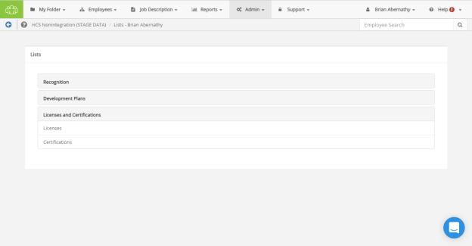
Clicking a list name under a heading displays its list management page. These pages display any existing items, in both Published and Pending status, that have been added to the list.
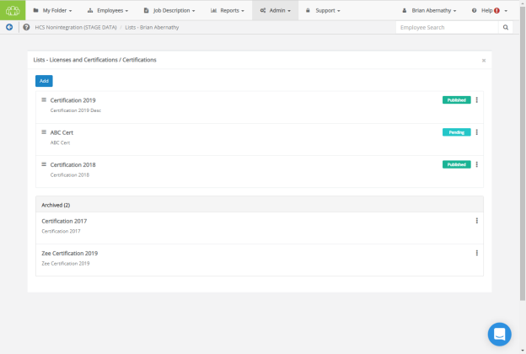
Adding Items to a List
Clicking Add at the top of the page displays an Add New Item modal window. Enter a name for your item, and give it an appropriate description. When you're satisfied with the item, clicking Add in the modal adds the item to the list one the page, with a status of Pending. The status must be changed to Published if you want the item to appear for other users.
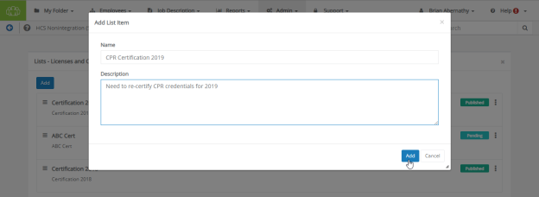
Publishing, Editing, and Deleting Items
When an item has a Pending status, there are three actions available to perform on it when selecting its context menu (the three vertical dots): Edit, Publish, and Delete.
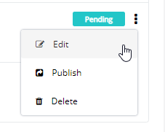
- Edit. Re-opens the Add New Item modal, where you can make changes to the title and description. Clicking Add re-adds it to the list, and Cancel scraps your changes.
- Publish. Changes the item's status to Published, enabling other users to see this item on their list.
- Delete. Permanently removes the item from the list.
Archiving and Re-Publishing Items
After an item is published, it can be removed from the list by selecting Archive from its vertical-dot context menu.
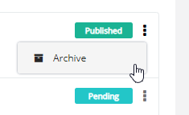
Alternately, an archived item can be re-published by selecting Publish from its vertical-dot context menu.

360 Review Settings
The settings for 360 Reviews can be modified from the 360 Review Settings area of the Settings page under the Admin menu.
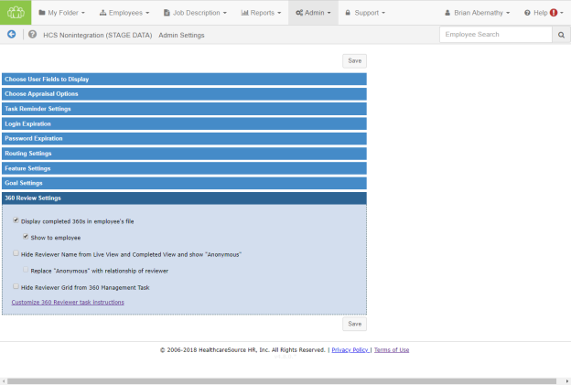
This area contains settings related to the 360 Reviews feature. Options include:
- Displaying completed 360 reviews in the subject employee's profile.
  - Show to employee
- Hiding reviewer names on the Live and Completed view for Facilitators.
  - Display the relationship of the reviewer instead of "Anonymous".
- Hiding the Reviewer table completely on the 360 Management task.
- The final option in this tab is a link to Customize 360 Reviewer Task Instructions. Clicking the Customize 360 Reviewer task instructions link at the bottom of the section opens a new page where you may edit the 360 Review Task Acceptance messaging.
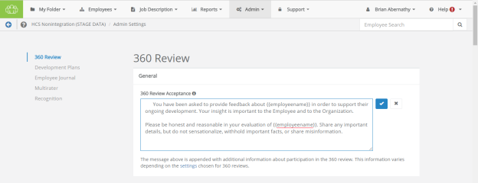
Clicking any underlined text displays that text in a field where edits can be made. Clicking the checkmark saves your revisions. Clicking the X cancels any changes.
Note: The content contained in this window is appended with additional information shown to the user about their participation in the 360 Review process. Information provided is based on the specific settings that have been chosen for 360 Reviews on the Admin's Settings page.

Appraisal Options
The settings for Appraisals can be modified from the Choose Appraisal and Job Description Options area of the Settings page under the Admin menu.
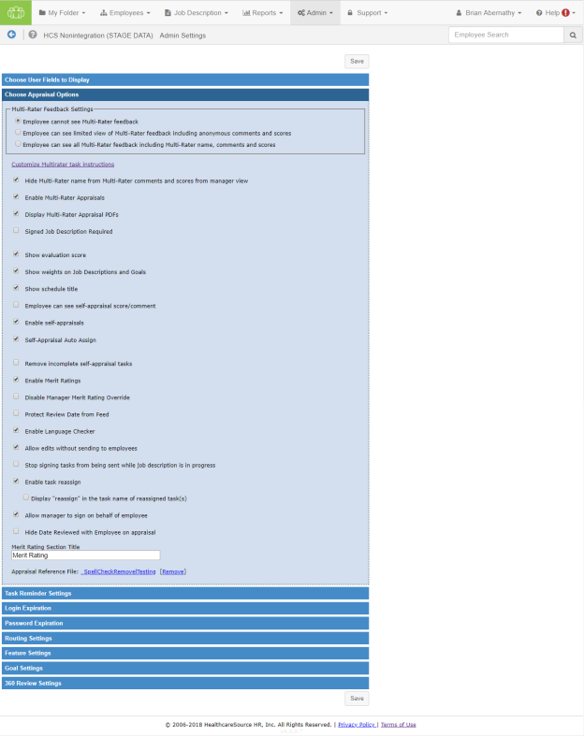
This area contains settings to define the appraisal workflow within Performance Manager. Options include:
- Multi-rater feedback settings. These options determine to what extent employees can see the feedback given to them by co-workers.
- Customize Multirater Task Instructions. Clicking the Customize Multirater task instructions link near the top of the section opens a new page where you may edit the Multirater Task Acceptance messaging.
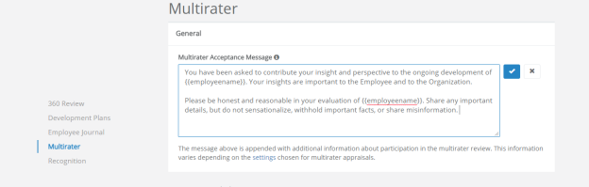
Clicking any underlined text displays that text in a field where edits can be made. Clicking the checkmark saves your revisions. Clicking the X cancels any changes.
Note: The content contained in this window is appended with additional information shown to the user about their participation in the Appraisal process. Information provided is based on the specific settings that have been chosen for Appraisals on the Admin's Settings page.
- Hide multi-rater name. Enabling this option hides the names of multi-raters from managers on scores and comments left on appraisals.
- Enable multi-rater appraisals. This option allows administrators to enable multi-rater appraisals (checking the box enables multi-rater appraisals). If the setting is enabled (checked), managers have the option to receive feedback during the appraisal from the employee’s co-workers.
- Display multi-rater appraisal PDFs. Provides access to completed multi-rater appraisals for employees in PDF format.
- Signed job description required. Checking this option requires job descriptions to be signed by the employee before the manager can conduct an appraisal. When enabled, managers will not be able to start working on an appraisal unless the employee signs off on the job description linked to that appraisal.
Note: If your appraisals are not based on job descriptions, this setting will not apply to your appraisal workflow.
- Show evaluation score, Show job description/goal weights. These settings apply to organizations that have scores and weights tied to their appraisals. Enabling these allows managers and employees to see scores/weights on the appraisal.
- Show schedule title. Displays the title of schedules as task names.
- Employee can see self appraisal score/comment. Keep this setting on if you would like the employee to review the self appraisal information along with the manager appraisal at the time of the appraisal sign off.
- Enable self appraisals. Enabling this option allows managers to send self appraisals and get feedback from the employee at the time of the appraisal.
- Self appraisal auto-assign. Allows self-appraisals to be automatically assigned to employees when schedule is activated.
- Remove incomplete self appraisal tasks. This option lets the Performance Manager system automatically delete incomplete self appraisals after the appraisal has been conducted and discussed by the manager and the employee has signed off on the final document.
- Enable merit ratings. This option allows the Performance Manager system to automatically calculate overall performance or a merit increase based on scores and weights on the appraisal.
Note: It is recommended that you consult with your Account Manager to get this feature set up for your organization.
- Disable manager merit rating override. When this option is enabled (checked), managers will not have the ability to override merit recommendation made by the Performance Manager system.
- Protect review date from feed. This option maintains review dates in Performance Manager only. This is useful for clients that do not send review dates in the HRIS feed.
- Enable language checker. This option maintains a library of questionable language in Performance Manager. Managers will have access to the library at the time of the appraisal.
- Allow edits without sending to employees. This option allows users to make edits to an appraisal without sending an alert to other employees.
- Stop signing tasks from being sent. This option prevents any task that requires a job description signature from being sent if the job description has not been signed by the employee.
- Enable task reassign. Allows users to reassign tasks to other users.
- Allow manager to sign on behalf of employee. Allows managers to provide signoff on an appraisal for both themselves and the employee at the same time when reviewing the appraisal with the employee.
- Hide Date Reviewed with Employee on appraisal. Removes the Date Reviewed with Employee field on appraisals.
- Merit rating section title. This is entered by your Account Manager.
- Appraisal reference file. This option allows the upload of any document (Word, Excel, PowerPoint, and PDF) that you wish to have as supporting documentation for managers.

Data Maintenance
The Data Maintenance page allows administrators to update Facility, Department, and Position information in Performance Manager.
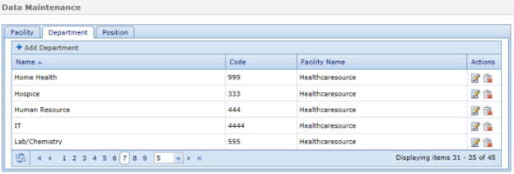
Each tab contains an Add button that allows the creation of new list items.
Existing items can also be edited and removed from the tables using Edit and Delete icons found under the "Actions" column.

Groups
Groups are used during scheduling of appraisals, training, and competency checklists. They are used to group together positions/departments that have the same scheduling demographic.
Example: You can create a Leadership group that consists of all management positions if leadership is evaluated on a different date than the rest of the staff, or if leadership consistently has trainings assigned that are specific to that group.
Exceptions can be added that exclude subsets of the group (employees and/or departments) from being included in the group activites/assignments. Assignments can be removed from groups as well.
Group types
The available group types include:
- Compensation.
- Data Access.
- People.
- Role.
- Schedule.
Creating a group
To create a group:
- Click the Add button. This opens the Add Group window.
- Enter a Group Name.
- Select a Group Type from the drop-down list.
- Select if you wish to add Facility/Department/Positon or Employee to the group.
- Browse the company hierarchy or use the available search fields to locate the desired entity.
- Select the desired entity from the Choices list and use the arrow button to move them to the Selected list.
- Click the Add button. Selected entities are added to the Group Assignments table.
- Click the Save.
Clicking the Save button adds the new group. You can now edit the group to include Exceptions, if necessary.

Language Checker
Language checker is a library of words and/or phrases that are marked as "questionable" when used on an appraisal form. It is used to assist managers (helping them to avoid using harsh or offensive language) when completing appraisals.
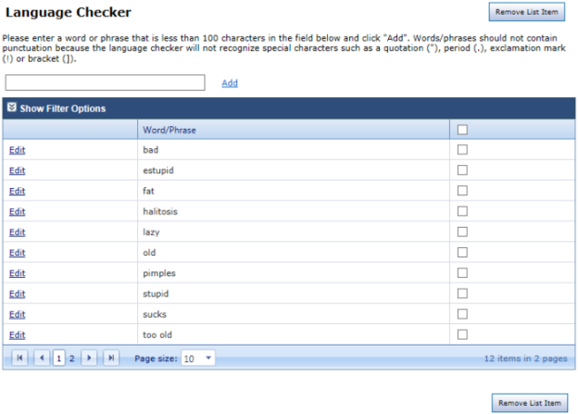
The Language Checker is enabled from the Choose Appraisal Options heading on the Settings page under the Admin area. When enabled, any word or phrase used in an appraisal form that matches an entry in the Language Checker table is automatically flagged for editing.
Enter a word or phrase in the text box above the table and click the Add button to create a new listing.
Select the checkbox for an item and click the Remove List Item button to remove it from the table.

Manager Override
Manager override is used to create a temporary override if an employee’s manager cannot perform a scheduled evaluation.
Note: This feature can only be used if manager IDs are being sent in the Person/Position HRIS feed file. If your organization is sending manager IDs in the Department/Position file or is managing employee/manager relationships in Performance Manager, all changes must be made on the User Maintenance page under the Admin area.
Creating a manager override
These steps take place on the Manager Override page under the Admin area.
- Click the Add Override button.
- Select the employee(s) for whom you wish to create the override using the available search fields.
- Select the employee from the Choices list and use the arrow button to move them to the Selected list.
- Click the Continue button.
- Using the same search options as before, select a manager for the override.
- Click Continue.
Clicking Continue returns you to the main Manager Override page. The newly-created override appears in the table.

Message Center
The Message Center page controls email reminder settings for tasks. The table lists all the available email notifications that can be sent by the system, organized by Performance Manager features (Appraisals, Goals, etc).
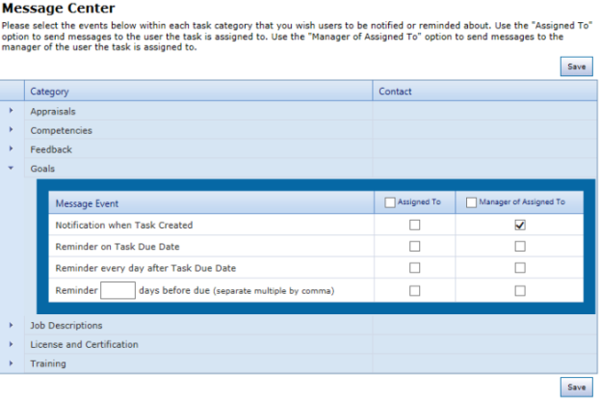
There are four notification options for each feature in the table:
- Notification when task created
- Reminder on task due date
- Reminder every day after task due date
- Reminder X days before due (where X represents the number of days desired)
Notifications can be sent to both the Assigned To user as well as the Manager of Assigned To. Checking off a selection from the table enables the email notification for that event.
Options found under the notifications list (Send notification to the evaluator of the appraisal when:) controls notification settings for when employees have taken an action on their appraisal.
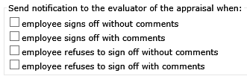
There's also a 360 Reviews notification option for Send notification to the facilitator of the 360 when subject completes set up task.
Finally, there's a text area that allows a custom message to be included with these automatic email notifications.

Routing Users
The Routing Users page allows you to control which users in Performance Manager can be used for routing various forms in the system. Users can be assigned as routing users for multiple forms.
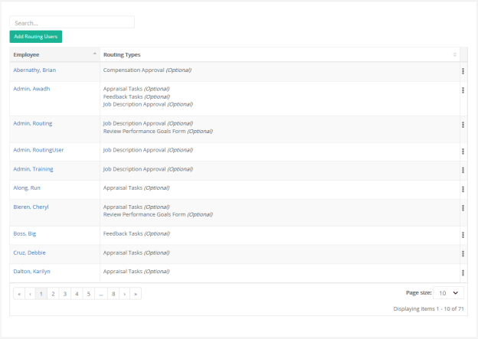
The table can be sorted by either column heading (Employee, Routing Types), and a Search field allows you to narrow the results displayed in the table.
Routing User types
There available types of routing users include:
- Appraisal Tasks. These are employees who review appraisal forms.
Example: Your organization may require that a manger's supervisor reviews all appraisals he has completed before final submission to HR. The manager's supervisor is a routing user.
- Feedback Tasks. These are employees who review corrective feedback before it is discussed with the employee.
Example: Your organization may require that all “Corrective” feedback is sent to Employee Relations before it’s discussed with the employee. The employees in Employee Relations are routing users.
- Job Description Approval. These are employees who review job description edits made by managers.
Example: Your organization allows managers to initiate job description changes. These changes are reviewed by HR, then sent to employees for signature. Employees in HR are routing users.
- Review Performance Goals Form. These are employees who send and receive appraisals for approval/sign off during the evaluation process.
Example: Your organization may require that all “Exceptional” appraisals are routed to the director by the manager for sign off. Both the manager and director are routing users.
- Compensation Approval. These are employees who review and approve compensation worksheets completed by managers. This approval usually takes place before worksheets are sent to HR for final processing.
Example: Your organization requires compensation worksheets to be approved by a finance manager before adjustments are made. The finance manager is a routing user.
Some of these features are optional and may be turned on or off. Please contact your Account Manager to review these settings.
Setting up a routing user
These steps take place on the Routing Users page under the Admin area.
- Click the Add Routing Users button. This opens the Add Routing User pop-up window.
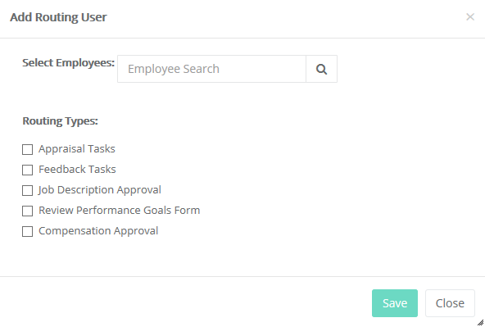
- Use the search field to locate desired users. Results matching your entry automatically begin to appear under the field.
- Select a name from the results shown to add that user as a routing user. Multiple users can be added.
- Select the type of routing user from the available checkboxes.
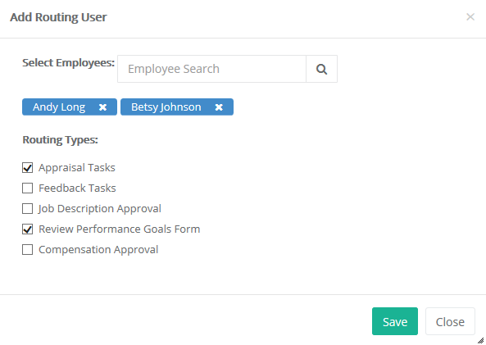
- Click the Add Selected User button.
If you need to edit the routing user, click on the name in the Routing Users table. You can also click the Delete link to remove them from the routing user list.

Performance Vitals Configuration
The Vitals Configuration page under the Admin area contains settings for determining which Summary and Detail tiles appear on the Performance Vitals page. This page is available when the Enable Performance Vitals options is selected on the Settings page.
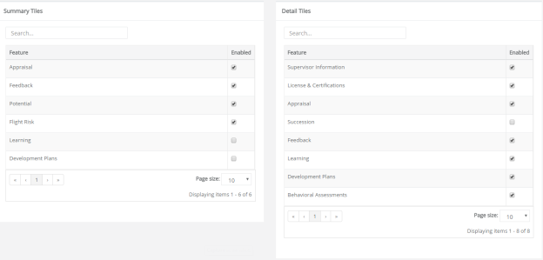
Checking the Enabled checkbox for options in either list enables that tile. Changes are automatically saved when options are updated.
Summary tiles
Summary tiles are the colored tiles that appear at the top of the Performance Vitals page.
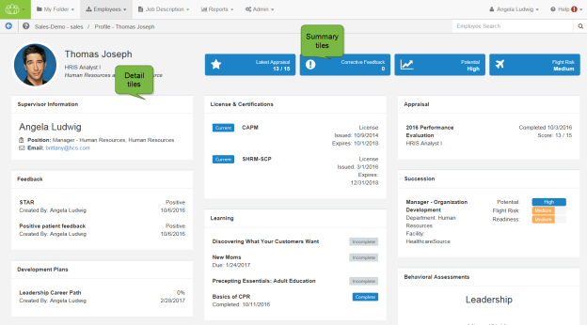
Available tiles include:
- Appraisals. Shows the results from the most recently completed appraisal. Depending on the evaluation method used, this tile displays the Merit Rating, Total Weighted Average, or Total Score.
- Feedback. Displays the number of corrective feedback items added to the employee’s profile.
- Potential. Shows the employee’s potential rating from succession.
- Flight Risk. Shows the employee’s flight risk rating from succession.
- Learning. Displays the number of incomplete learning assignments from NetLearning.
- Development Plans. Displays the completion percentage from the most recent development plan.
Note: A maximum of four (4) Summary tiles can be enabled at once.
Detail tiles
The Detail tiles are informational cards on the Performance Vitals page containing information for the various areas of an employee's profile. These cards display more detailed information than Summary tiles.
Available tiles include:
- Appraisal. Displays details from the latest appraisal for the employee, including the name of the appraisal, related position, completion date, and scoring results.
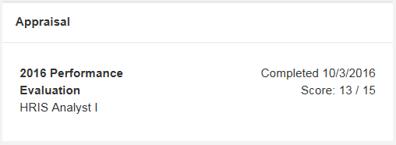
- Behavior Assessments. Displays the results of any assessment completed by the employee. A radar chart of the results helps define competencies for the employee, with overall scores available by hovering over the chart’s data points. Clicking the View Report link opens the PDF report from the assessment in a new browser window.
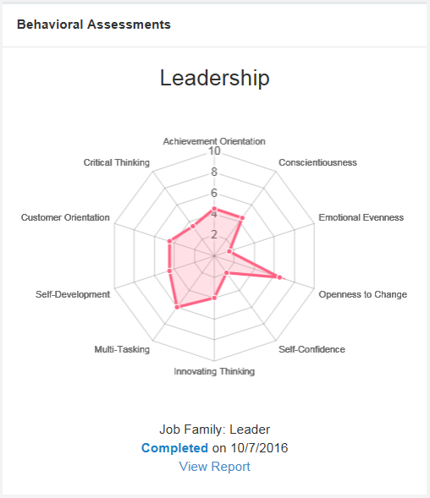
- Compensation. Shows all compensation cycles for the employee within the past year, along with a color-coded status of the cycle.
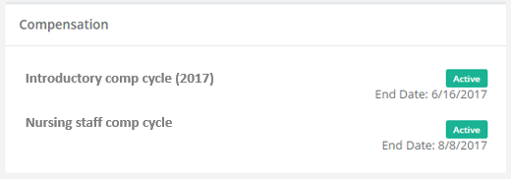
- Development Goals. Lists development goals the employee has completed within the past year, along with the goal's due date.
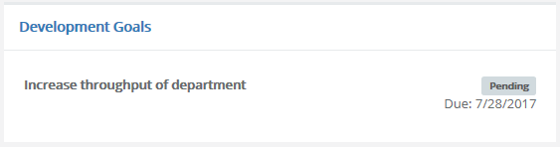
- Development Plans. Displays all development plans in the employee’s profile along with the overall completion percentage for each plan.
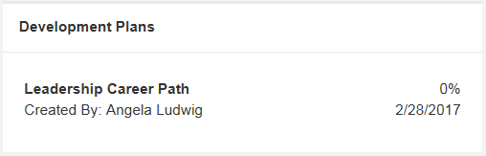
- Document. Lists documents that have been added to the employee's profile within the past year.
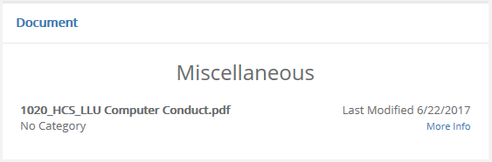
- Feedback. Displays all feedback items in the employee’s profile. Though tiles in the employee profile header only shows the number of corrective feedback items, this Feedback card shows details for all types of feedback left for the employee.
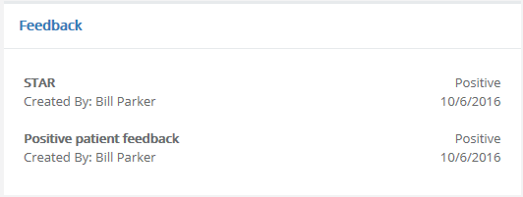
- Job Descriptions. Lists any job description the employee has signed within the past year and the date it was signed.
- Learning. Available for clients with integrated NetLearning solutions, this card displays a list of incomplete and complete learning assignments for the employee.
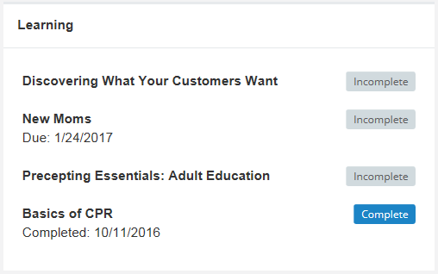
- License & Certifications. Shows the details of any licenses and certifications for the employee along with their current status.
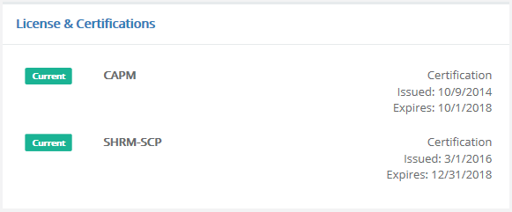
- Performance Goals. Lists performance goals the employee has completed within the past year, along with the goal's due date.
- Recognition and Remarks. Lists all the feedback left for the employee from the Recognition and Remarks feature.
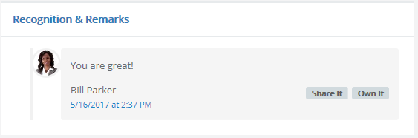
- Succession. Displays details from all available succession plans in the employee’s profile, including visual representations for Potential, Flight Risk, and Readiness for each plan.
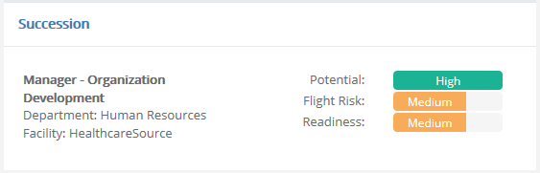
- Supervisor Information. Lists the employee’s manager and their position, department, and contact information (email and/or phone number). If an employee has multiple managers, they are all listed in this informational card.
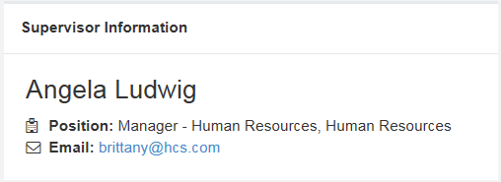
- Training & Assessments. Lists any training and assessment activities assigned to the employee within the past year, along with a color-coded status and any associated credit hours.
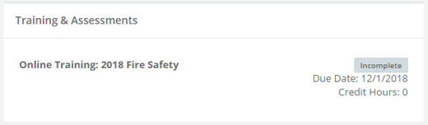
- 360 Review. This card displays any 360 reviews for the employee. The card includes the schedule title for the review, the applicable employee position, the status of the review, and a due date (if the review is still in progress).
Note: There's no limit for the amount of Detail tiles that can be enabled at once.

Settings
The Settings page contains several display customization options for Performance Manager. Clicking an item from the list expands the area to display the available settings for that option.
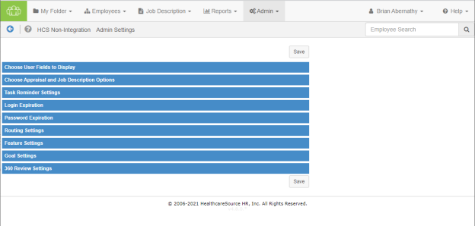
Choose User Fields to Display
Options found under Choose User Fields to Display allow you to select fields to display on job descriptions, appraisals, competency checklists and trainings. These fields are directly derived from feeds received from the HRIS system.
- The check box indicates if the field is displayed in that area and/or to the user role.
- The Field Name field cannot be changed; however, Alias allow you to customize the field name to meet your needs.
- Text entered into the Description field is only visible on this settings page and is not displayed to users.
Choose Appraisal Options
Choose Appraisal Options provides an area to define the appraisal workflow within Performance Manager.
Multi-rater feedback settings | These options determine to what extent employees can see the feedback given to them by co-workers.
Customize Multirater Task Instructions | Clicking the Customize Multirater task instructions link near the top of the section opens a new page where you may edit the Multirater Task Acceptance messaging.  Clicking any underlined text displays that text in a field where edits can be made. Clicking the checkmark saves your revisions. Clicking the X cancels any changes.  Note: The content contained in this window is appended with additional information shown to the user about their participation in the Appraisal process. Information provided is based on the specific settings that have been chosen for Appraisals on the Admin's Settings page.
Hide multi-rater name | Enabling this option hides the names of multi-raters from managers on scores and comments left on appraisals.
Enable multi-rater appraisals | This option allows administrators to enable multi-rater appraisals (checking the box enables multi-rater appraisals). If the setting is enabled (checked), managers have the option to receive feedback during the appraisal from the employee’s co-workers.
Display multi-rater appraisal PDFs | Provides access to completed multi-rater appraisals for employees in PDF format.
Signed job description required | Checking this option requires job descriptions to be signed by the employee before the manager can conduct an appraisal. When enabled, managers will not be able to start working on an appraisal unless the employee signs off on the job description linked to that appraisal.  Note: If your appraisals are not based on job descriptions, this setting will not apply to your appraisal workflow.
Show evaluation score, Show job description/goal weights | These settings apply to organizations that have scores and weights tied to their appraisals. Enabling these allows managers and employees to see scores/weights on the appraisal.
Show schedule title | Displays the title of schedules as task names.
Employee can see self appraisal score/comment | Keep this setting on if you would like the employee to review the self appraisal information along with the manager appraisal at the time of the appraisal sign off.
Enable self appraisals | Enabling this option allows managers to send self appraisals and get feedback from the employee at the time of the appraisal.
Self appraisal auto-assign | Allows self-appraisals to be automatically assigned to employees when schedule is activated.
Remove incomplete self appraisal tasks | This option lets the Performance Manager system automatically delete incomplete self appraisals after the appraisal has been conducted and discussed by the manager and the employee has signed off on the final document.
Enable merit ratings | This option allows the Performance Manager system to automatically calculate overall performance or a merit increase based on scores and weights on the appraisal.  Note: It is recommended that you consult with your Account Manager to get this feature set up for your organization.
Disable manager merit rating override | When this option is enabled (checked), managers will not have the ability to override merit recommendation made by the Performance Manager system.
Protect review date from feed | This option maintains review dates in Performance Manager only. This is useful for clients that do not send review dates in the HRIS feed.
Enable language checker | This option maintains a library of questionable language in Performance Manager. Managers will have access to the library at the time of the appraisal.
Allow edits without sending to employees | This option allows users to make edits to an appraisal without sending an alert to other employees.
Stop signing tasks from being sent | This option prevents any task that requires a job description signature from being sent if the job description has not been signed by the employee.
Enable task reassign | Allows users to reassign tasks to other users.
Allow manager to sign on behalf of employee | Allows managers to provide signoff on an appraisal for both themselves and the employee at the same time when reviewing the appraisal with the employee.
Hide Date Reviewed with Employee on appraisal | Removes the Date Reviewed with Employee field on appraisals.
Merit rating section title | This is entered by your Account Manager.
Appraisal reference file | This option allows the upload of any document (Word, Excel, PowerPoint, and PDF) that you wish to have as supporting documentation for managers.

Task Reminder Settings
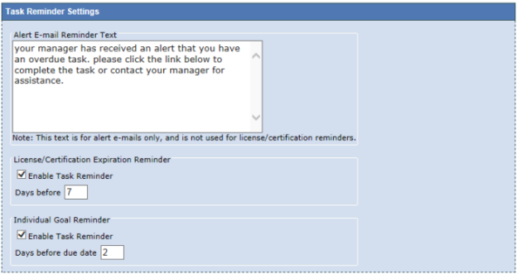
Options under this area provide an area to:
- Create a customized email alert that can be sent out by your managers for overdue tasks.
- Enable license/certification and goal reminders when they near their expiration date.
Login Expiration
This area provides a field where you can enter the number of minutes after which the system will log out the user due to non usage.
Note: The user will only be logged out if the system is idle. If the user is actively working in the system, they will not get logged out.
Password Expiration
This area provides a field where you can enter the number of days after which passwords will need to be changed by the user. The maximum number of days is 540.
To protect the security of the data within the system, all passwords must be changed periodically.
Routing Settings
This area provides options that control routing settings for appraisals.
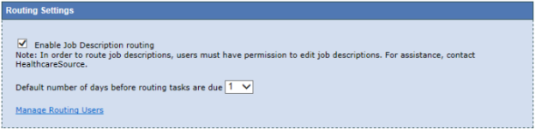
- The first option (Managers must route appraisals) forces managers to route appraisals when enabled.
- Enable Job Description Routing allows job descriptions to be viewed and edited by users.
- The final option determines the default number of days a newly-created routing task is due.
Feature Settings
This area contains general options relating to checklists, goals, and other areas.
- Enable checklist
- Enable multiple checklist validators
- Enable checklist signoff
- Allow manager to send checklist self assessment task
- Enable development goals
- Allow manager to edit feedback after routing
- Allow routing user to edit feedback
- Enable succession
- Enable compensation summary signoff task
- Enable document signoff
- Enable toggling of employee lock on the employee list
- Enable toggling of refuse to sign on the employee list
- Automatically reassign tasks to new supervisor
- Delete tasks when employee terminates
- Enable development plans
  - Allow managers to send plan to employee
  - Allow employees to create plan
- Allow employees to upload their own profile pictures
- Enable Performance Vitals
- Display compensation worksheet in rows by default
- Allow Managers to see only Job Descriptions in their reporting structure
- Allow Managers to assign delegates. Includes Customize access to Delegation link to manage delegate access throughout your organization.
The final option in this tab is a link to display Recognition and Development Plan Settings. The Development Plans Settings page contains options to configure your organization's Development Plans, Employee Journal, and Recognition and Remarks features.
Goal Settings
This section contains options pertaining to Goals, including:
- Enable Performance Goal shortcut on Appraisal
- Allow Manager to add/edit goal forms for direct reports
- Allow Manager to distribute goals to direct reports
- Allow manager to start appraisal prior to goal approval
The Performance Goal Instructional Text area provides a text box where the instructions for completing Performance Goals are managed. Information entered into this box is displayed on the Goals form for employees and managers.
360 Review Settings
This area contains settings related to the 360 Reviews feature. Options include:
- Displaying completed 360 reviews in the subject employee's profile.
  - Show to employee
- Hiding reviewer names on the Live and Completed view for Facilitators.
  - Display the relationship of the reviewer instead of "Anonymous".
- Hiding the Reviewer table completely on the 360 Management task.
- The final option in this tab is a link to Customize 360 Reviewer Task Instructions. Clicking the Customize 360 Reviewer task instructions link at the bottom of the section opens a new page where you may edit the 360 Review Task Acceptance messaging.
Clicking any underlined text displays that text in a field where edits can be made. Clicking the checkmark saves your revisions. Clicking the X cancels any changes.
Note: The content contained in this window is appended with additional information shown to the user about their participation in the 360 Review process. Information provided is based on the specific settings that have been chosen for 360 Reviews on the Admin's Settings page.

Recognition and Remarks Administration
The Recognition and Remarks feature is highly customizable to help it fit into existing organizational feedback programs. Settings provide control over the feature name and descriptive/instructional text, as well as specific options such as anonymous comments and email notifications.
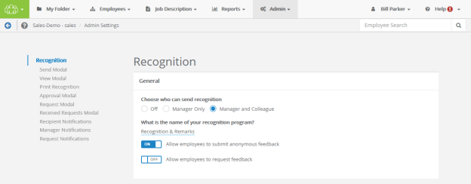
The settings page for Recognition and Remarks can be opened from the Feature Settings area of the Settings page under Admin. Clicking the Please click here for Recognition settings link at the bottom of the section opens a new page with all applicable settings for Development Plans, Employee Journal, and Recognition and Remarks.
General
The first section contains options to enable Recognition and Remarks for employees and/or managers, and other basic functions of the feature.
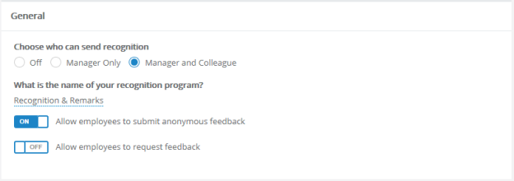
- Choose who can send recognition. Turn the entire feature Off, or select if input can be left by Managers Only or both Managers and Colleagues.
- What is the name of your recognition program? Customize the name of the feature. This appears as the name of the feature throughout Performance Manager.
- Allow employees to submit anonymous feedback. Enabling allows employees to send feedback anonymously (the recipient does not see the sender's name).
- Allow employees to request feedback. Enabling allows employees to request input from specific colleagues.
Send Modal
This area allows the customization of text that appears in the Send Recognition modal.
Clicking any underlined text displays that text in a pop-up where edits can be made.
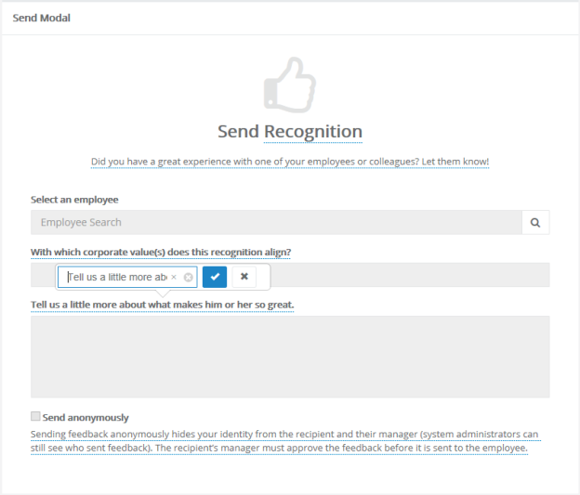
View Modal
This area allows the customization of text that appears in the View Recognition modal.
Clicking any underlined text displays that text in a pop-up where edits can be made.
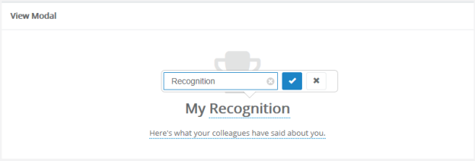
Print Recognition
This area allows the customization of text that appears in the Print Recognition modal.
Clicking any underlined text displays that text in a pop-up where edits can be made.
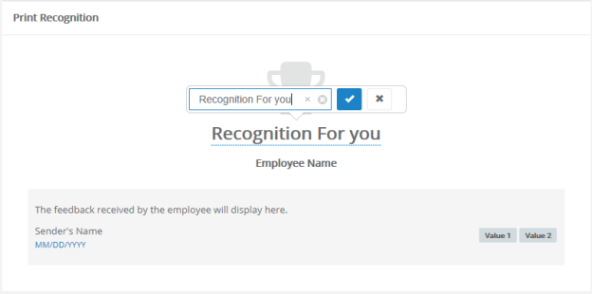
Approval Modal
This area allows the customization of text that appears in the Recognition Approvals modal.
Clicking any underlined text displays that text in a pop-up where edits can be made.
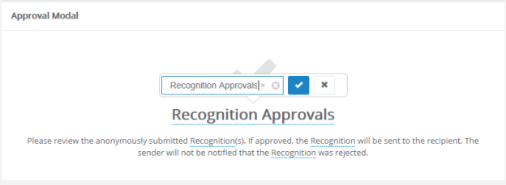
Request Modal
This area allows the customization of text that appears in the Request Recognition modal.
Clicking any underlined text displays that text in a pop-up where edits can be made.
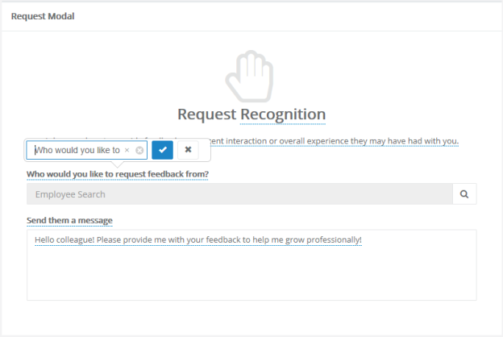
Received Requests Modal
This area allows the customization of text that appears in the Received Requests modal.
Clicking any underlined text displays that text in a pop-up where edits can be made.
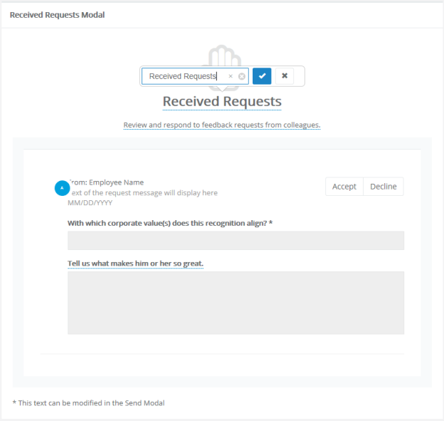
Recipient Notifications
Contains an option to enable notifications to employees when they receive new recognition.
Clicking the underlined text for Email subject and Email body allows edits to that text.
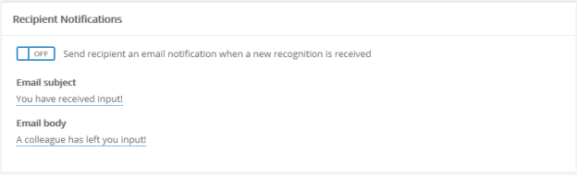
Manager Notifications
Contains an option to enable notifications to managers when their employees receive new recognition.
Clicking the underlined text for Email subject, Email body, and Email body when submitted anonymously allows edits to that text.
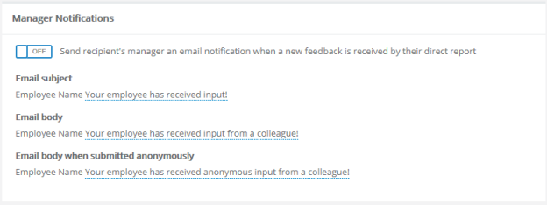
Request Notifications
Contains an option to enable notifications to colleagues when employees request recognition.
Clicking the underlined text for Email subject and Email body allows edits to that text. The {{requester}} merge field can be added to these areas to automatically include the name of the requesting employee in the notification.
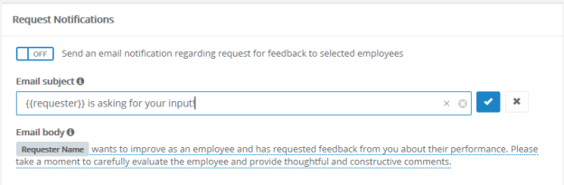
Additional settings
Recognition and Remarks allows you to customize the list of corporate values that can be assigned to feedback left for employees.
The page for customizing this list can be reached by clicking the Click here to add and edit Custom Lists link on the Custom Lists page.

User Maintenance
The User Maintenance page allows administrators to add users into the system, change user statuses for active or terminated employees, and update user demographic data. This page is also used to assign managers to user groups directly within Performance Manager.
You can view an existing employee's profile by searching for the desired employee and clicking the Load Employee button. This opens the profile page for the selected employee. Profiles can be viewed and edited as necessary.
Additional options allow you to add new users to Performance Manager, as well as assign managers.

Adding a user
Administrators have the ability to add users directly into Performance Manager. This feature is usually used to add contractors or non-employees into the system.
- From the User Maintenance page, click the Add User button. A blank user profile opens.
- Complete the necessary required fields as indicated with an asterisk (*).
- Select the desired permission groups for appropriate access.
- Select the Protect Employee Info box to ensure the user's information does not get overwritten by the HRIS feeds.
- Click Save when the form is complete.
Clicking the Save button adds the user to the system. The user will receive an email notification at the email addressed entered on the profile form.

Assigning a manager
Managers can be assigned to an employee or a group of employees. This can be done for standard managers as well as compensation managers.
Note: This feature should only be used if manager assignments are not being sent in the HRIS feed files. Assigning managers in Performance Manager while also sending manager assignments in the feed will create duplication of manager assignments.
Assign a manager
- From the User Maintenance page, click the Assign Manager button.
- Select if you wish to assign a manager to a Facility/Department/Position or just an Employee.
- Browse the company hierarchy or use the available search fields to locate the desired entity.
- Make a selection from the Choices and use the arrow buttons to move the selection to the Selection area.
- Click the Next button.
- Use the same hierarchy navigation or search fields to locate the manager to assign to your selection.
- Select a manager from the Choices area.
- Click the Save button.
Clicking the Save button assigns the manager to the selected entity.
Assign a compensation manager
- From the User Maintenance page, click the Assign Compensation Manager button.
- Select the desired compensation cycle from the drop-down list.
- Select if you wish to assign a manager to a Facility/Department/Position or just an Employee.
- Browse the company hierarchy or use the available search fields to locate the desired entity.
- Make a selection from the Choices and use the arrow buttons to move the selection to the Selection area.
- Click the Next button.
- Use the same hierarchy navigation or search fields to locate the manager to assign to your selection.
- Select a manager from the Choices area.
- Click the Save button.
Clicking the Save button assigns the compensation manager to the selected entity.

Employee Profile
The Employee Profile page lists basic information about each user in the system, including permission groups and manager information.
Employee profile pages are divided into sections as follows:
Employee info
The Employee Info section lists the basic information about the selected employee, such as Position, Manager, Hire/Start dates, etc.
It is important to remember that the demographic information is primarily controlled by your HRIS feed. Information will be automatically updated by the feed unless you protect the information from the feed.
- The employee account can be locked or unlocked by simply clicking on the lock icon next to the employee name.
- The refuse to sign function can be enabled or disabled by simply clicking on the little hand icon next to the employee name. The refuse to sign option allows managers and administrator to close out tasks that employees will not sign.
- Facility, department and position information can be changed by using the drop down lists. These lists are populated from your HRIS system and cannot be managed in Performance Manager.
- The manager can only be changed using the Assign Manager feature.
- The employee id can be changed but please bear in mind this is the employees unique identifier.
- The Hire Date, Start Date, Status Change Date are all received from your feed and can be changed in Performance Manager but these changes must be protected in order to be maintained in Performance Manager.
- The Review Date can be sent in the feed or maintained in Performance Manager and also protected as needed.
- The protect review date from feed check box will only maintain the review date changes for that employee.
- The protect employee info checkbox will protect all employee demographic data from the HRIS feeds.
Permission Groups
Permission Groups determine the actions a user is able to perform in Performance Manager. Checking the various groups in a user's profile assigns them to that group.
User Info
This section allows you to maintain the employee’s username and password.
The username can be sent in the HRIS feed or can be created by the user during registration. Administrators can view and change usernames as needed.
The password cannot be viewed or changed by the administrator. The Expire Password button allows the administrator to force the user to change their password. The Unregister User button forces the user to recreate their user profile (username, password and security questions).
Personal Info
All information in this section comes from the HRIS feed files. Information changed in this section should reflect the feed or it will revert back to what is received on the feed.

Permission groups
Permission Groups determine the actions a user is able to perform in Performance Manager. Checking the various groups in a user's profile assigns them to that group.
The available permission groups are as follows:
- Admin. This gives the user unlimited access to all Performance Manager functionality. The user will have access to all items in the navigation bar, as well as the ability to add and modify data as needed.
- Users. This is used for general employee access. The user only sees My Folder and has access to their tasks and employee file.
- Manager. This allows the user to conduct appraisals, assess competencies, give feedback and add goals to employee records within their reporting structure. Managers also have access to run reports for their departments. They have access to four areas: My Folder, Employees, Reports, and Job Descriptions.
- Checklist validation. This is for users who validate competencies for employees alongside the manager. This permission gives the user access to competency checklists for all employees. They have access to two areas: My Folder and Employees. Under Employees, they can only access checklists.
- HR Admin. These users have limited permission to administrator functionality. They are able to create and run reports, view the job description and competency libraries, and access and manage employee files (including goal management). They have access to My Folder, Employees, Reports, Job Description, and All Employees.
- Compensation Admin. Allows users to access and edit compensation worksheets for all employees, including updating worksheets and modifying approvals.
- Learner Management. Allows the user to view and manage learning activities for employees. This only applies to clients with integrated NetLearning.
- Development Coach. Users with this role can be added to development plans as a coach. This includes overall plans and specific plan activities.

Compensation administration
Performance Manager systems that utilize the Compensation module contain a Compensation category under the Admin area in the navigation bar that contains system configuration and usability options. This area is only accessible to users that have the necessary system privileges.
While the majority of work performed in this administration area takes place upon initial setup of the Compensation module, many options can be edited or added at any time.
The available configuration pages for compensation are:
- Cycle management. The Cycle management page provides an area to create and manage compensation cycles and their specific settings. These cycles are available in the drop-down menu on the worksheet.
- Worksheet configuration. The Worksheet configuration page determines which fields appear on the worksheet for users. It also allows the customization of field names.
- Guideline configuration. Guideline configuration is where specific rules for compensation merit increase recommendations are defined.

Compensation cycles
Cycles determine the time period for compensation activities and set certain configuration options for those cycles.
The Cycle Management page provides an area to create and maintain compensation cycles in Performance Manager. The table lists all the available cycles, and provides a way to edit or delete existing cycles.
When creating a new compensation cycle, there are several fields and options available. Fields marked with an asterisk (*) are required fields.
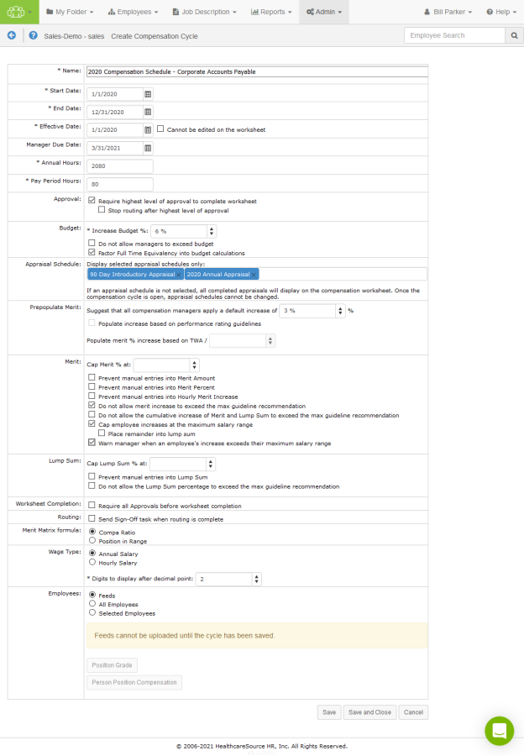
Name | The Name of the cycle, which appears in the drop-down list on the Compensation page.
Start Date | When the compensation cycle begins.
End Date | When the compensation cycle ends.
Effective Date | The date on which the employee's increase becomes effective.
Manager Due Date | The date that managers must complete their worksheet task for the compensation cycle.
Annual Hours | Annual Hours indicates the number of hours over the course of a year that constitutes a full-time employee. This setting defaults to 2080 hours.
Pay Period Hours | Pay Period Hours indicates how many hours are considered full-time for an employee during a pay period. This setting defaults to 80 hours.
Approval | The option in this section requires the highest level of approval for a worksheet to be selected before it can be completed.  If Require highest level of approval to complete worksheet has been checked, a secondary option displays allowing you to prevent further routing of a compensation worksheet once the highest level of approval has been received. The Stop routing after highest level of approval option is available only when Require highest level of approval to complete worksheet setting is enabled for a worksheet.
Budget | Options in the Budget area apply to the Increase Budget for worksheets.  The percentage entered into Increase Budget is used to calculate the available merit increase budget for a manager based on the total salary of their employees.  Additional options include:  - Do not allow managers to exceed budget  - Factor Full Time Equivalency into budget calculations  The Allow budget overrides field allows you to search for and add compensation managers that can override budget restrictions for the cycle.
Appraisal Schedule | This option allows limiting the compensation cycle worksheet to only display scores from specific appraisal schedules. Omitting unnecessary appraisal scores this way helps simplify things for managers and to ensure the increase is based on the correct appraisal score.  Select which appraisal scores to show by clicking appraisal schedule titles within the Display selected appraisal schedules only: drop-down/search field. When a schedule is chosen, it displays in the field as a blue box. To remove a schedule from your selections, simply click the X on the box's right-hand side.  There are no limits to the amount of schedules that can be selected from this menu, and schedules may be added while a cycle has a status of Pending and Open. However, once a cycle is open, schedules cannot be removed.  By default, all appraisal schedules display on the worksheet.
Prepopulate Merit | A suggested default increase percentage can be set and used to recommend an increase for all employees in a worksheet. Managers are prompted about this recommended increase when they open a worksheet, and have the option to accept or reject the recommendation. Adjustments to the increase can still be made for individual employees when the recommended increase is accepted.  (Managers are re-prompted about the increase when employees are added to a worksheet. The increase is only applied to employees who do not already have an increase added to their record.)  The Populate increase based on performance rating guidelines option does exactly that: prepopulates the merit increase field based on the individual employee's performance rating. Increase amounts are based on the guidelines for the specific cycle, and either uses the set percent in the guideline, or if a range is used, populates with the lower side of the range.  The Populate merit % increase based on TWA / option lets you enter the desired value to use for dividing the total weighted average, removing the need for managers to do the math themselves.
Merit | The Merit area contains options that determine how maximum merit increase ranges are handled in worksheets.  A Cap Merit % can be set to prevent managers from applying larger amounts for individual employees.  Additional options include:  - Prevent manual entries into Merit Amount  - Prevent manual entries into Merit Percent  - Prevent manual entries into Hourly Merit Increase  - Do not allow merit increase to exceed the max guideline recommendation  - Do not allow the cumulative increase of Merit and Lump Sum to exceed the max guideline recommendation  - Cap employee increases at the maximum range recommendation  - Place remainder into lump sum  When this option is selected, a Calculate lump sum remainder at field is displayed that allows you to enter a percentage for automatically calculating lump sum amounts.  - Warn manager when an employee's increase exceeds the maximum recommendation
Lump Sum | Contains options for how Lump Sum distributions are handled.  - Cap Lump Sum % prevents managers from applying larger amounts for individual employees.  - Prevent manual entries into Lump Sum. This makes the Lump Sum field a read-only field on worksheets.  - Do not allow the Lump Sum percentage to exceed the max guideline recommendation
Worksheet Completion | Require all Approvals before worksheet completion prevents compensation worksheets from being completed until all approvals have been checked.
Routing | Send Sign-Off task when routing is complete allows users to control sign-off tasks related to compensation workflows.
Merit Matrix formula | This option determines if merit increase recommendations are calculated using an employee's Compa Ratio or their Position in Range.
Wage Type | Determines the type of wages for employees in the cycle (Annual or Hourly). The following fields on the compensation worksheet are adjusted accordingly based on the selected wage type:  - Minimum  - StartQ2  - Midpoint  - StartQ4  - Maximum  The person_position_compentation feed field should contain either the hourly_rate or annual_salary field. Fields not provided are automatically calculated.  There's also an option to determine how many Digits to display after decimal point.
Employees | This field determines which employees are assigned to the compensation cycle. Options include Feeds, All Employees, or Selected Employees.  Selecting Feeds allows you to upload Person Position Compensation and Position Grade feed files to populate worksheets.  Choosing Selected Employees displays a drop-down list appears where you can select a compensation group to assign to the cycle.  Note: Selections made here cannot be edited once the cycle is saved, even if the cycle is not yet active.

Adding compensation cycles
New compensation cycles can be added at any time. There is no limit to the number of compensation cycles that can be added to the system.
These steps take place on the Cycle Management page under the Admin area.
- Click the Add button. A blank compensation cycle form opens.
- Complete the fields and options on the form as necessary.
- Click the Save button when finished.
Clicking the Save button commits the new cycle to the system. The cycle becomes available for use based on the Start Date entered for the cycle.

Guideline configuration
The Guideline Configuration page is where the merit matrix for a compensation cycle is defined.
The main page lists all of the available compensation cycles. Merit matrices for cycles in progress cannot be edited.
Selecting a cycle from the list opens the Merit Guideline Configuration page that lists the available matrices for the cycle. The matrices that are available are based on the merit rating lists associated with employee appraisals in Performance Manager. Each merit rating list is assigned its own matrix.
Each matrix on the page utilizes either quartile (position in range) or compa ratio along with the merit rating list to create a matrix for the compensation cycle. Each matrix can be configured independently as needed.
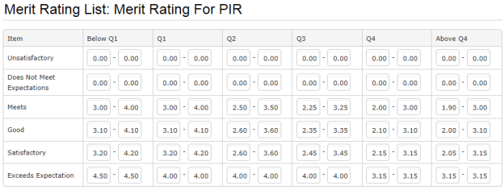
There's also an option to Use Percentage Mode when viewing an individual merit guideline. When this option is selected, a set percentage is used in the Merit Guideline field on worksheets instead of the merit matrices.

Worksheet configuration
The Worksheet Configuration page controls which fields are visible in the compensation worksheet, and the field name that is displayed.
The table lists the available fields based on the section (or Group) where they appear in the worksheet: Basic, Employee Data, Current Pay, Merit, Proposed Pay, and Bonus. Expanding each section opens the list of fields in that section.
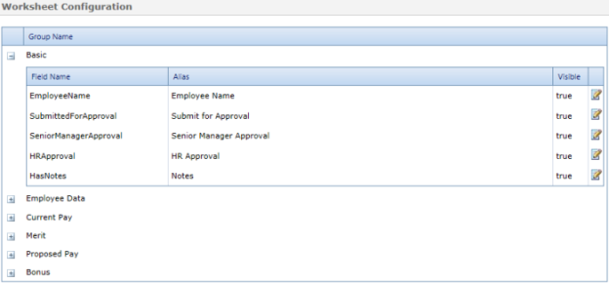
Each field has a Field Name (how the field appears in the database) and an Alias (the name of the field displayed in the worksheet). Only the Alias field can be edited.
The Visible column indicates if the field is shown in the worksheet. True means the field is displayed to users; False means the field is hidden.
Clicking the Edit icon () opens a pop-up window where the Alias and visibility settings for a field can be changed.
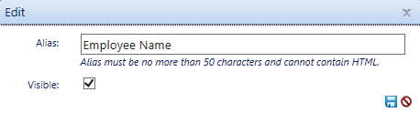

Merit matrix
A merit matrix defines how ratings from employee appraisals are transformed into merit guidelines on the compensation worksheet.
Matrices are built using the merit rating from an appraisal and either quartile (also known as position in range) or compa ratio. The result is a merit guideline that appears on the employee’s compensation worksheet, which the manager uses when determining a merit increase.
An example of a merit matrix using quartiles is shown below.
In this example, the values on the left refer to the merit rating list used for an employee appraisal. The quartiles are listed across the top of the table. The rest of the table contains ranges of merit increases based on the rating list and quartile, which is shown to managers as the merit guideline.
Merit matrices are built from the Guideline Configuration page under the Admin area.
Along with a merit matrix, other performance metrics are used when determining an employee's merit recommendation.
Merit rating list
Employee appraisals use merit rating lists to gauge employee performance over the evaluation period. Performance Manager supports the use of many merit rating lists for various positions across an organization. However, only one merit rating list can be used for a single position.
Rating lists can contain either numerical or text values.
Merit rating question
Appraisals have the option to include a merit rating question as the final manager input. Based on the manager’s rating of the employee on the appraisal, the system makes a merit increase recommendation. The manager then has the opportunity to select a different merit increase than what the system has recommended.
If merit rating questions are not used on appraisals, then a default merit rating list will be used. Otherwise, the merit rating list for the merit rating question on that appraisal will be used, as will the corresponding merit matrix.
Performance rating
A performance score is the merit rating value that corresponds to that performance score. If the merit rating question is used, this is the same value as on the appraisal. If the merit rating question is not used on the appraisal, they can still have a merit rating list so that score can be translated into performance ratings on the worksheet.
Performance score
A performance score is populated with the total weighted average (TWA) from the appraisal.

Feed files
Feed files can be uploaded to compensation cycles to populate worksheet fields.
A Feed option is available for the Employees field on the Add/Edit Cycle page. Selecting this option and saving the new cycle reveals buttons that allow the uploading of either Person Position Compensation or Position Grade feed files.
Feed files overwrite any changes made to the compensation worksheet as long as the highest level of approval has not been selected. If a record has already received the highest level of approval, no changes are made to that record when the feed file is uploaded.
After a file has been successfully uploaded, a summary window is displayed that provided details of the data imported from the feed file, including any errors that may have occurred.

Compensation employee groups
When creating a cycle, there are three options for assigning employees to that cycle:
- Feeds. Employees are assigned using the person_position_compensation feed file.
- All employees. Every employee in your organization is included in the cycle. This is used if every employee falls under the same compensation cycle and rules.
- Selected employees. This option allows you to select a group to assign to the cycle. These groups can contain any number of employees from your organization.
Employee compensation groups are created and managed from the Groups page under the Admin area of the navigation bar.
When a new compensation cycle is created, the Selected Employees option allows you to choose which group of employees should be assigned to the cycle. Only one group can be selected per cycle.

Compensation managers
Compensation managers can be assigned to employees that differ from their direct supervisor (such as Department Head or Compensation Department).
An Assign Compensation Manager option is available on the User Maintenance page under the Admin area. Clicking this button opens a page that allows users to select departments, positions, or individual employees to assign to a compensation manager.
A drop-down menu also allows the selection of specific compensation cycles to modify.
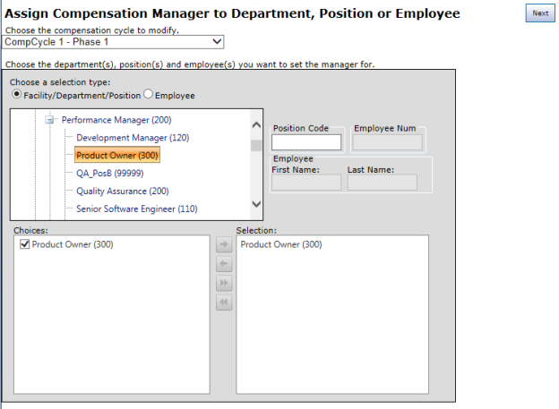
Compensation managers can also be assigned using the person_position_compensation feed file by providing the manager's employee ID in the compensation_manager_employee_id field.
Note: A user cannot assign themselves as their own compensation manager.

Document Library
The Document Library page under Admin provides a place to manage documents used with the Document Sign Off feature in Performance Manager.
The table on the page contains two tabs: Active and Archived. Only Active documents can be used with document sign off schedules.
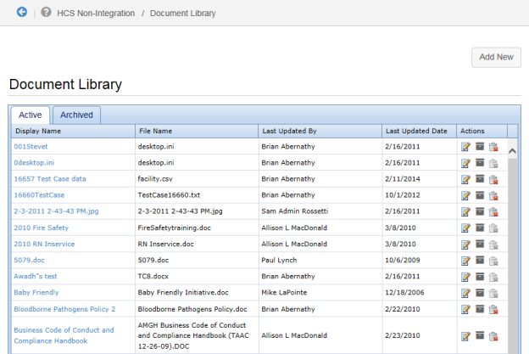
The Actions column in the table contains icons for Editing, Archiving, and Deleting documents from the library. Documents can be edited and archived at any time, but documents associated with active schedules cannot be deleted.

Adding documents
Documents can be added to the document library for use with document sign off schedules at any time. There's no limit to the number of documents stored in the library.
To add a new document:
- Click the Add New button. A pop-up window opens.
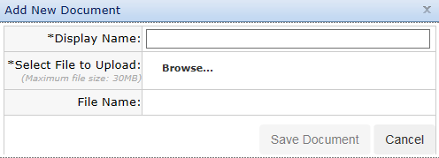
- Enter a Display Name for the document.
- Click the Browse link next to the Select File to Upload field. This opens a file browser where you can locate the desired file to upload on your computer.
- Click Save Document when finished.
The new document now appears in the library and can be used with document sign off schedules.

Goals administration
Performance Manager systems that utilize the Goals module contain a Goals section under the Admin area in the navigation bar that acts as an administrative area to configure system and usability options. This area is only accessible to users that have the necessary system privileges.
While the majority of work performed in this administration area takes place upon initial setup of the Goals module, many options can be edited or added at any time.
The available configuration pages for goals are:
- Performance Goal Forms. This page is where goal forms are managed. Once a goal form has been created, it can be added to job descriptions for inclusion in an appraisal process.
- Pillars. Pillars act as the foundation for goals, providing a set of corporate values for other facility/department/individual goals to tie into.
- Assessment lists. Assessment lists determine how goals are rated during appraisals. This page provides an area to create and customize assessment lists for the goal forms in your organization.

Assessment lists
Assessment lists provide a scale that is used to rank user performance against a goal. They help determine overall performance over a review period.
Assessment lists are customizable, and multiple lists can be created and used. However, only one (1) assessment list can be assigned to each goal form.
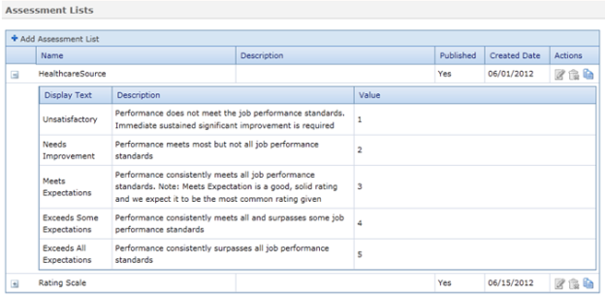

Adding assessment lists
New assessment lists can be added to the system at any time. There are two ways to add assessments lists: creating one from scratch, or copying an existing list.
Creating an assessment list from scratch
These steps take place from the Assessment Lists page under the Admin area.
- Click the Add Assessment Lists button at the top of the table. A new blank line is added to the Assessment Lists table.
- Type in a Name for the new list.
- Type in a Description for the list, if necessary.
- Click the Save button when finished. A + appears to the left of the new entry when the save is complete.
- Click the + to the left of the new entry to expand the row. This displays the options available for the assessment list. If this is a new list, the sub-table will be empty.
- Click the Add List Item link at the top of the sub-table for the list. A new blank row appears in the table.
- Type in what you would like the list item to show as under Display Text.
- Type in additional descriptive text you want to appear under Description, if necessary.
- If desired, type in a Value for the list item.
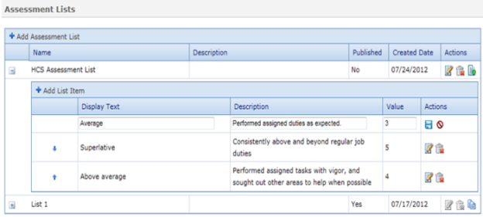
- Click the Save button when finished.
- Repeat steps 6 through 10 until all desired items have been added to the list.
- If necessary, use the arrow buttons to the left of the list items to reorder the list.
- When you have finished adding and reordering list items for the new assessment list, you must click the Publish button in the “Actions” column in order to make the list available for use in goal forms.
Warning: Once you publish an assessment list, it cannot be edited.
Copying an existing assessment list
As an alternative to creating a new assessment list, you can copy an existing assessment list and use it as a template to create a modified version for use.
These steps take place from the Assessment Lists page under the Admin area.
- Click the Copy button next to any assessment list in the table. This creates a copy of the list using the original name of the list appended with the current date.
- Click the Edit button to update the Name and Description for the new list.
- Click the Save button when finished.
- Click the + next to the list to expand the row and view the available options for the assessment list.
- Make any necessary edits to the list items by clicking the Edit button next to those items that require updates.
- Click the Save button when finished.
- If necessary, use the arrow buttons to the left of the list items to reorder the list.
- When you have finished adding and reordering list items for the new assessment list, you must click the Publish button in the “Actions” column in order to make the list available for use in goal forms.
Warning: Once you publish an assessment list, it cannot be edited.

Editing assessment lists
All aspects of an assessment list can be edited up until the point the list is published for use. Once a list is published, it cannot be edited or deleted.
These steps take place from the Assessment Lists page under the Admin area.
- Click the Edit button next to the desired list to update the Name and Description for the list.
- Click the Save button when finished.
- Click the + next to the list to expand the row and view the available options for the assessment list.
- Make any necessary edits to the list items by clicking the Edit button next to those items that require updates.
- Click the Save button when finished.
- If necessary, use the arrow buttons to the left of the list items to reorder the list.
- When you have finished adding and reordering list items for the assessment list, you must click the Publish button in the “Actions” column in order to make the list available for use in goal forms.
Warning: Once you publish an assessment list, it cannot be edited.

Pillars
Pillars are the starting point for all goals in Performance Manager. They represent the basic ideals and overarching values your company strives towards.
All goal forms, whether on the level of corporate, facility, or department, are tied back to a pillar.
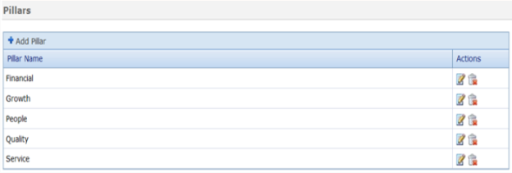
Though you can add, remove and edit pillars at any time, each new installation of the Goals module comes pre-loaded with five (5) standard pillars:
- Financial
- Growth
- People
- Quality
- Services

Adding Pillars
The first step in setting up goals is to define pillars your company will use throughout the Goals module. Only system administrators are able to create pillars.
These steps take place from the Pillars page under the Admin area.
- Click Add Pillar button at the top of the table. A new blank line is added to the Pillars table.
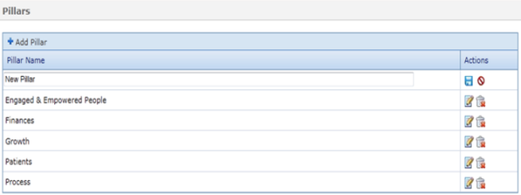
- Type in a name for the new pillar in the new blank line.
- Click the Save button to the right when finished.
Repeat the above process until you have entered all necessary pillars for your company. Pillars are available for use in goal forms once they are saved to the system.
You can also edit existing pillars by clicking the Edit icon in the row of the pillar you wish to update.

Goal forms
Goal forms are where corporate, facility, and department goals are created in the system. These forms are used to define goals for individual employee goals to align to. There must be at least one (1) corporate form to start the goals process.
All goals on a goal form align, or link to, either a pillar or a higher level goal that has been added.
Example: When creating a facility-level goal form, you can link a new goal to a pillar or a corporate-level goal from the related goal form.
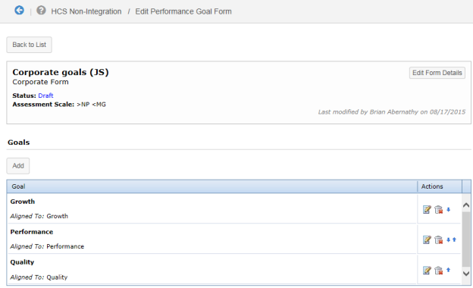

Adding goal forms
Goals forms must be added to Performance Manager before they can be included in job descriptions and used during appraisals.
Only administrators have the ability to add new goal forms.
These steps are performed from the Performance Goal Forms page under the Admin area.
- Click the Add button under the Performance Goal Forms table. The Create Performance Goal Form page opens.
- Type in a Name for the new goal form.
- Type in a Description for the new goal form, if necessary.
- In the Type drop-down menu, select the type of goal form you are creating (corporate, facility, or department). Once a selection is made, additional fields will appear under the Type field based on your selection.
Corporate
Select an Assessment Scale from the drop-down list to use on the goal form.
Facility
  - In the Inherits From drop-down menu, select which Corporate Goal Form you wish to inherit goals from in your Facility Goals form.
  - Select the Facility to associate with your new goal form from the drop-down menu.
Department
  - In the Inherits From drop-down menu, select which Corporate or Facility Goal Form you wish to inherit goals from in your Department Goals form.
  - Select the Department to associate with your new goals form from the drop-down menu.
Note: The items available in the Department drop-down menu are controlled by the selection made in the Inherits From field.
- Click the Save and Continue button when finished. The Edit Performance Goals page opens. This is where the goals themselves are defined.
- Under the Goals section of the form, locate the pillar or specific goal where you wish to align your goal.
- Click the Add button to add the goals to the form.
When you have finished adding all the necessary goals to your form, click the Back to List button at the top of the Edit Performance Goal Form page. The new goal form is saved and ready to be used for employee goal creation.

Adding goals to job description forms
In order to utilize goals in appraisal forms, the goals section must be added to job description forms. This allows the appraisal forms to pull in employee goals during scheduled evaluations.
Note: Users must have administrator access to job description templates in order to add goals to appraisal forms.
When adding new sections to job description templates, select the Performance Goals option from the list on the left. The available text box is used to label the goals section and include instructions that appear on the appraisal form.
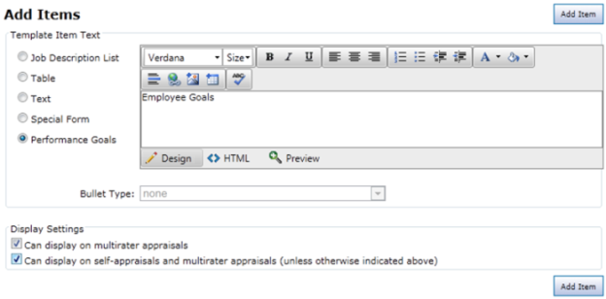

Job Description
The Job Description area in the navigation bar provides access to job descriptions and templates used to create them. Administrators can manage positions and their related job descriptions, templates used to create job descriptions, and special forms used to populate job descriptions.
Positions are added to Performance Manager from an HRIS feed, or by manually adding position information. Positions need to have a job description assigned to it before it can be published and used in Performance Manager.
The available pages under the Job Description area include:
- Job Descriptions. This page lists all the available job descriptions in Performance Manager. This page allows you to locate and made any necessary updates to job descriptions.
- Templates. Templates are used to build job descriptions.
- Special Forms. Special forms are sections of generic and/or universally-applicable information that are included in templates and/or job description forms.

About the Job Descriptions page
The Job Descriptions page provides a table that lists all available job descriptions.
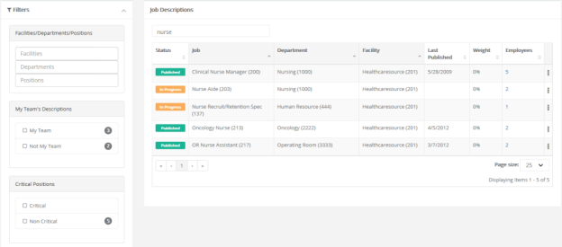
Clicking any row in the table opens the detail page for the selected job description.
Filters on the left side of the page allow you to quickly narrow the list of results shown in the table. These filters include:
- Facilities/Departments/Positions
- My Teams Descriptions
- Critical Positions
- Position Status
- Job Description Status
There's also a Search field above the table for locating specific job descriptions in the list.
The actions menu () on the far right of the table provides access to additional actions you can perform on job descriptions, such as:
- Print
- View History
- View Weights
- Flag Critical

Building a Job Description
A job description needs to be "built" before it can be published and used for employee appraisals. Building a job description involves assigning a job description template to a position, adding any desired or necessary special forms, then sending the job description for review and publication.
These steps take place from the Job Descriptions page under the Job Description area.
- Select the desired position by clicking its row in the positions table. The job description detail page opens, with data from the selected template is pre-loaded into the form.
- Make any necessary edits to the form, such as adding new sections and/or items. When finished, select Publish and Send Options.
- A confirmation pop-up window opens. Click the desired button as instructed in the window.
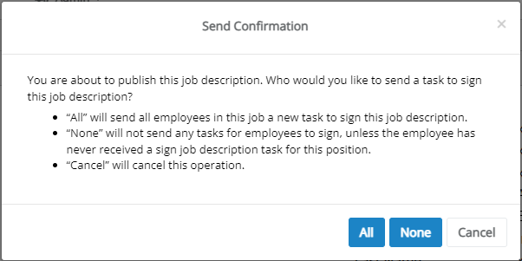
Selecting All publishes the job description. Signing tasks are generated for all employees who have this job description.
Selecting None also publishes the job description. However, no signing tasks are generated for employees who have this job description (unless the employee never received a Sign Job Description task for this job in the past). The None option is only available if the Allow edits without sending to employees setting is enabled under the Admin area.

Changing the Template for a Job Description
Templates used for job descriptions can be updated in Performance Manager. Changing the template overwrites any previous data associated with the job description with information contained in the selected template.
These steps take place from the Job Descriptions page under the Job Description area.
- Select the job description you want to update. This displays its Job Description Editor page.
- Select Change Template from the Actions column on the left.
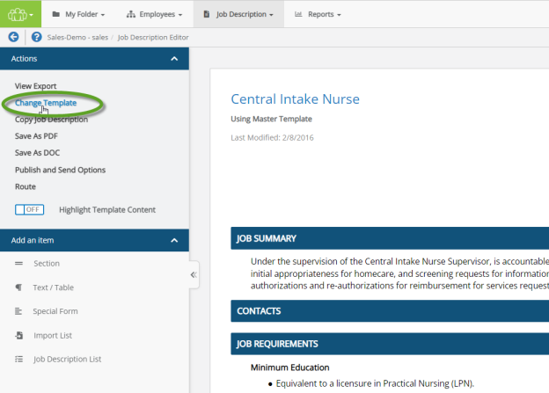
- Click OK in the confirmation message that appears.
- Select the desired template from the drop-down list and click the Save button. The page reloads to display the job description with the selected template data.
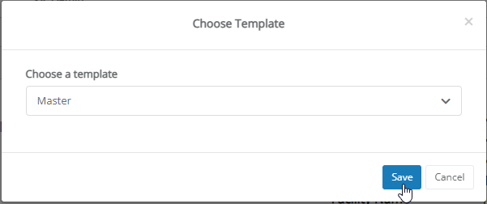
- Make any necessary updates to the job description.
- When finished making updates, select the Publish and Send Options from the Actions section of the column on the left side of the page.
- A confirmation pop-up window opens. Click the desired button as instructed in the window.
Selecting All publishes the job description. Signing tasks are generated for all employees who have this job description.
Selecting None also publishes the job description. However, no signing tasks are generated for employees who have this job description (unless the employee never received a Sign Job Description task for this job in the past). The None option is only available if the Allow edits without sending to employees setting is enabled under the Admin area.

Copying a Job Description
Job descriptions can be copied, providing a way to quickly modify existing job descriptions. All the information contained in the source description is copied over into another description, overwriting any previously-existing description in the destination.
Warning: When copying a job description, the destination you copy to is overwritten, and not duplicated or backed up. Use this option carefully!
To copy an existing job description, complete the following steps from the Job Descriptions page.
- Select the job description you wish to copy. This displays its Job Description Editor page.
- Select Copy Job Description, found in the Actions section of the column on the left side of the page. This displays the Copy modal window. Available positions are arranged in the left column.
- Drill-down and browse the various levels of positions by selecting the + icon and scrolling down the column. You can also instantly filter the list by entering text into the Search field.
- When you find the position you need, select the triangle icon on the right-hand edge of the title to send it to the destination column.
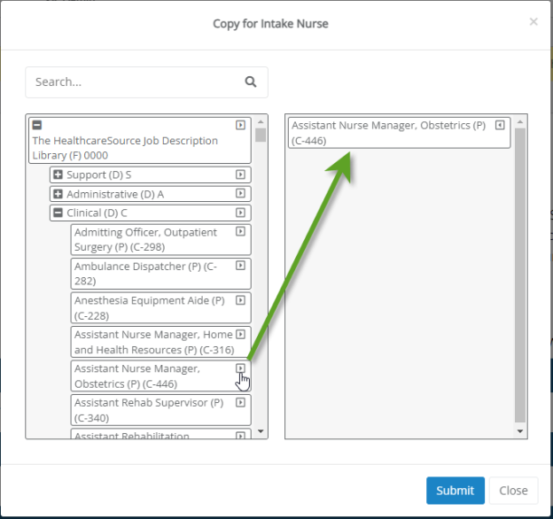
- Select Submit when you have added all the descriptions you need.
- Selecting OK in the confirmation popup window confirms your decision and overwrites the selected job description(s), completing the process.

Editing a Job Description
Existing job descriptions (and job description templates) can be edited at any time. Editing a job description template automatically updates all job descriptions that use that template, even if they are published and active.
To begin editing a job description, click the row for the job description to be updated. This displays the existing job description form in edit mode. This allows you to modify existing items in the description and add new sections and content by drag-and-dropping desired items from the panel on the left of the page.
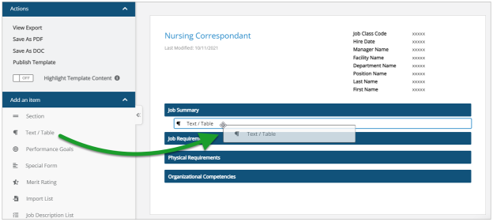
Any changes made to a section are automatically saved, eliminating the risk of losing your work due to sudden connectivity outages, accidental closing, or other types of unforeseen circumstances.
Using Copy, Cut, Paste, and other Commands in the Editor
The Job Description editor uses a different style of text-entry fields, which display their own context menu when you right-click within them. As such, you cannot use the right-click menu to use text-editing commands like copy, cut, and paste like you might normally do. However, you can still use these commands while working in the editor by using keyboard shortcuts.
The key combinations required for these commands differ based on whether you're using Windows or Mac OS. To make things easier, we've included a "cheat sheet" here, which includes the most commonly-used and helpful commands available.
Command | Windows Keyboard Combination | Mac OS Keyboard Combination
Copy | CTRL + C | Command + C
Cut | CTRL + X | Command + X
Paste | CTRL + V | Command + V
Select All | CTRL + A | Command + A
Undo | CTRL + Z | Command + Z
Redo | CTRL + Y | Shift + Command + Z
Document Search (Find & Replace) | CTRL + F | Command + F
Symbol & Emoji Menu | Windows Key + . | Control + Command + Space Bar

Job Description History
When a published job description is modified, Performance Manager keeps a revision history. This history allows you to view the previous versions of the template, and revert back to a previous version if desired.
Selecting the View History option from the actions menu () opens a new page listing any previous versions for the selected job description. Clicking the link in the Version column opens a view of the previous version of the template. Clicking the Revert link for a previous version updates the current template to the selected version.
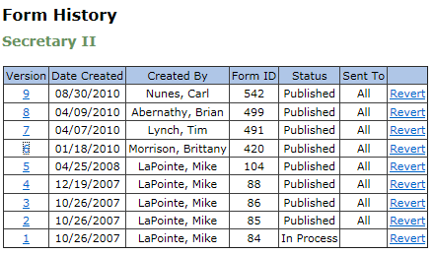

Import List
The Import List item provides a way to quickly add lists into sections of job templates by copy and pasting content from external sources such as Word documents or other online systems.
When Import List is added to a section of your template, an Import List pop-up window opens for you to add, format, and configure content. The window outlines each step in the process in different sections to make it easy to add desired content to the template.
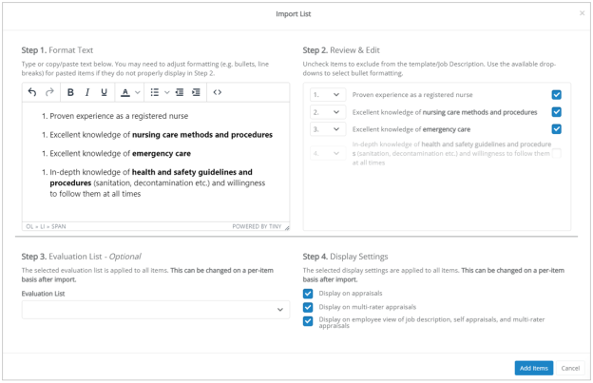
- Format Text. Type in or copy-and-paste desired content into the text box. Use the available formatting tools at the top of the text field to make any necessary formatting changes.
- Review & Edit. Content added to the text box is automatically parsed and displayed here. Deselect (uncheck) any items to remove them from the import process.
- Evaluation List. Use the drop-down to select an evaluation list to apply to the selected items.
- Display Settings. Select the appraisals you want to use the imported items.

Special Forms
Special forms are sections of information that are included on job description forms. These sections are generic or universally applicable across many, if not all, job descriptions for an organization, so they are included in Performance Manager as special forms to make it easier to include them in job descriptions and templates.
Example: Your organization uses the same Environmental Demands description for all nurse positions. Creating a special form for this Environmental Demands section allows you to easily pull it into each new job description template instead of having to re-create it each time a new template is added.
Special forms are created the same way as new sections in job descriptions and templates. When adding a special form to an existing job description and/or template, simply select the Special Form option from the Add Items window and select a form from the drop-down list.
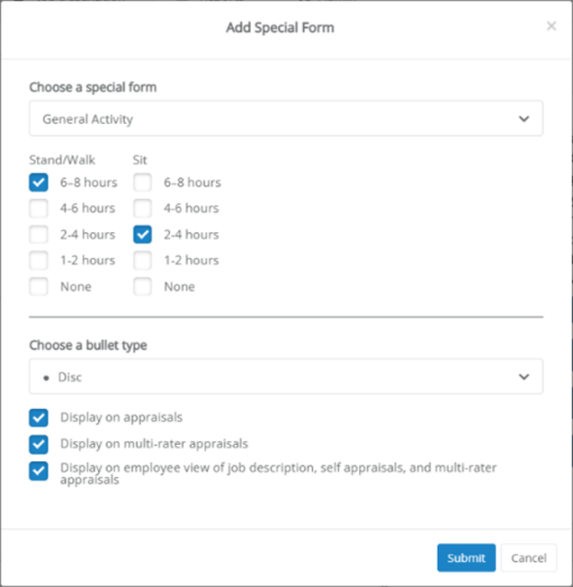

Adding a template
Job description templates are used to populate positions in Performance Manager. They also provide information and evaluation forms for appraisals.
Each position in Performance Manager must have an associated job description, so it is important to ensure necessary job description templates are available.
These steps take place from the Templates page under the Job Description area.
- Click the Add Template button. This reloads the page and opens the Create Template modal.
- Enter a Name and Description for the template.
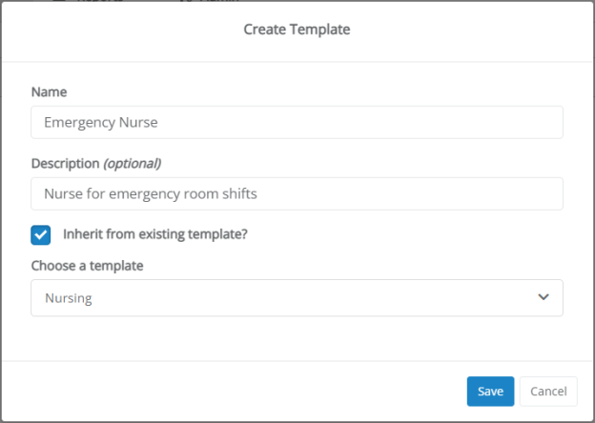
- If you wish to include information from an existing template, check the Inherit from existing template option. This displays an additional Choose a template drop-down field where you select a template whose information you want to include.
- Click Save. The template page displays.
- Add items as necessary for the template by dragging the desired item type from the panel on the left and dropping it into the template.
Adding Sections to Template
Sections help organize the information within the template. Templates can contain any number of sections.
The form automatically saves your progress as items are added, so there’s no Save button to click along the way.
  - From the Add an item panel on the left of the page, click on the Section item in the list and drag it over to the main area of the job description template.
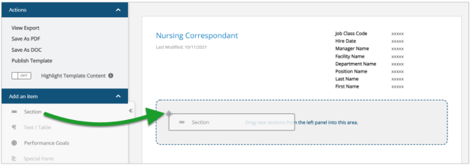
  - Once dropped into the template, the section header displays and allows you to enter a title for the new section. A text editor above the section header provides formatting options for the title (font, text size, color, alignment, etc.).
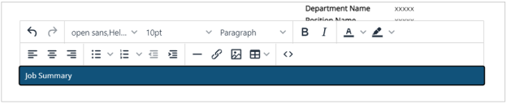
  - Select a section header to reveal appraisal display settings for that section and adjust as needed. These settings determine which appraisals the section should appear (if any).
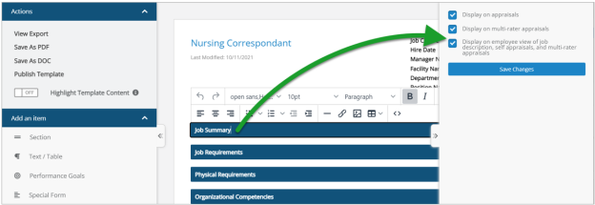
  - Repeat these steps as necessary until all desired sections have been added.
Adding Content to Sections
After all the desired template sections have been added, begin adding content to those sections. This is done the same as adding Sections: drag-and-drop the desired content from the Add an item panel on the left to the heading where the content should appear.
There are various types of items that can be added to templates. Depending on the type of content added, additional options are displayed (e.g. selecting pre-defined content, checking specific items to include, bullet types, appraisal display options).
  - Text/Table. An open text field that supports basic text entry and the insertion of tables.
  - Performance Goals. Adds a new section to the template that automatically populates with performance goals pulled from individual employee profiles. Only one Performance Goals section can be added to a job description template.
  - Special Form. Special forms are generic or universally applicable sections of information. Adding Special Form content to a template opens the Add Special Form modal that prompts you to select a pre-defined form.
Once a form is selected, contents of that form are displayed so you can check specific items to include. The window also prompts you to select bullet types and appraisal display options.
  - Merit Rating. Similar to Performance Goals, this item adds a new section to the template that automatically populates with merit rating content. Only one Merit Rating section can be added to a job description template.
  - Import List. This option is used to copy/paste content from external sources such as Word documents.
  - Job Description List. Similar to Special Forms, adding a Job Description List item opens a modal with options for selecting pre-defined content, choosing which list items to include, formatting bulleted items, and, when applicable, including an evaluation list for the selected items.
- When finished adding items to the template, click the Publish Template link in the Actions area.
Clicking Publish Template reloads the page and displays a message stating the template was successfully published. The new template is now available for use with existing positions.

Copying a Template
Job description templates can be copied, providing a way to quickly create new templates that are similar to existing ones. All the information in the source template is copied over to the new template, saving time on data entry and template setup.
To copy a template, simply click the Copy link next to the template you wish to copy in the template table on the Templates page. After providing a Name and Description, the main template form is displayed, containing all the information from the copied template, where you can make any necessary edits before saving.

Job Description Weights
Job descriptions can have weights associated with each section in the form. These weights are used during the appraisal process when evaluating employee performance based on desired job description metrics.
Each job description in the table on the Job Description page has a Weight column that lists the total weight for the entire description. Selecting the View Weights option from the actions menu () opens a new page that lists each item in the job description an it's associated weight.
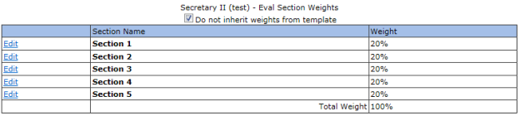
Note: When making edits to job description weights, make sure that all items add up to 100%.

Recognition and Remarks Administration
The Recognition and Remarks feature is highly customizable to help it fit into existing organizational feedback programs. Settings provide control over the feature name and descriptive/instructional text, as well as specific options such as anonymous comments and email notifications.
The settings page for Recognition and Remarks can be opened from the Feature Settings area of the Settings page under Admin. Clicking the Please click here for Recognition settings link at the bottom of the section opens a new page with all applicable settings for Development Plans, Employee Journal, and Recognition and Remarks.
General
The first section contains options to enable Recognition and Remarks for employees and/or managers, and other basic functions of the feature.
- Choose who can send recognition. Turn the entire feature Off, or select if input can be left by Managers Only or both Managers and Colleagues.
- What is the name of your recognition program? Customize the name of the feature. This appears as the name of the feature throughout Performance Manager.
- Allow employees to submit anonymous feedback. Enabling allows employees to send feedback anonymously (the recipient does not see the sender's name).
- Allow employees to request feedback. Enabling allows employees to request input from specific colleagues.
Send Modal
This area allows the customization of text that appears in the Send Recognition modal.
Clicking any underlined text displays that text in a pop-up where edits can be made.
View Modal
This area allows the customization of text that appears in the View Recognition modal.
Clicking any underlined text displays that text in a pop-up where edits can be made.
Print Recognition
This area allows the customization of text that appears in the Print Recognition modal.
Clicking any underlined text displays that text in a pop-up where edits can be made.
Approval Modal
This area allows the customization of text that appears in the Recognition Approvals modal.
Clicking any underlined text displays that text in a pop-up where edits can be made.
Request Modal
This area allows the customization of text that appears in the Request Recognition modal.
Clicking any underlined text displays that text in a pop-up where edits can be made.
Received Requests Modal
This area allows the customization of text that appears in the Received Requests modal.
Clicking any underlined text displays that text in a pop-up where edits can be made.
Recipient Notifications
Contains an option to enable notifications to employees when they receive new recognition.
Clicking the underlined text for Email subject and Email body allows edits to that text.
Manager Notifications
Contains an option to enable notifications to managers when their employees receive new recognition.
Clicking the underlined text for Email subject, Email body, and Email body when submitted anonymously allows edits to that text.
Request Notifications
Contains an option to enable notifications to colleagues when employees request recognition.
Clicking the underlined text for Email subject and Email body allows edits to that text. The {{requester}} merge field can be added to these areas to automatically include the name of the requesting employee in the notification.
Additional settings
Recognition and Remarks allows you to customize the list of corporate values that can be assigned to feedback left for employees.
The page for customizing this list can be reached by clicking the Click here to add and edit Custom Lists link on the Custom Lists page.

Recognition lists
Recognition and Remarks allows you to customize the list of corporate values that can be assigned to feedback left for employees.
The lists page for Recognition and Remarks can be opened from the Custom List page under Admin. Clicking the Click here to add and edit Custom Lists link under the table opens a new page displaying customizable lists for Recognition.
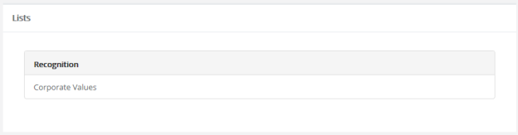
Clicking on Corporate Values under the Recognition heading opens a new view for editing the selected list.
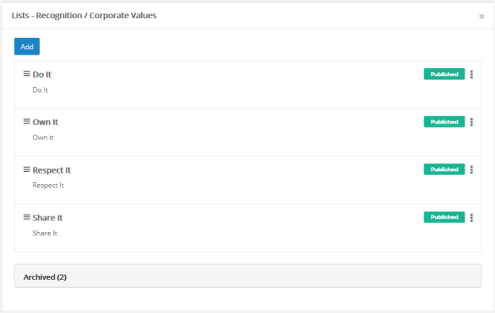

Schedule
The Schedule pages under Admin provide areas for managing the various schedules in Performance Manager.
The tables on these pages list all the available schedules for the different areas for viewing and editing as needed. New schedules can be created at any time.
The available scheduling pages are:
- Appraisal Schedule. Appraisals are employee reviews by their managers and peers that drive merit increases.
- Checklist Schedule. Checklists are designed to test employee knowledge and skills in specific areas related to their job descriptions.
- 360 Review Schedule. 360 reviews provide an opportunity to collect feedback about an employee from coworkers. These reviews assist managers during appraisals.
- Document Schedule. These schedules control the tasks for document sign off by employees.

Schedule Details
Each schedule type in Performance Manager (360 Review, Appraisal, Checklist, and Document) has its own form that define the details of the schedule, such as due dates and frequency. These forms contain many of the same fields, but are not entirely identical.
This form is the first one presented when creating new schedules in Performance Manager.
360 Review Schedule
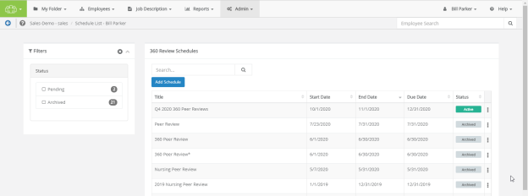
When creating a new 360 Review Schedule, you must complete a 10-step process to enter all the necessary details.
- Assign Template. Select an existing evaluation template from the drop-down menu. Selecting Next continues to step 2.
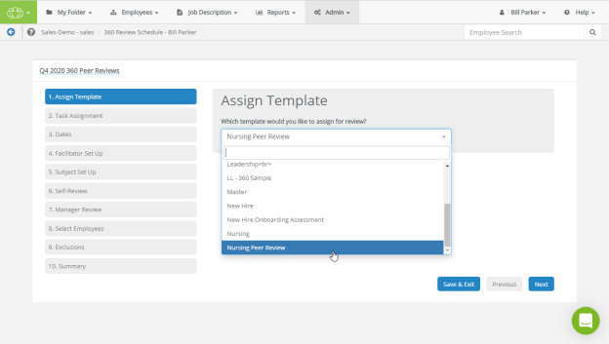
- Task Assignment. Your choice here determines whether an employee receives a single review task, or is given a review task for each position they held during the schedule dates. This second option is primarily used if an employee has transferred departments or has obtained an additional position, to review each position held.
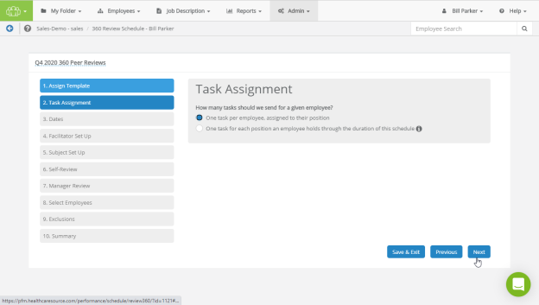
- Dates. On this step, all tasks may be assigned and due based on a fixed date you enter, or can be calculated and assigned and due based on one of the employee-specific dates you provide.
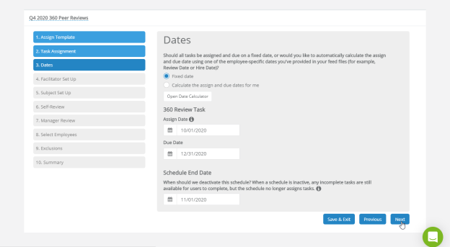
- Facilitator Set Up. Determine who will conduct the review. You can select to automatically assign the employee's manager, or specify a particular reviewer using the Employee Search bar. Enter text in the field below if you want to give any additional written instruction to the facilitator.
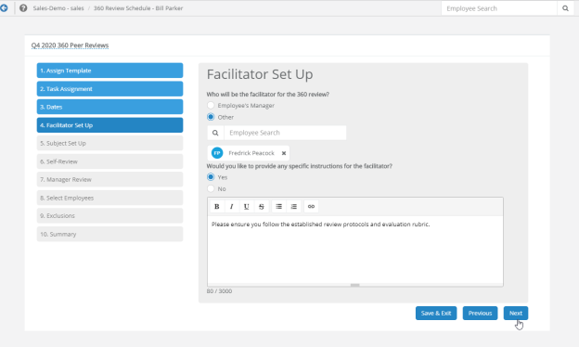
- Subject Set Up. Select if you wantto send a subject set-up task to the employee. Enter text in the field below if you want to give any additional written instructions on the subject.
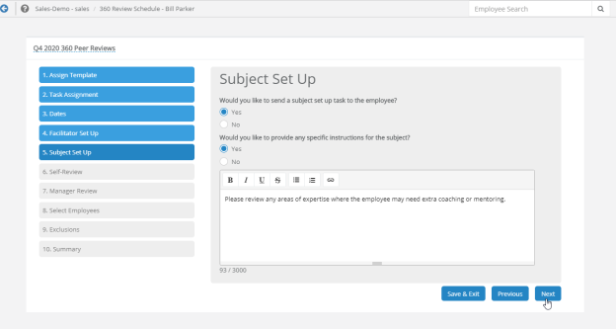
- Self-Review. Selecting Yes or No on this step determines whether each employee receives a Self-Review task in addition to their 360 Review task.
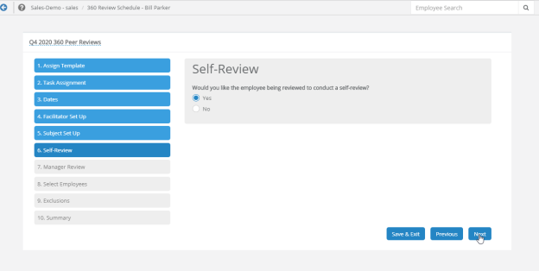
- Manager Review. Selecting Yes or No on this step determines whether the employees' manager receives a review task in addition to their 360 Review task.
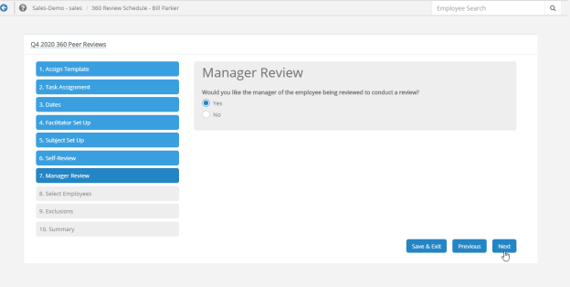
- Select Employees. Select the employees, positions, departments, facilities or groups to be appraised with this review.
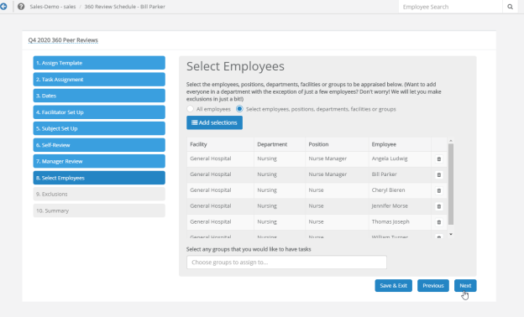
- Exclusions. Decide if you like to exclude employees from this schedule by name, position, department or facility, or exclude any employees from this review based on an event (for example, if they were hired less than 60 days before the start of the review schedule).
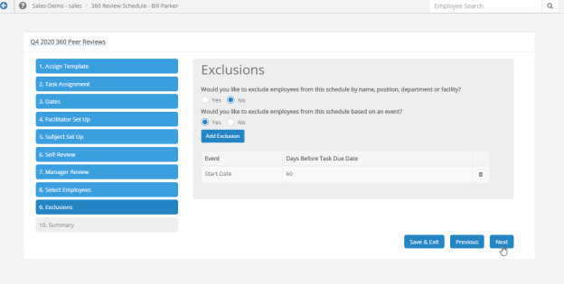
- Summary. Displays all the options and selections made in the schedule. If it looks correct, selecting Activate (and confirming via the pop-up window) activates the schedule, assigns any tasks, and displays the schedule on the 360 Review Schedules list.
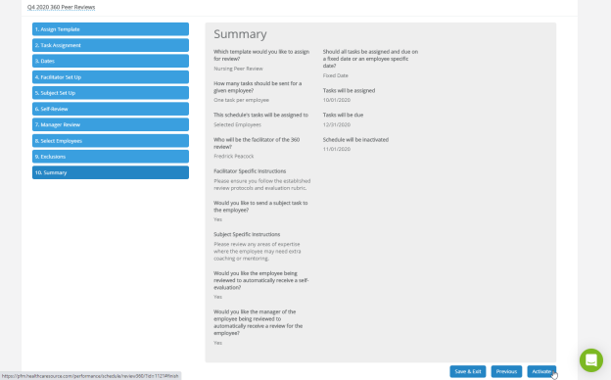
Appraisal Schedule
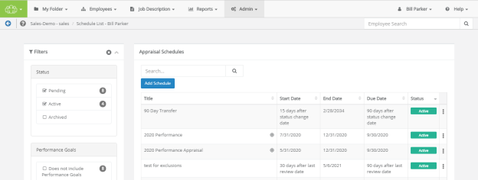
When creating a new Appraisal Schedule, you must complete a 9-step process to enter all the necessary details.
- Goals. Select whether or not you want to include Performance Goals in the appraisal cycle. If selecting Yes, you are also prompted to select a Performance Goal form and must decide whether the Employee or Manager must initiate the goal-setting process.
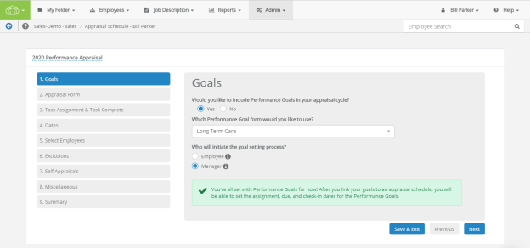
- Appraisal Form. Select whether you'd like to use a position-specific or stand-alone appraisal template, and which job description to include.
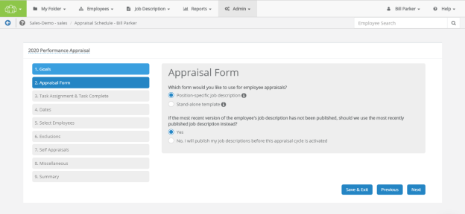
- Task Assignment & Task Complete. Your choice here determines whether an employee receives a single review task, or is given a review task for each position they held during the schedule dates. This second option is primarily used if an employee has transferred departments or has obtained an additional position, to review each position held.
Additionally, you may set the criteria to determine when the system deems the appraisal is complete.
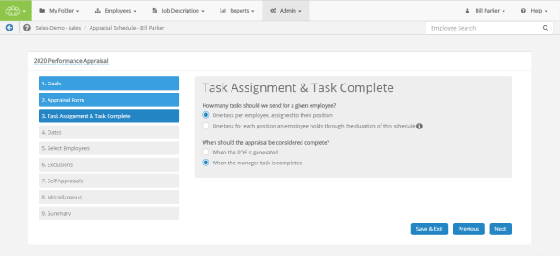
- Dates. On this step, all tasks may be assigned and due based on a fixed date you enter, or can be calculated and assigned and due based on one of the employee-specific dates you provide.
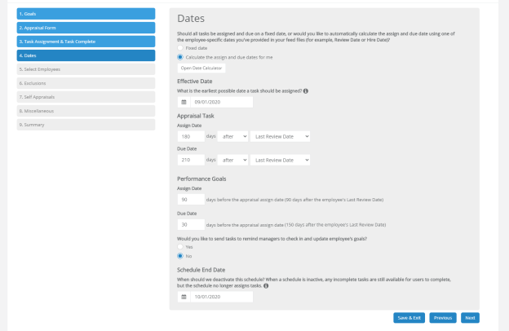
- Select Employees. Select the employees, positions, departments, facilities or groups to be appraised with this review.
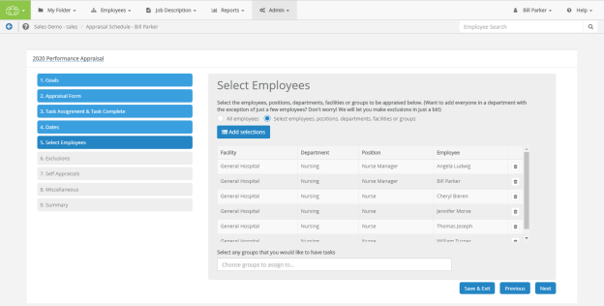
- Exclusions. Decide if you like to exclude employees from this schedule by name, position, department or facility, or exclude any employees from this review based on an event (for example, if they were hired less than 60 days before the start of the review schedule).
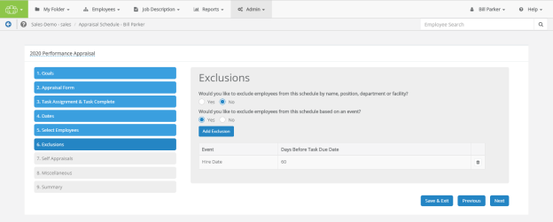
- Self-Appraisals. Selecting Yes or No on this step determines whether each employee automatically receives a Self-Appraisal task.
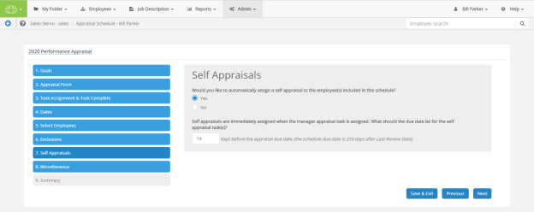
- Miscellaneous. You can adjust several settings pertaining to how data from this assessment shows during compensation adjustments and how much (if any) multi-rater feedback is shown to those being evaluated.
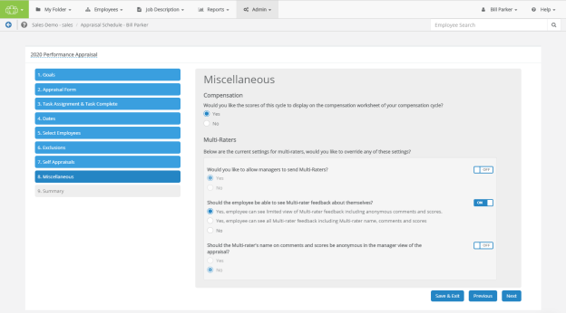
- Summary. Displays all the options and selections made in the schedule. If it looks correct, selecting Activate (and confirming via the pop-up window) activates the schedule, assigns any tasks, and displays the schedule on the Appraisal Schedules list.
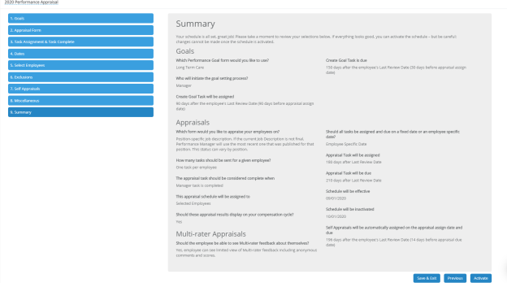
Checklist Schedule
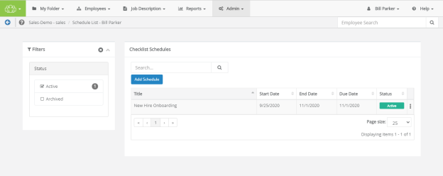
When creating a new Checklist Schedule, you must complete a 7-step process to enter all the necessary details.
- Assign Checklist. Select an existing evaluation template from the drop-down menu. Selecting Next continues to step 2.
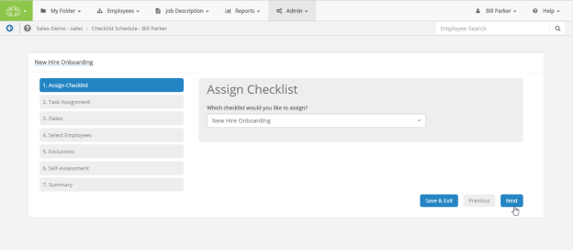
- Task Assignment. Your choice here determines whether an employee receives a single review task, or is given a review task for each position they held during the schedule dates. This second option is primarily used if an employee has transferred departments or has obtained an additional position, to review each position held.
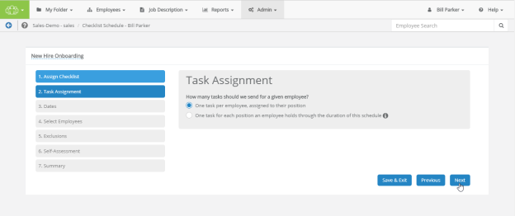
- Dates. On this step, all tasks may be assigned and due based on a fixed date you enter, or can be calculated and assigned and due based on one of the employee-specific dates you provide.
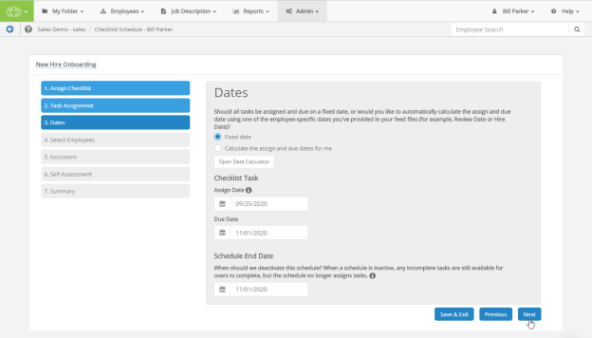
- Select Employees. Select the employees, positions, departments, facilities or groups to be assigned with this task.
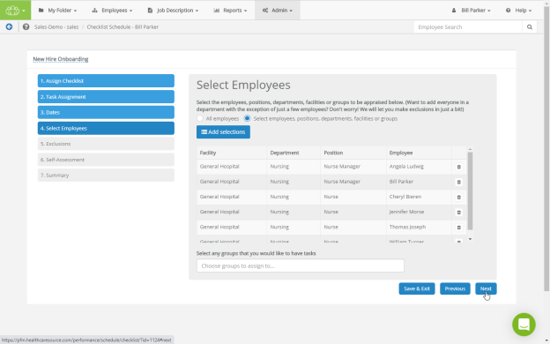
- Exclusions. Decide if you like to exclude employees from this schedule by name, position, department or facility, or exclude any employees from this review based on an event (for example, if they were hired less than 60 days before the start of the review schedule).
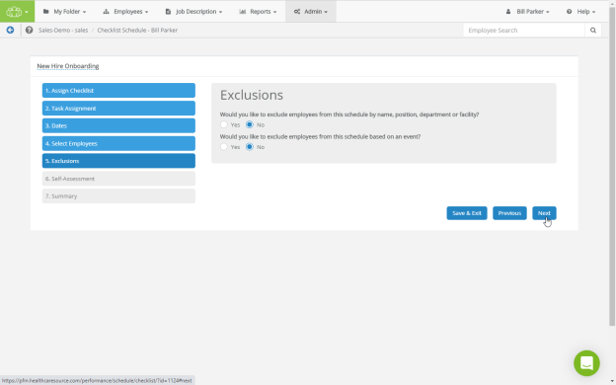
- Self-Assessment. Selecting Yes or No on this step determines whether each employee receives a Self-Assessment task in addition to their Checklist task.
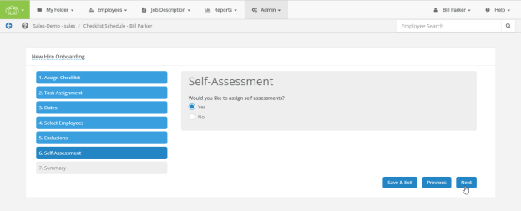
- Summary. Displays all the options and selections made in the schedule. If it looks correct, selecting Activate (and confirming via the pop-up window) activates the schedule, assigns any tasks, and displays the schedule on the Checklist Schedules list.
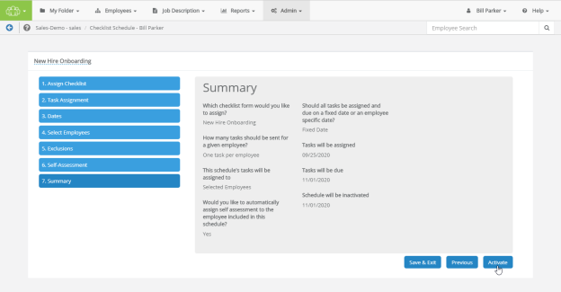
Document Schedule
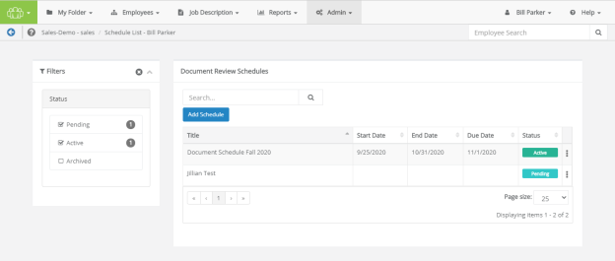
When creating a new Document Schedule, you must complete a 6-step process to enter all the necessary details.
- Assign Doocument. Select an existing document to assign from the drop-down menu. Selecting Next continues to step 2.
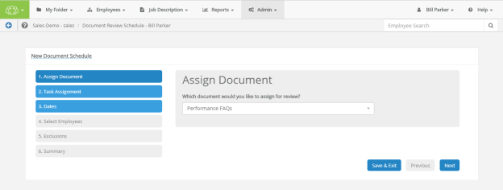
- Task Assignment. Your choice here determines whether an employee receives a single review task, or is given a review task for each position they held during the schedule dates. This second option is primarily used if an employee has transferred departments or has obtained an additional position, to review each position held.
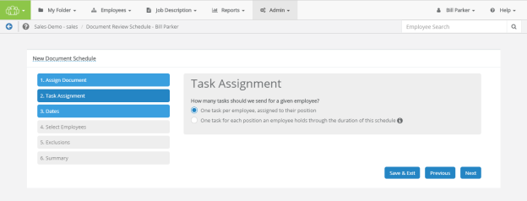
- Dates. On this step, all tasks may be assigned and due based on a fixed date you enter, or can be calculated and assigned and due based on one of the employee-specific dates you provide.
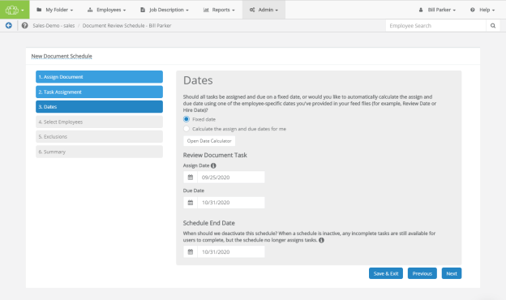
- Select Employees. Select the employees, positions, departments, facilities or groups to be assigned with this document review.
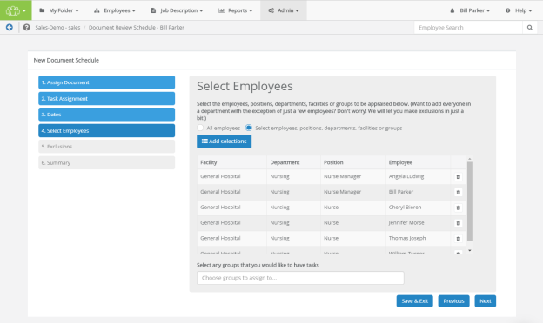
- Exclusions. Decide if you like to exclude employees from this schedule by name, position, department or facility, or exclude any employees from this review based on an event (for example, if they were hired less than 60 days before the start of the review schedule).
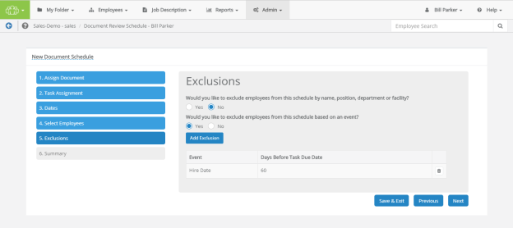
- Summary. Displays all the options and selections made in the schedule. If it looks correct, selecting Activate (and confirming via the pop-up window) activates the schedule, assigns any tasks, and displays the schedule on the Document Review Schedules list.
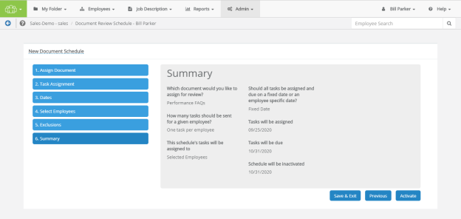

Schedule Assignments
Assigning a schedule to an employee or group of employees determines who receives tasks to complete the schedule.
Assign To
Determines if the schedule is applied to everyone in Performance Manager, or just select groups or individuals.
- Selected Employees. This option allows you to select defined Groups or individual Employees.
- All Employees. This option assigns the schedule to every user in Performance Manager.
Exclusions
Use these options (previously called "Exceptions") if you wish to exclude new hires and/or transferred employees from being assigned an appraisal. Employees listed in the Exclusions table are not included in the schedule, even if they are part of a selected group.
The Exclusions table contains a row for each employee or group listed. Selecting the trash can icon removes the employee or group from the Exclusions table.
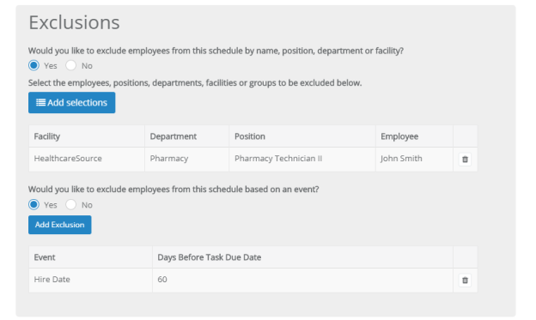
Selecting Employees, Positions, Departments, Facilities, or Groups
The employee picker allows you to select individual employees to include in the schedule. Use the available search filters to locate the desired employees and click the Add button under the picker.
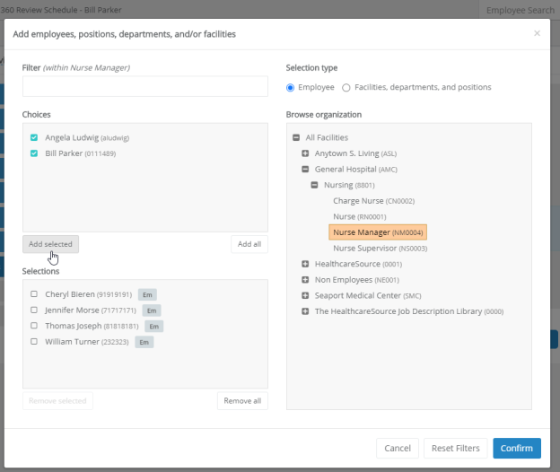
This form lists all the defined groups in Performance Manager within your organization. Simply check the desired groups from the list and click the Add button under the section to include users in those groups in the schedule.
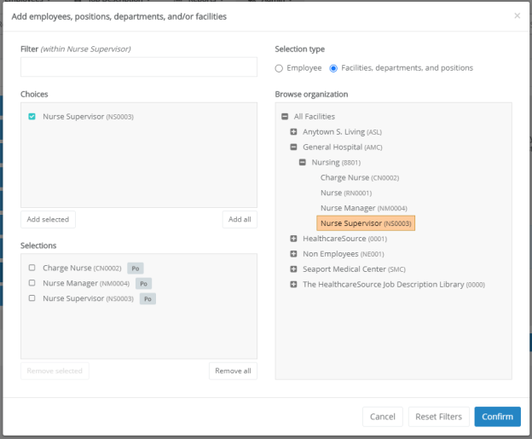

Schedule Date Types
When creating schedules in Performance Manager, the available date fields are determined by the type of schedule being created. Schedules may offer different date fields to determine each scheduled task. The available options for each type are described below.
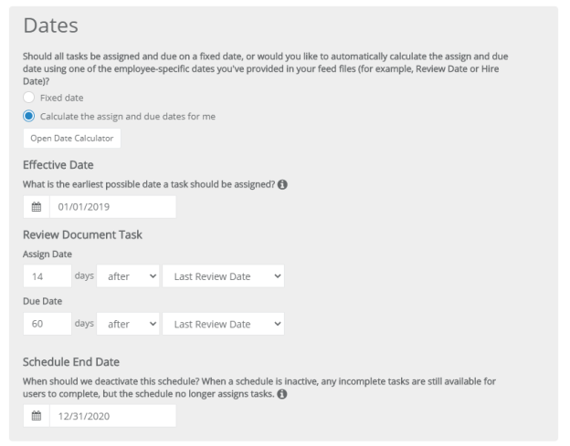
- Effective Date. This is the earliest possible date for a task assignment. A date in the past can be used.
- Assign Date. This is the date that a task appears on the task list for associated employees.
- Due Date. Date the task will be due for completion.
- Schedule End Date. Date the schedule will be archived and no new tasks are sent. Tasks that have already been scheduled will not be impacted or deleted - they will still need to be completed by the person to whom they were assigned.

Adding Schedules
New schedules can be added at any time. There is no limit to the number of schedules that can reside in the system, or be active at any one time.
New schedules can be created from scratch, or you can copy an existing schedule to create a new one in the system.
To create a new schedule from scratch:
- Navigate to the Appraisal, Checklist, 360 Review, or Document Schedule page by selecting the desired link from the Admin menu in the navigation bar. This displays the main schedules page for the selected item.
- Click the Add Schedule button above the table. This opens a pop-up window prompting you to name your new schedule.
- Enter the schedule name, then select Next to begin the Schedule Details workflow.
- Complete the schedule details workflow as required for the chosen schedule type.
- The Summary page shows at the end to confirm the details of your schedule. Verify that the information is correct, then select Activate to activate your new schedule.
Note: Schedules are not sent if they are still in the Pending status. They must be Active!

Copying Schedules
Copies can be made of existing schedules to create new ones. This speeds up the schedule creation process if several schedules share the same settings.
- Click the Copy option from the actions menu in the table on the desired Schedule page under the Admin area.
- In the pop-up window, check if you want to copy the Schedule Definition and/or Employee Assignments.
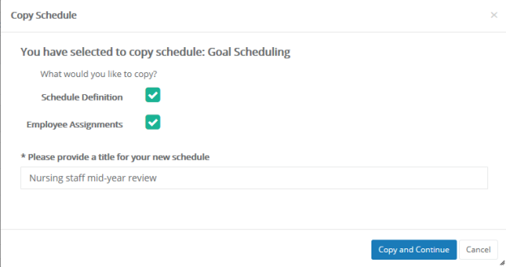
- Enter a title for the new schedule.
- Click the Copy & Continue button.
At this point, you are taken to the Schedule Details step for scheduling appraisals. Continue this process to finish adding your copied schedule.

Editing Schedules
When editing schedules, the status of the schedule determines how much of the schedule information is available for editing.
Pending schedules are fully available for edits at any time. This includes both the detail form and assignments for the schedule.
Active schedules are a little different. The employee assignments can still be edited at any time, but the detail form is mostly unavailable for edits. The only exception is for those schedules with a Type of Fixed Review Date. When this option is selected, the dates for the schedule can be modified.
Editing schedule details
To edit the detail form for a schedule:
- Open the desired Schedule page under the Admin area.
- Click the row in the table for the desire schedule. This opens the detail form.
- Make the necessary edits on the detail form.
- When finished, click the Save and Exit button to return to the Schedule page, or click the Save and Continue button to view the Assignments page for the schedule.
Editing schedule assignments
To edit employee assignments for a schedule:
- Open the desired Schedule page under the Admin area.
- Click the View Assignments option from the actions menu in the table for the desire schedule. This opens a page listing the employees currently assigned to the schedule, if any.
- Click the Manage Employees button. This opens the Assignments page for the schedule.
- Make the necessary edits to the assignments.
- When finished, click the Save and Exit button to return to the Schedule page.

Date Calculator
The Date Calculator is a tool that helps calculate dates to enter into date fields when selecting a schedule type.
The calculator takes an entered Base Date and displays the calculated date based on the number of Days, Weeks, Months, and/or Years indicated. Clicking to toggle the + or - icon lets you calculate dates either after (+) or before (-) the entered base date.
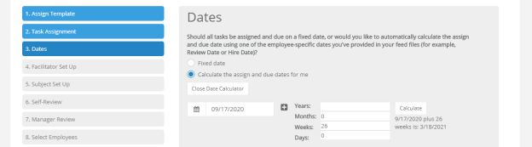

360 Review Schedule Administration
The 360 Review Schedules page under Admin provides an area to manage the 360 review schedules in Performance Manager.
The table on the page lists all the available schedules. Schedules in this table can be modified (if they are Pending), copied to create new schedules, or archived so they no longer appear in the table.
The table can be sorted by clicking any of the column headings. Filters to the left of the table help narrow the displayed results, and a search field allows you to locate specific schedules.
Table columns
Title | Name for the schedule.
Start Date | This is the Assign Date, or the date that 360 Review task appears in task lists for associated employees.
End Date | This is the Schedule End Date, or the last date for which a task can be created. This is the date the schedule will be archived.
Due Date | This is the Due Date for tasks created by the review schedule.
Status | The status of the schedule.  - Pending. The schedule is not yet in use and can be edited.  - Active. The schedule is currently being used to create and assign tasks.
[actions menu] | Clicking this icon () opens the actions drop-down menu with additional options:  - Copy. Copy the schedule to create a new one.  - Archive. Moves the schedule into an Archived state.  - Edit Dates. This option shows for any Active schedules. Allows you to modify the Assign Date, Due Date, and Schedule End Dates.  - View Assignments. Opens a page listing the assignments for the schedule.

Appraisal Schedule Administration
The Appraisal Schedules page under Admin provides an area to manage appraisal schedules in Performance Manager.
The table on the page lists all the available schedules. Schedules in this table can be modified (if they are Pending), copied to create new schedules, or archived so they no longer appear in the table.
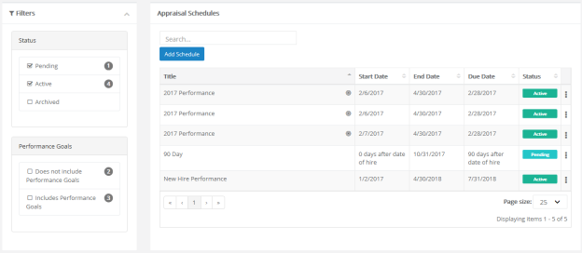
The table can be sorted by clicking any of the column headings. Filters to the left of the table help narrow the displayed results, and a search field allows you to locate specific schedules.
Table columns
Title | Name for the schedule.  A bullseye icon () in this column indicates the schedule uses Performance Goals.
Start Date | This is the Assign Date, or the date that Appraisal task appears in task lists for associated employees.
End Date | This is the Schedule End Date, or the last date for which a task can be created. This is the date the schedule will be archived.
Due Date | This is the Due Date for tasks created by the review schedule.
Status | The status of the schedule.  - Pending. The schedule is not yet in use and can be edited.  - Active. The schedule is currently being used to create and assign tasks.
[actions menu] | Clicking this icon () opens the actions drop-down menu with additional options:  - Copy. Copy the schedule to create a new one.  - Archive. Moves the schedule into an Archived state.  - Edit Definition of Done. Opens a pop-up window that allows you to change what determines when the schedule is complete (PDF Generated or Manager Completed).  - View Assignments. Opens a page listing the assignments for the schedule.

Checklist Schedule Administration
The Checklist Schedules page under Admin provides an area to manage checklist schedules in Performance Manager.
The table on the page lists all the available schedules. Schedules in this table can be modified (if they are Pending), copied to create new schedules, or archived so they no longer appear in the table.
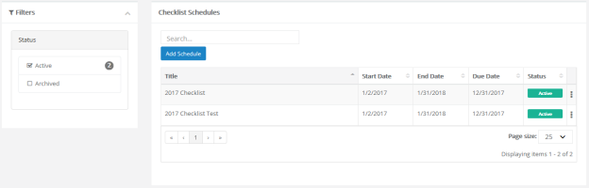
The table can be sorted by clicking any of the column headings. Filters to the left of the table help narrow the displayed results, and a search field allows you to locate specific schedules.
Table columns
Title | Name for the schedule.
Start Date | This is the Assign Date, or the date that 360 Review task appears in task lists for associated employees.
End Date | This is the Schedule End Date, or the last date for which a task can be created. This is the date the schedule will be archived.
Due Date | This is the Due Date for tasks created by the review schedule.
Status | The status of the schedule.  - Pending. The schedule is not yet in use and can be edited.  - Active. The schedule is currently being used to create and assign tasks.
[actions menu] | Clicking this icon () opens the actions drop-down menu with additional options:  - Copy. Copy the schedule to create a new one.  - Archive. Moves the schedule into an Archived state.  - View Assignments. Opens a page listing the assignments for the schedule.

Document Schedule Administration
The Document Schedules page under Admin provides an area to manage the document sign off schedules in Performance Manager.
The table on the page lists all the available schedules. Schedules in this table can be modified (if they are Pending), copied to create new schedules, or archived so they no longer appear in the table.
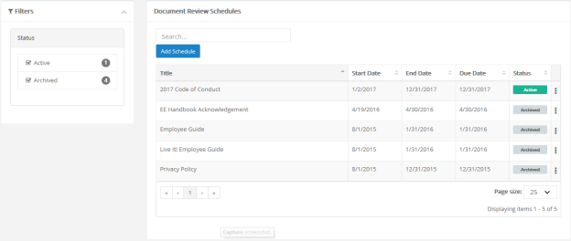
The table can be sorted by clicking any of the column headings. Filters to the left of the table help narrow the displayed results, and a search field allows you to locate specific schedules.
Table columns
Title | Name for the schedule.
Start Date | This is the Assign Date, or the date that 360 Review task appears in task lists for associated employees.
End Date | This is the Schedule End Date, or the last date for which a task can be created. This is the date the schedule will be archived.
Due Date | This is the Due Date for tasks created by the review schedule.
Status | The status of the schedule.  - Pending. The schedule is not yet in use and can be edited.  - Active. The schedule is currently being used to create and assign tasks.
[actions menu] | Clicking this icon () opens the actions drop-down menu with additional options:  - Copy. Copy the schedule to create a new one.  - Archive. Moves the schedule into an Archived state.  - View Assignments. Opens a page listing the assignments for the schedule.

Reports
The Reports area provides access to all the system reporting tools available for viewing and extracting defined data in Performance Manager.
Performance Manager provides a wide range of reports so you can easily gather and examine the data you need to ensure your employee management is efficient and successful. Each report provides several data filters, allowing you to manipulate your results without the need of sifting through records you don't need.
The Reports area contains several sub-pages:
- Standard. Standard reports include all the pre-packaged reports offered in Performance Manager. The reports found on this page are diverse and address many of the data needs for users.
- Custom. The Custom Reports page contains those reports specifically designed for your organization.
- Appraisal Status Reporting. This report displays the status of appraisals throughout your organization to help track where deficiencies exist in the appraisal process. This is similar to the Appraisal Status Standard Report, but the version of the report on this page allows a greater degree of flexibility and customization of data views, filters, and other details.
- Checklist Status Reporting. This report displays the status of checklists throughout your organization to help track where deficiencies exist in the checklist process. This is similar to the Checklist Status Standard Report, but the version of the report on this page allows a greater degree of flexibility and customization of data views, filters, and other details.

Custom Reports
The Custom Reports page lists all the available custom reports for your organization. These reports were specifically requested by and designed for your specific organization, so the available reports vary from company to company.
As with the Standard reports page, clicking a report name from the list on the left side of the page reloads the page to display the filters for the report.

Exporting Reports
All reports in Performance Manager can be exported to various formats. Available file types include XML, CSV (comma delimited), PDF, MHTML (web archive), Excel, TIFF, and Word.
After a report has been generated and the results are displayed, a toolbar appears above the report. This toolbar contains two separate buttons for exporting the report results: one to export the report as a file (), and another to save this report as an item in an RSS feed ().
Clicking the export icon opens a drop-down menu of file types to which you may export the on-screen report. Upon clicking the desired file type, the report will immediately download to your machine in the specified format. From your Downloads directory (or the bar that appears along the bottom of the window), you may Open the report to view, work with, or even print, from your computer.
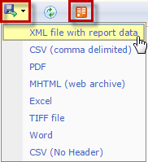
Note: The options available after clicking a file type to export may vary depending on the browser you are currently using.
The exported report only contains the results that appear based on the filters set when the report is generated. If some time has passed since the file was exported and you believe the set of results in the file are not up to date, simply re-run and re-export the report to a new file.

Available Reports
The Standard Reports page lists the reports available down the left-hand side of the page. Clicking a link opens the search filters for that report and allow you to run the report.
The list is organized by category, with related reports shown under each heading.
Administrative
- Job Description Audit. Provides details regarding modification and publication of job descriptions, including the templates used to create and user who last modified the description.
- Job Description. Lists employees who have not received a Review Job Description task, including the related job description and status.
- Manager Assignments. List of employee manager assignments.
- User Maintenance. Provides a list of employees with their user maintenance information, including position data, registration status and email addresses.
Appraisals
- Appraisal and Goal Status. Displays the completion status and summary information for all the appraisals and goals in a given date range.
- Annual Appraisal Review Date. Lists employees and their annual review due date.
- Appraisal Status. Displays the overdue or completion status and summary information for all appraisals in a given date range.
- Employees Without Appraisals. Lists employees who have not had an appraisal within a given date range.
- Performance Distribution. Displays distribution of performance scores along with the list of relevant employees and performance score information.
- Self-Appraisal. Lists self-appraisals and completion dates for employees and managers within a given date range.
Checklist
- Employee Checklist Status. Displays all the training competencies that have been completed by employees in a department or group of departments. This report can be filtered based on departments or date range.
Compensation
- Compensation Approval Status. Displays employees and whether or not compensation changes have been submitted for approval.
- Compensation Detail. Displays employee-level detail for selected compensation cycles within facilities and departments.
Feedback
- Feedback Detail. Displays employees who have received feedback within a given date range, along with feedback details such as type, notification, and action taken.
- Recognition and Remarks Detail. Displays employees who have received recognition within a given date range, along with details such as facility, manager, department, approval status, and organizational values exemplified.
Feeds
- Feed Detail. Displays details on feed files processed within a given date range and lists errors for easy troubleshooting.
Miscellaneous
- 360 Summary Report. Displays an employee's detailed responses to a selected 360 Review survey.
- Development Plan Status. Displays the details of development plan tasks that are either pending, open, or completed, within a given date range.
- Document Status. Displays the details of review document tasks that are either completed or outstanding, within a given date range.
- Employee Census. Provides a list and totals of positions, employees, and FTE's.
- License and Certification. Displays employees who have licenses and/or certifications on record for a given date range.
Performance Goals
- Goal Completion Status. Displays a rollup of goal status for a given date range, along with details on individual goals.
- Goal Task Status. Displays status of goal tasks for a given date range.
Succession Planning
- 9 Box Succession Planning. Displays performance vs. potential for a given date range, including details for each employee.
- Succession Planning Detail. Displays succession planning details for each employee within a given date range.
Tasks
- Non-Appraisal Task Status. A filterable report capable of delivering a wide range of task information.

Viewing reports
Viewing reports in Performance Manager is a simple matter of selecting the desired report and setting available filters for your data.
- Locate the report you wish to view from the list on the left side of the page.
- Click the link for the name of the desired report. The page will load the available filters for the report.
- Select the desired filters for the report using the available fields.
Note: Available filters may vary from report to report based on the type of report you are running.
- Click the Generate Report button.
Clicking the Generate Report button loads the report in the main viewing area where the filters were displayed.
If you wish to update the filters for a custom report, click the Back button under the report. This re-opens the Filters page. Make any necessary adjustments to the filters then click Generate Report to re-run the report.
Report Graphs
All reports in Performance Manager provide a table view of the requested data. In addition to this table view of your data, some reports may also offer a graphical view of the information.
Graphs are automatically available on a select set of reports. If the report you are running is able to produce a graphical representation of your data, you will see an Expand for Graph link above your report results table. Clicking this link displays the graph view of your report results.
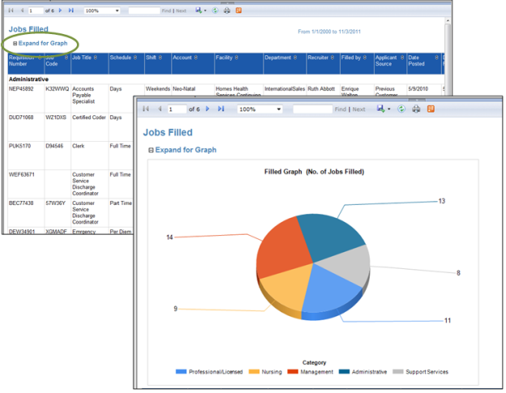
Tip: If you want to include the graph of your data when exporting the report to a file, make sure the graph is expanded and visible in your screen view. If the graph is not expanded, it will not be included in your export.
Report Data Latency
In an effort to increase the overall responsiveness of Performance Manager, reports are actually run against a copy of the databases that hold your data. Using a copy of the database allows better optimization of the reporting application, provides greater system stability, and develops a software foundation necessary for effective custom report building.
So what does this mean for your reports?
Since information isn't being pulled directly from the working databases, it must be copied to the reporting database at set intervals (every 15 minutes, in this case). That means the information you are seeing in your reports will never be more than 15 minutes behind what's actually in the system.
If you want to see just how recent your report data is, you need look no further than the footer of the report. There you will find a line that states:
"Data current as of MM/DD/YYYY HH:MM:SS"
The date and time displayed in this line indicates the last time data was copied to the reporting database - or, how recent your report data is.

