Employee Guide
Performance Manager
Effective 2/14/2022

Contents
Getting Started 4
System requirements 4
Mobile Support 5
New user registration 6
Interface Basics 9
Navigation areas 10
Help menu 10
Inline help 11
User menu 12
My Folder 14
Appraisals 15
Checklists 15
Compensation 15
Development 16
Documents 16
Feedback 18
Goals 21
Job Description 21
Personal Info 22
Personal Routing Users 22
Tasks 23
Training & Assessment 24
User and Help menus 25
Help menu 25
User menu 25
Tasks 27
About the Tasks page 27
Completing tasks 32
Job Descriptions 34
Reviewing a Job Description 34
Performance Goals 36
Adding goals 36
Copying goals 38
Updating goals 39
More about Performance Goals 40
Check in tasks 40
Notes 41
Notifications 41
Weighting 42
Development Goals 44
About the Development Goal form 44
Completing Development Goals 45
Refuse to Sign 46
Appraisals 48
Completing a self appraisal 48
Completing a multi-rater appraisal 49
Reassigning Appraisals 50
Rejecting Appraisals 51
Recognition and Remarks 52
About the Recognition form 53
Anonymous Recognition 55
Batch Recognition 57
Requesting Recognition 58
Responding to Recognition requests 60
Sending Recognition 61
Viewing Recognition 63
Checklists 66
About the Checklists form 66
Completing skills 68
Self assessments 68
Completing a self assessment 69
Sign Off task 70
Refuse to Sign 70
Feedback 72
Refuse to Sign 74
Reviewing Feedback (employee) 75
Reviewing Feedback (routing user) 75
Document Sign Off 77
Signing off on Documents 77

Getting Started
Welcome to Performance Manager! Your company has chosen one of the most powerful, versatile, and easy-to-use performance management systems available for the healthcare industry today.
Before diving into Performance Manager, let's review system requirements and some basic concepts about general system use to help you understand system workflows, navigation, and functionality.
- System requirements. Make sure you have the latest and greatest browsers so you're able to take full advantage of all the features and functionality we offer.
- Interface basics. The navigation bar provides all the links and icons to features you need so you can locate information and get work done quickly.
- New user registration. You'll need to register before you can log in, so start here. It's done in a few simple steps.

System requirements
At HealthcareSource, our goal is to provide the best possible user experience across the wide range of desktop and smart device browsers. To achieve this goal, we prioritize supporting browsers with the most advanced technology. Our solutions are designed to function with the browser versions we’ve identified in the chart below as A-Grade — we actively test on these browsers to optimize user experience.
HealthcareSource recognizes that some legacy browsers, which we’ve identified as X-Grade, don’t provide the technology needed to deliver new features with a modern user experience. In order to continue providing the best solutions and support, we’ve decided to discontinue support for these X-Grade browsers.
In addition, there are browser versions for which we provide limited support, identified below as C-Grade. While we don’t regularly test this set of browser versions, customers have found them to work well with our software. Problems reported with these versions may be addressed, but we cannot make specific commitments as to if or when a fix will be available. In some cases, we know of select features or functionality that don’t work with these browsers. We do our best to document those cases and make this information available upon request.
By prioritizing A-Grade browsers and discontinuing the support of X-Grade browsers, HealthcareSource can release features more frequently, provide better support, and resolve issues faster.
Please contact support@healthcaresource.com if you have questions on browser support. We’re constantly upgrading our solutions to make them more browser agnostic. This work is ongoing and incremental, and we’ll notify customers when browser support changes.
A-Grade | C-Grade | X-Grade
Optimal user experience  HealthcareSource actively tests all A-Grade browsers and reported bugs are addressed with high priority. | Adequate user experience  HealthcareSource tests a sampling of C-Grade browsers periodically and reported bugs are addressed with high priority. | Not supported  HealthcareSource does not test X-Grade browsers or address reported bugs. There may be limited user experience.
Microsoft Edge*  Google Chrome* | Mozilla Firefox*  Apple Safari* (mobile only) | Microsoft IE 11 and below  (effective July 2021)  Browsers not listed are X-Grade

*Latest versions
Notes:
- HealthcareSource Hiring System supports Apple Safari (mobile only) as A-Grade across the application and explicitly blocks X-Grade browsers.
- HealthcareSource eLearning Library partner content varies by partner and isn’t implicitly compatible with the browsers listed above.
- Clients using reporting in Position Manager 11 will experience optimum performance using Chrome or Edge.
- The video conferencing feature in both HealthcareSource Hiring System and Position Manager does not work in IE11. Chrome or Edge is recommended.

Mobile Support
HealthcareSource supports mobile in many areas within our applications, notably throughout candidate workflows. The following table outlines specific areas within each product where mobile is supported.
Product | Areas where mobile is supported
Position Manager | Career Site, Profile Creation, Apply, Onboarding
HealthcareSource Hiring System | The application is mobile-responsive and any device using one of the supported browsers will work.
Job Board | The application is mobile-responsive for all areas except the administrative module.
Assessments (HSA, HLA, HRA) | The application is mobile-responsive and any device using one of the supported browsers will work.
HealthcareSource Recruitment Marketing – Source & CRM | Talent Network
HealthcareSource Recruitment Marketing – Career Site | Career Site
NetLearning | The learner experience is mobile-responsive. Course content may or may not be mobile-responsive depending on the course's design.
Performance Manager | Task List only

New user registration
As with most software solutions these days, Performance Manager requires a username and password in order to log in and access the site. But what if you’re a new user and don’t have either of those things yet? No worries. A quick registration process is all that’s needed for you to retrieve your username and create a password so you can log in and get stuff done.
Let’s dive in, shall we?
- Click the Register link on the main login page for Performance Manager.
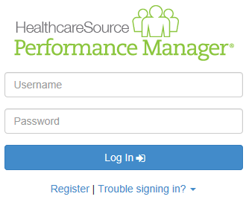
- The page reloads and asks for your First Name, Last Name, and Employee ID number. Enter these into the text fields and click Next.
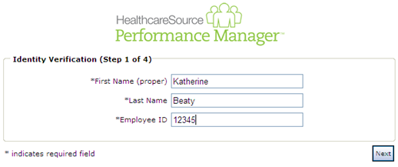
- The next form asks for your Username. Make sure to enter a username that follows the guidelines set by your organization. Click Next when finished.
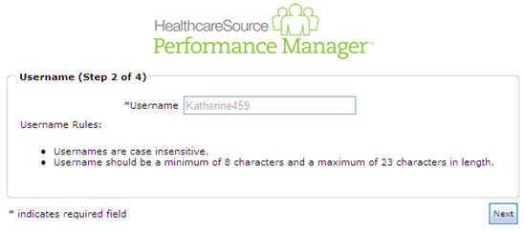
- Next up is the password. Enter a password for your account and confirm it, making sure to follow those guidelines again. Click Next when finished.
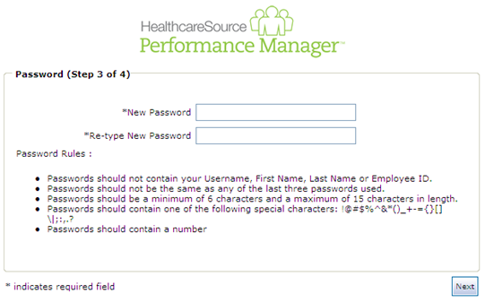
- Last step is the security questions. Security questions are used to help you retrieve your username and/or password in the future if you should ever have trouble remembering. Three default questions are selected, but you can choose different ones from the drop-down lists. Make sure to select questions and provide answers that you can remember!
When you’ve completed all the necessary fields, click Next to complete the registration process.
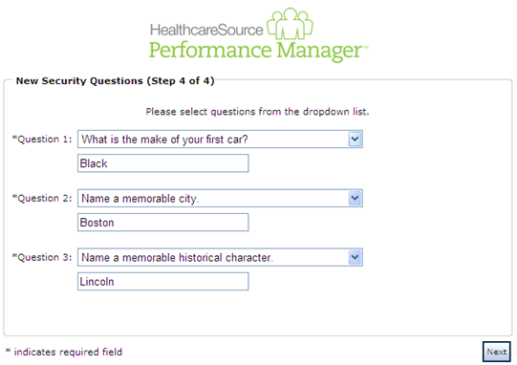
The page reloads again to display a message stating you have successfully registered. Nice job! You can now click the available Login button to return to the main login page and log in using the displayed username and password you just created.

Interface Basics
The navigation bar found at the top of the screen in Performance Manager contains all the links and icons for accessing the various areas and features of the system. From the drop-down menu items to the icons and breadcrumbs in the lower bar, this provides an easy way to get to the features you need.
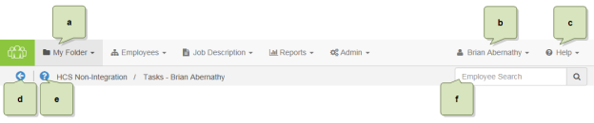
- Available areas. The main items in the navigation bar allow you to access different features throughout Performance Manager. Access to these items are controlled by system-wide permission sets, so you may not see all the options listed here. In fact, most employees only have access to the My Folder item.
- User menu. The user menu is the one that has your name on it - so hopefully it's pretty obvious which one we're referring to. This menu provides access to several Settings pages that control your account security and other system options, along with the system's Log Out link.
- Help menu. The Help and Release Notes options under this menu item launch the online help system in a new browser window or tab. The selected option determines which page of the online help system is displayed once opened. Clicking the Support option takes you to the HealthcareSource Community Support portal.
- Back button. This button merely takes you back to the previous page you were viewing. We recommend using this button instead of your browser's Back button when navigating around Performance Manager.
- Inline help. The icon opens the inline help window for the page you're currently viewing. These windows provide smaller chunks of help material so you can get past those sticking points without having to dive into the full help system for answers.

Navigation areas
The main navigation bar has several menu items containing the various functionality for Performance Manager. Access to the items is controlled by system-wide permissions, so chances are you won't see all the items listed unless you're an administrator for the system.
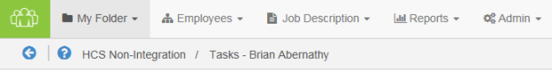
- My Folder. This is the one item that all users have. The pages under this area contain employee profile information and provide easy access to appraisals, checklists, feedback, and other items saved to your profile.

Help menu
The Help menu in the navigation bar provides quick access to pages found in the online help system. Clicking any of the available links launches the online help system in a new browser window or tab and displays the topic for the selected option.
- Help. Opens the help system to the home page, from which you can perform a search for topics, download user guides, or browse the available content.
- Release Notes. Opens the help system to the Release Notes topic, which lists feature enhancements and bug fixes we've delivered over the given time periods.
- Support. Takes you to the HealthcareSource Community Support portal, where you can search our knowledgebase of articles and submit support tickets.

Inline help
Inline help was created as a way to provide targeted bits of information that assist you in performing necessary tasks or functions within Performance Manager without having to dig through pages of information in online or printed user guides. Inline help delivers condensed chunks of user assistance that only relate to the page currently being viewed so you get the help you need now.
Clicking the icon next to the breadcrumbs in the navigation bar opens a pop-up window within Performance Manager itself - not a new browser window or tab - so you can view necessary information about features or procedures without having to switch back and forth between multiple windows. Viewing assistance information in the same window as the feature you're trying to use makes it easier to get past those sticking points.
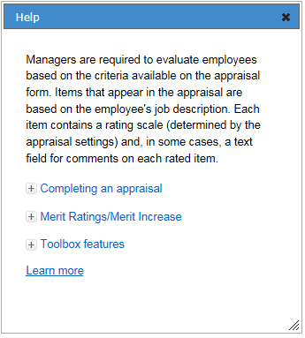
Another great thing about these inline help windows is that you can move them around the page and still interact with Performance Manager in the background. Open up an inline help window so you can see the steps necessary to complete your task, and click along in Performance Manager as you walk through the procedure. You can also resize the inline help window so it's never in the way.
Finally, if you're feeling particularly curious, clicking the Learn More link in the inline help window opens the full online help system for Performance Manager where you can view more detailed information about the feature(s) in question and all other areas of the system.

User menu
The user menu provides access to several settings pages that control security for your account and how certain features in Performance Manager operate. There's also a link for logging out of the system completely.
Selecting the Settings option opens the Change Password page by default. Additional pages can be viewed by selecting an option from the Settings drop-down list.
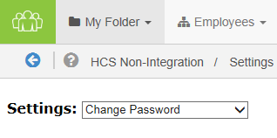
Change Password
Need to update your password? You're in the right spot. This page has the typical fields necessary for creating a new password for your account.
Make sure to review the rules listed when entering a new password, and definitely don't forget to click Save when you're done.
Note: Recovering a forgotten password (or username) is handled using a different process available on the system's Login page.
Change Security Questions
Another page to help beef up your account security. These security questions help you retrieve forgotten usernames and/or passwords should you ever forget and can't log into the system.
Each of the three questions uses a drop-down list of pre-set questions. Select one, provide an answer, and move on to the next.
Finished with picking and answering the questions? Click Save. All done.
Enable Appraisal Auto Save
Don't you just hate it when you're working on something and your computer decides it's time to freeze up on you and you lose the last hour or so of work? Who has time for that?
Fear not. Check the Enable Auto Save option on this page, and your appraisals will automatically save as you're working on them. So even if your computer takes a nap, you won't lose all your work.
Enter Email Address
People move all the time, so constantly need to update their mailing address. Well, same thing goes for email addresses. You probably don't change your email that often, but if you ever do, this page lets you update both your work and home (personal) email address.

My Folder
The My Folder tab contains all the available pages for an employee's profile in Performance Manager. These pages allow all users to view their own profile information listed on the various pages. Due to the permission levels of many basic employees using Performance Manager, My Folder is the only option shown in the navigation bar. Managers and administrators have more navigation bar items.
There are several pages listed under My Folder. However, not all pages may be available to you, depending on system settings and your own user role.
- Appraisals. The Appraisals page provides an area to review manager, self, and multi-rater appraisals that have been conducted.
- Checklists. The Checklists page lists the competency checklists you have been assigned and have completed. The table includes an "Action" column that allows you to edit the checklist or download a PDF of the completed checklist.
- Compensation. The Compensation page is where users are able to view the results of previous compensation cycles, and where managers complete compensation adjustments for employees.
- Development. The Development page in your profile lists the available reports for any assessments you have completed.
- Documents. The Documents page simply lists reference materials related to your employee record, such as certifications and training files.
- Feedback. The Feedback page allows users to review feedback that has been given to the employee by their manager.
- Goals. The Goals page allows administrators to review and, sometimes, edit goals that you have been assigned to and completed. Development and performance goals are displayed in separate tables.
- Job Description. The Job Description page provides links to view job descriptions that were signed off on by employees. Clicking the link for a job title opens a new page that displays the PDF, as well as a link to download the file.
- Personal Info. The Personal Info page displays your employee demographic information supplied by the HRIS feed. Personal information here can simply be reviewed and not edited.
- Personal Routing Users. The Personal Routing Users page provides an area for you to manage the list of other users in Performance Manager that you use for routing appraisals and goals.
- Tasks. The Tasks page lists all your relevant tasks in a table for easy access. Quick links and a table filter feature allow you to locate necessary tasks quickly.
- Training & Assessment. The Training and Assessment page provides a view of training that has been assigned or completed by the employee. Clicking the link for a specific item in the tables opens a new window with further details about the selected training.

Appraisals
Appraisals in Performance Manager provide the ability for managers (and employees) to rate performances based on associated job description forms. The page provides an area to review manager, self, and multi-rater appraisals that have been conducted.
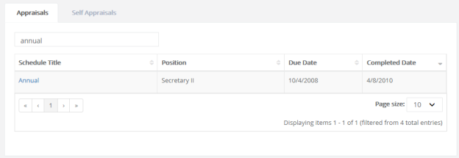

Checklists
Checklists provide a way for managers to assess employees on basic skills that relate to their positions in your organization by listing the competency checklists you have been assigned and have completed. The table includes an "Action" column that allows you to edit the checklist or download a PDF of the completed checklist.
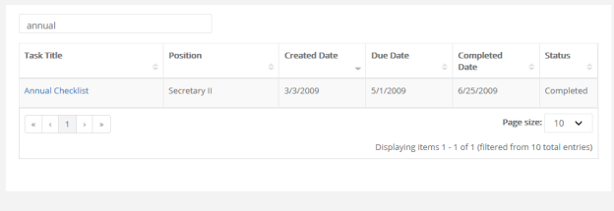

Compensation
The Compensation page is where users are able to view the results of previous compensation cycles, and where managers complete compensation adjustments for employees.
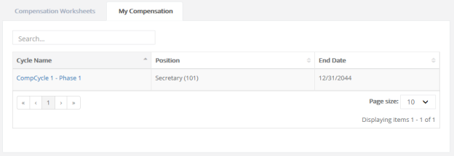

Development
The Development page under My Folder contains information relating to your professional development at your organization. The page contains tabs for Assessment Reports and Development Plans.
- Assessment Reports. This tab lists the reports for any completed assessments. Clicking on the completed assessment opens the PDF version of the report.
- Development Plans. The table on this tab displays all the development plans that have been created. These plans can be created by you, your manager, or system administrators. Clicking a plan from the table opens the plan details page where you can view the plan and make updates about your progress.

Documents
The Documents page under the My Folder area lists all reference materials related to your employee record, such as certifications and training files.
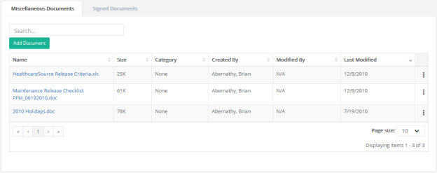
There are two tabs available on this page:
- Miscellaneous Documents. This displays documents that you have uploaded to your employee profile.
- Signed Documents. The table on this tab lists all the documents you have reviewed and signed off on using the Document Sign Off feature.
Selecting a document's title opens a new window displaying a PDF of the document, as well as a link to download a copy of the file.
Adding/Removing documents
Clicking the Add Document button brings up the menu for uploading a new file. Choose the file you wish to add, pick the category from the Select a Category drop-down menu, then click Upload.The file is added to the Miscellaneous Documents table. Now you can reference this file any time you log in, no matter what computer you're using.
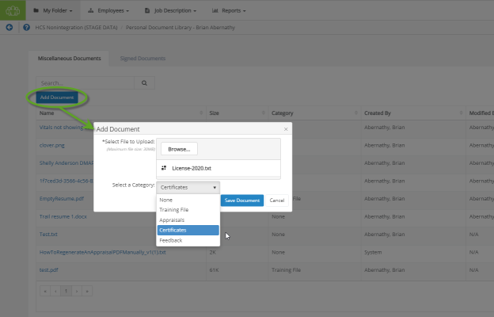
Note: The Category field is simply for your own reference and does not affect how the file is opened or displayed.
Changing a document's category is done by selecting Edit from the Actions menu at the right-hand side of the row.
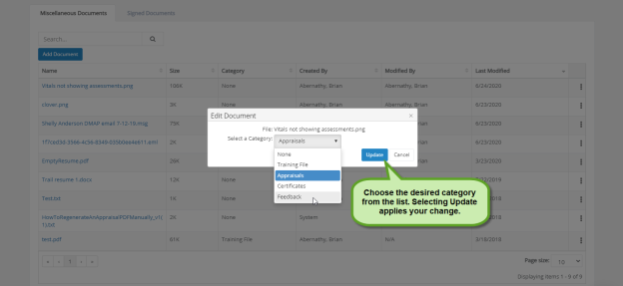
Deleting a document no longer needed is done by selecting Remove from the Actions menu at the end of the row. As always, delete carefully!
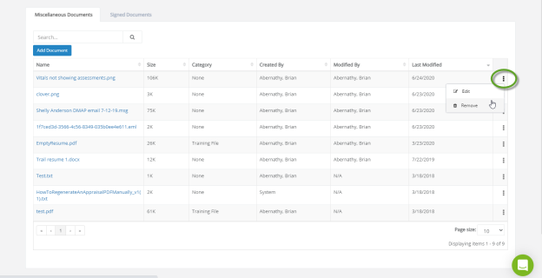

Feedback
There are a few different methods of logging feedback, issuing recognition, and keeping track of personal events within Performance Manager, and they can all be viewed from the three tabbed sections on this page. The Feedbackpage allows users to review Feedback that has been given to the employee by their manager, as well as review any Recognition and Remarks sent by colleagues. Additionally, if users wish to make a written record of something that occurred, the Journal tab allows them to add or review entries in their Employee Journal.
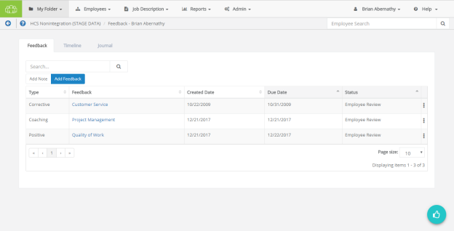
Feedback
On this page, the area found under the Feedback tab allows the administrator to view and manage feedback for the selected employee. Whether it's positive reinforcement, coaching to foster improvement, or issuing corrective feedback, such occurrences may be issued and reviewed from here.
Any existing feedback can be viewed by clicking the link in the available tables. Alternately, it can also be printed or deleted via the options found in the Actions drop-down menu in the right-most column of the feedback table.
New feedback (and notes) can be created as well by using the Add Note and Add Feedback buttons. For additional details about these options, please refer to the Notes and Adding Feedback pages.
Recognition
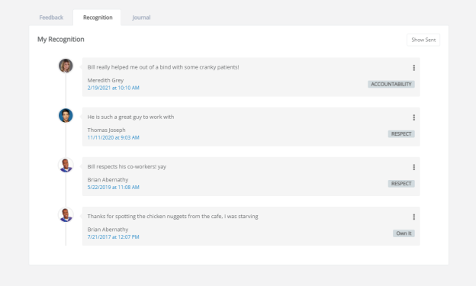
The Recognition tab on this page shows a list of feedback received via the Recognition and Remarks form, presented in chronological order.
Clicking Show Sent in the upper-right corner of the tab displays a list of all recognition sent to other employees. When clicked, this button changes to Show Received. Clicking this button again reverts the page back to its original display.
Additional options to Print or Delete items from the recognition timeline are found by clicking the Actions menu, which is shown as three vertically-aligned dots on the right-hand side of an entry.
Journal
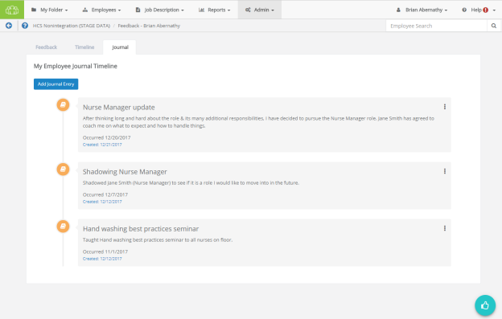
The Journal tab displays your own record of events and accomplishments that were entered using the Journal form. Entries in this page are presented in chronological order, based on the date the entry was created. Creating a new entry is conducted via the Add Journal Entry button, which displays the same form that appears after clicking the Journal icon. The Actions menu presents options to Edit an entry or Delete it from your timeline.

Goals
The Goals page lists goal forms created and/or assigned to you. This includes both Development and Performance goals, which are displayed in separate tabs on the page.

Job Description
The Job Description page provides links to view job descriptions that were signed off on by employees. Clicking the link for a job title opens a new page that displays the PDF, as well as a link to download the file.

Personal Info
The Personal Info page under the My Folder area lists your profile information, such as job title and manager, as well as any Licenses and Certifications that are attached to your record in Performance Manager. Though you are not able to change any of this information from this page, you should contact your manager if you notice any discrepancies in your profile.
Licenses and Certifications Table
The table for Licenses and Certifications displays information at-a-glance for licenses or certifications.
- Name: Name or type of license or certification
- State: State the license or certification was issued by
- Start Date: Date the license or certification was given
- Expiration Date: Date the license or certification expires
Note: Only users holding Admin permissions may add, edit, or delete information from the Licenses and Certifications table. If you need to update your license or certification details, you'll need to reach out to your Performance Manager system administrator for their assistance with the task.

Personal Routing Users
The Personal Routing Users page under the My Folder area provides an area for you to manage the users that you route specific forms to for review. These users appear in drop-down lists when you route forms for review in Performance Manager.
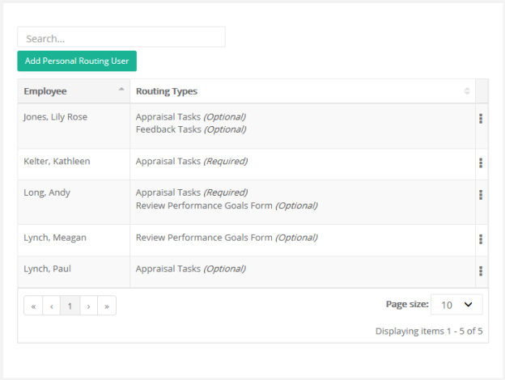
Clicking the Add Personal Routing User button opens a new page with an employee picker where you can locate and select a user to add to your list. The Type of routing user is determined by your system administrator.
Routing User types
There are four types of routing users:
- Appraisal Tasks. These are employees who review appraisal forms.
- Feedback Tasks. These are employees who review corrective feedback before it is discussed with the employee.
- Job Description Approval. These are employees who review job description edits made by managers.
- Review Performance Goals Form. These are employees who send and receive appraisals for approval/sign off during the evaluation process.

Tasks
All tasks that have either been assigned to you, or are related to you in some way, are listed on this page.
Your relevant tasks are laid out in a table for easy access. Quick links and a table filter feature allow you to locate necessary tasks quickly.

Training & Assessment
The Training and Assessment page provides a view of training that has been assigned or completed by the employee.
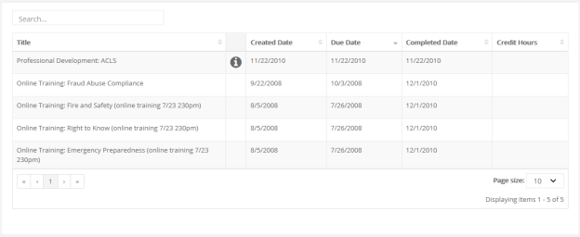
This table is read-only; items are automatically added when training and assessment tasks are completed.

User and Help menus
The navigation bar in Performance Manager has two rouge options hanging out to the far right side, away from the usual solution feature menus.
- User menu. The user menu is the one that has your name on it - so hopefully it's pretty obvious which one we're referring to. This menu provides access to several Settings pages that control your account security and other system options, along with the system's Log Out link.
- Help menu. The Help and Release Notes options under this menu item launch the online help system in a new browser window or tab. The selected option determines which page of the online help system is displayed once opened. Clicking the Support option takes you to the HealthcareSource Community Support portal.

Help menu
The Help menu in the navigation bar provides quick access to pages found in the online help system. Clicking any of the available links launches the online help system in a new browser window or tab and displays the topic for the selected option.
- Help. Opens the help system to the home page, from which you can perform a search for topics, download user guides, or browse the available content.
- Release Notes. Opens the help system to the Release Notes topic, which lists feature enhancements and bug fixes we've delivered over the given time periods.
- Support. Takes you to the HealthcareSource Community Support portal, where you can search our knowledgebase of articles and submit support tickets.

User menu
The user menu provides access to several settings pages that control security for your account and how certain features in Performance Manager operate. There's also a link for logging out of the system completely.
Selecting the Settings option opens the Change Password page by default. Additional pages can be viewed by selecting an option from the Settings drop-down list.
Change Password
Need to update your password? You're in the right spot. This page has the typical fields necessary for creating a new password for your account.
Make sure to review the rules listed when entering a new password, and definitely don't forget to click Save when you're done.
Note: Recovering a forgotten password (or username) is handled using a different process available on the system's Login page.
Change Security Questions
Another page to help beef up your account security. These security questions help you retrieve forgotten usernames and/or passwords should you ever forget and can't log into the system.
Each of the three questions uses a drop-down list of pre-set questions. Select one, provide an answer, and move on to the next.
Finished with picking and answering the questions? Click Save. All done.
Enable Appraisal Auto Save
Don't you just hate it when you're working on something and your computer decides it's time to freeze up on you and you lose the last hour or so of work? Who has time for that?
Fear not. Check the Enable Auto Save option on this page, and your appraisals will automatically save as you're working on them. So even if your computer takes a nap, you won't lose all your work.
Enter Email Address
People move all the time, so constantly need to update their mailing address. Well, same thing goes for email addresses. You probably don't change your email that often, but if you ever do, this page lets you update both your work and home (personal) email address.

Tasks
Performance Manager simplifies the employee performance management process by automating the workflow and content for performance appraisals, job descriptions, skills, goals, succession planning, and performance reporting. These automated processes are driven by specific tasks assigned to employees.
The Tasks page (found under the My Folder drop-down menu) lists all the tasks that have been assigned to you in Performance Manager. It provides a searchable, filterable, sortable table that makes it easy to browse, locate, and complete your various tasks and assignments.
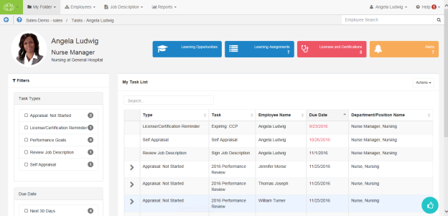
Most features of Performance Manager have associated tasks so employees know when they are required to complete work in the system. Notifications are also sent when tasks are assigned, so users don't need to continually log in to check for new assignments.

About the Tasks page
The Tasks page under My Folder displays a list of all the tasks you have been assigned. This table provides a way to easily locate and complete necessary tasks.
The interface provides information at a glance, and several ways to filter the Tasks table in order to locate specific items.
Employee Profile header
The Employee Profile header displays key information and provides quick links to take action on the listed items. A color-coding system for items delivers additional quick-view indicators so it’s easy to see when it’s time to review and update profile information.
Available areas in this header include:
- Employee and Position information. This area displays the employee name and position. Scroll arrows are available when an employee has multiple positions.
- Licenses and Certifications. This tile shows how many Licenses and Certifications reside in the employee’s profile. A green background indicates everything is up-to-date; red background means there’s items that have a renewal date upcoming or past due. Clicking the tile opens a table view that lists items under the header.
- Learning information. Available to clients with integrated NetLearning functionality, these areas provide access to NetLearning widgets for enrolled and available courses and classes. The Learning Assignments tile also displays the number of current assignments for the employee.
- Task Alerts. Displays the number of overdue tasks in the task list. Clicking this tile in the header opens a new page that lists the overdue tasks.
Filters and Search
The new Taskspage lists available filters in their own area to the left of the Tasks table. Filters include options forTask Type and Due Date.
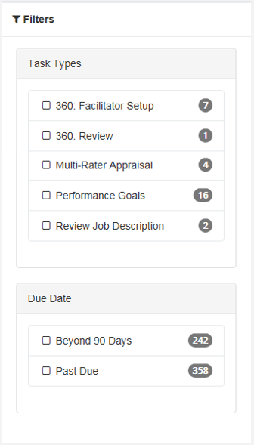
The items listed in each set of filters displays a number that indicates how many tasks match that specific filter. Clicking the checkbox next to an item filters the results shown in the table.
Right above the table is a Search field that allows you to search for specific tasks in the list. This field is a type-ahead field, so the table automatically begins to filter down with each character entered into the field. This field searches across numerous fields for tasks.
Tasks table
Tasks are opened by clicking anywhere in their row. Tasks with associated sub-tasks display an arrow that, when clicked, expands the row to display the related sub-tasks.
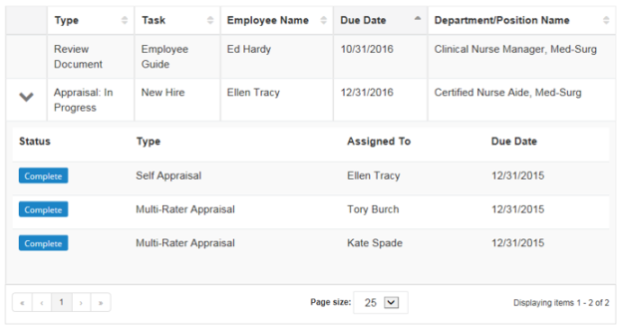
The tasks table can be sorted by almost any of the available columns to help you quickly locate tasks. Simply click on the column heading to toggle between Ascending, Descending, and Off.
The column currently being used for sorting is indicated with a gray background fill. By default, the table is sorted by Due Date.
Recognition and Remarks
Recognition and Remarksis a commenting system that allows employees to send input to other employees about a recent exchange or behavioral observation at any time - not just when requested or during annual review periods. Its feedback form provides fields for selecting employees, associating specific values, and general comments for feedback.
Hovering your cursor over theRecognition and Remarksicon in the lower-right corner of the page displays additional feedback options, including:
- My Recognition. Displays all of your received recognition.
- Recognition Approvals. For managers only; displays a list of recognition sent to your employees anonymously.
- Request Recognition. Allows you to send a request for input from specific employees.
- Received Requests. Lists any requests for input you have received from colleagues.
- Send Recognition. Opens the form used to send recognition to a colleague.
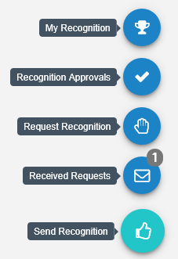
Note: Depending on your system's settings, theEmployee Journalmay also be included with these feedback options.
Employee Journal
TheEmployee Journal is a quick and easy way to keep your own written record of events and accomplishments that happen throughout the year. Using the journal allows you to quickly jot down a summary of events and activities, then reference them just as quickly whenever you need. Keep track of your training seminars, conference attendance, or any quick activities you want to remember, all within your own personal profile.
TheEmployee Journalicon is found in the lower-right corner of theTaskspage.
Note: Depending on your system's settings, theEmployee Journalmay either be grouped in with theRecognition and Remarksfeedback options, or displayed independently.

Completing tasks
The Tasks page in Performance Manager provides an way to quickly locate and complete necessary tasks.
- From the Tasks page, locate the desired task from the table.
- Click anywhere in the task's row. This opens the page necessary to complete the task.
The type of page that displays after clicking a task depends on the type of task selected. After completing the necessary actions for the task, it is marked as Complete and removed from your task list.

Job Descriptions
Job descriptions in Performance Manager are detailed descriptions of positions at your organization. They typically include such information as duties and expectations for the job.
Every employee in Performance Manager is assigned to at least one job description, though it is also possible to be assigned to multiple job descriptions if necessary. Job descriptions are reviewed and signed off by both the employee and their manager. PDF versions of approved job descriptions are saved to employee profiles.
Employees are able to view their own job description from the Job Description page under My Folder. The table on this page lists all the job descriptions signed off by the employee and the date they were approved. Clicking the title of a job description displays its detailed description on a new page.
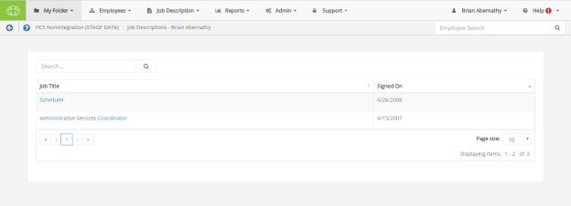
Only system administrators are able to manage positions and their related job descriptions, templates used to create job descriptions, and special forms used to populate job descriptions. In other words, if you need to draft a new job description, or edit an existing one, you'll need to work with your local administrators to set things up the way you need.

Reviewing a Job Description
Employees are required to review and sign off on all job descriptions they are assigned to in Performance Manager. Any time a new job description is assigned to an employee, they receive a task to review and approve that job description.
To review and approve a job description:
- Click anywhere within the Job Description task, in the table on the Tasks page under My Folder.
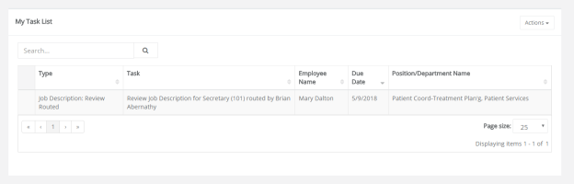
- Scroll down to review all the information contained in the job description.
- Click Sign button at the bottom to acknowledge your review of the job description.
Clicking Sign creates a read-only PDF file of the job description and places it in the employee electronic folder on the Job Description page.
Some employees may have the option to Refuse to Sign the job description based on their permissions. Refusing to sign a job description indicates that the employee has an issue with some information included in the description. Clicking Refuse to Sign allows the employee to send the job description back to their manager, with comments, for further review.

Performance Goals
Performance goals provide a way to track and evaluate employee performance across an organization. Corporate directives in the form of basic pillars are defined and subsequent goals for departments, facilities, and individual employees are aligned upwards.
Employees can view their performance goals on the Goals page under My Folder. Managers are able to view and assign goals to employees from the Performance Goals page under Employees.

Adding goals
Goals can be added by either a manager or an employee, depending on the options chosen when the appraisal is scheduled.
A Performance Goals task appears in the task list when you have been assigned a goal form to complete for the appraisal schedule. Clicking the link from the task list opens the Performance Goals page, where goals can be reviewed, added, and edited.
Goals can be created from scratch, or copied from previous goal forms. This topic covers creating goals from scratch.
Adding goals - Employee
These steps take place from the Performance Goals page.
- Click Add option from the Actions menu above the Goals table. The Add a goal pop-up window opens.
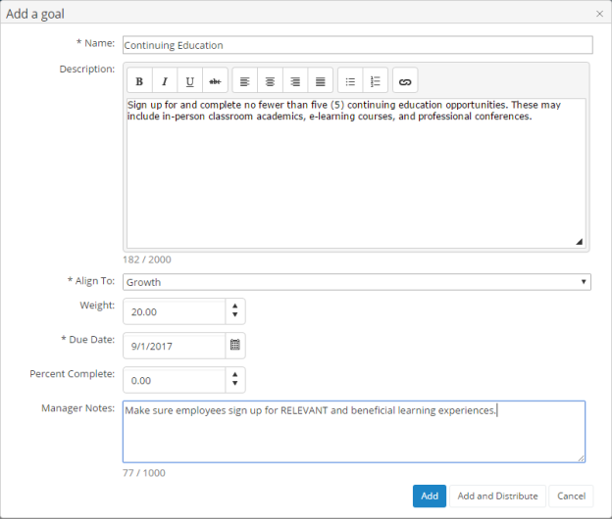
- Complete the fields in the Add a goal window as needed.
- Click the Add button when complete. The pop-up window closes and the new goal now appears in the list.
- Repeat steps 1 through 3 until all goals have been added to the table.
Once all the necessary goals have been added to the My Goals table, you must submit the goal form for approval from your manager. Simply click the Send for Approval button under the table when you are ready to submit your goals.
Tip: Remember, if you are using weights for your goals, the Total Weight of your goal form (shown in the upper right corner of the My Goals table) must equal 100% before you submit the form for approval.

Copying goals
When adding goals, users have the option to create goals from scratch, or copy goals from previous goal forms.
Managers and employees can copy active, approved goals from previous goal forms. Only individual goals can be copied (no corporate goals).
Copying goals - Employee
These steps take place from the Performance Goals page.
- Click the Copy button above Goals table. The Select goals to copy pop-up window opens.
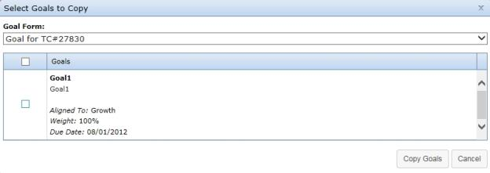
- Select a Goal Form from the drop-down menu. A list of goals on the selected form loads in the table below.
- From the list of goals, check the box next to each goal you wish to copy.
- When a goal is selected, the Weight and Due Date field become editable. Make necessary edits to these fields.
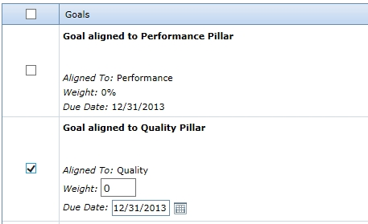
- Click the Copy Goals button at the bottom of the window when finished.
Clicking Copy Goals adds the selected goals to the goal form and closes the pop-up window. Additional goals can be created and/or copied to the goal form at this point.

Updating goals
Updating a goal consists of either adding notes (both managers and employees) and/or changing the Percent Complete field for a goal (managers only).
Adding notes
Goal notes are added to individual goals from a goal form. Managers are able to add notes to employee goals, and employees can add notes to their own goals and respond to any manager notes.
An employee can reach their goal form by clicking the Goals link under the My Folder area in Performance Manager.
These steps take place from the goals form found on the Goals page.
- From the goal form, click the Show Notes link for the goal where you want to add a note. This expands the row and displays any previous notes that may have been left and provides a text box to add a new note.
- Type in text for the new note.
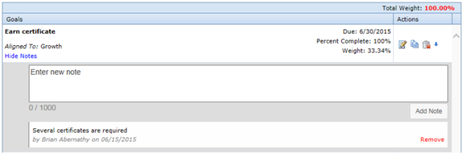
- Click the Add Note link under the text box when finished with the note.
The row reloads to show the new note has been added to the goal.

More about Performance Goals
While many of the most common tasks and procedures handled via Performance Goals have been discussed, there are some more features and capabilities you may be interested in learning about.
These include:
- Check-in tasks. These tasks are intended to function as reminders to review or update any previously-approved goals.
- Department Goal Forms. Managers are given greater control over the goals set for their own individual departments here, and they may add and edit their departmental goal forms as needed.
- Notes. Adding notes to individual goals helps you keep track of additional details, supplemental information, or even serve as a method of correspondence between employees and managers.
- Notifications. Manage automatic notifications that are sent whenever certain criteria are met.
- Weighting. Individual goals may be "weighted" more than one another, putting a greater (or reduced) level of importance on specific objectives.

Check in tasks
Check in tasks are reminders to review or update approved goals. They appear as tasks in a user’s My Tasks table in Performance Manager.
Check in tasks are created when setting up a new appraisal schedule, and are assigned before an employee's full appraisal. Employees are able to add notes to their list of goals when performing this task. Once finished, clicking the Dismiss button completes the task and removes it from the employee's task list.

Notes
Notes can be added to individual goals. Both managers and employees can add notes to a goal; only the person who created the note can delete it.
Notes can be used to keep track of important details regarding the goal, provide status information when updating completion percentages, or simply correspondence between an employee and a manager.
Notes are viewed by clicking the Show Notes link in the goal. The number of notes a goal has is indicated by the number in parenthesis next to the Show Notes link.
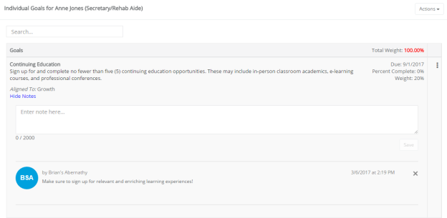
There are two types of notes that can be added to a goal:
- Manager notes. These are notes that are added to a goal when it is initially created, or when a manager returns to a goal form and edits an existing goal. Manager notes are not viewable by employees.
- Goal notes. Goal notes are notes added to individual goals that are viewable by anyone that has access to the employee goal form. Both managers and employees can create goal notes; only the person who created the goal note can delete it.

Notifications
In order to keep both employees and managers up to date with the progress of their goals in the system, automatic notifications are sent when certain actions take place.
- Manager approval of goals. When a manager approves an employee’s goal form, the employee is sent an email notification.
- Manager rejection of goals. Employees also receive a notification if a manager rejects their submitted goal form. This isn’t a notification of rejection; rather, when a manager rejects a goal form, the employee is re-assigned the task to enter their goals. Therefore, the employee receives a notification that they must enter their goals.

Weighting
The Goals module provides a weighting system for individual goals. This allows users to determine which goals hold more importance than others, or ones that may require additional effort to complete.
Individual goals can be assigned a weight when they are added to the system. When creating a set of goals for a user, the sum total of weight for all the combined goals must equal 100%. Users will not be able to submit their goals for approval unless the total weight equals 100%.
The Apply Weights Equally button allows you to quickly distribute weight evenly across the available individual goals.
It is not necessary to add weights to goals.
The weighting feature is an option for the Goals module. When the option is not activated, the “Weight” column does not appear in pop-up windows or goals tables. This option, labeled Show weights on Job Descriptions and Goals, can be found on the Settings page under the Admin area in the Choose Appraisal Options section.

Development Goals
Development goals are used by managers to encourage employees to improve and meet specific performance targets. These goals appear as tasks for employees to complete once the goal has been met.
Development goals can be found on the Goals page under My Folder. Updates to goals can be made by both employees and managers throughout the year.
Development Goals workflow
The basic workflow for development goals is as follows:
- A manager creates a development goal for an employee.
- The employee receives a task and completes the development goal.
- The manager reviews the employee's completion of the goal.

About the Development Goal form
The Development Goal form contains several fields for identifying and tracking the assigned goal.
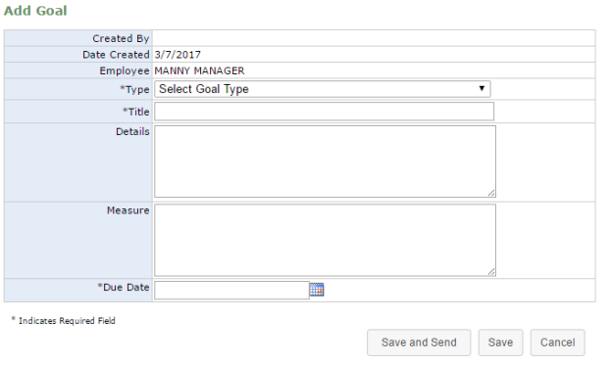
- Created By. The manager that created the goal for the employee.
- Date Created. The date the goal was added to the system.
- Employee. The employee assigned to the goal.
- Type. Drop-down menu with three selections for goal type:
  - Individual. These goals relate directly to the employee.
  - Departmental. These goals are related to goals set for the employee's specific department.
  - Organizational. These goals relate to the goals set for the overall organization. Selecting this option changes the Title field from a generic text field to a drop-down list that contains all available organizational goals.
- Title. Title of the goal. For Individual and Departmental goals, this field is a text box. However, when creating an Organizational goal, this becomes a drop-down field that lists all the available organizational goals, from which a selection must be made.
- Details. Details about the goal, which can include such information as why the goal has been created and what is hoped to be achieved.
- Measure. This details how success in meeting the goal is determined.
- Due Date. Sets the date by which the employee must complete the goal. It also serves as the due date for the task that is created for the employee.

Completing Development Goals
Employees must complete development goal tasks assigned to them by managers.
These steps take place from the Tasks page under My Folder.
- Click the link for the desired development goal task in the Tasks table. This opens the Goal page for the task.
- Enter in any Status Comments about the goal. Click the Save Comment button to save comments.
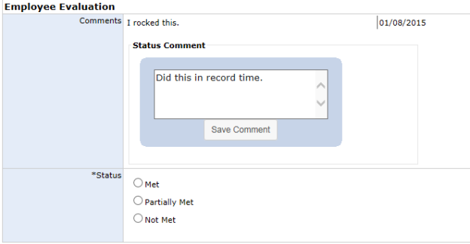
Note: Multiple comments can be added to goals. Employees can also add comments without completing the overall task by clicking the Save Comment button and not signing off on the task.
- Select a Status for the goal.
- Enter any additional Employee Comments as necessary.
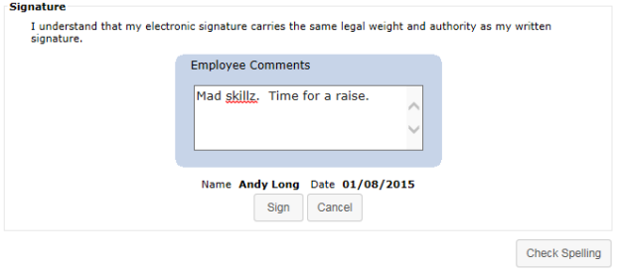
- Click the Sign button.
Clicking the Sign button completes the task for the employee. The manager receives a new task to review and finalize the development goal task for the employee. If the manager feels additional work or explanation is required, they may opt to send the task back to the employee. Otherwise, the manager's sign-off officially completes the task.

Refuse to Sign
A Refuse to Sign option is available that provides employees with the ability to refuse to sign off on developmental goals added by their manager.
When this option is enabled for an employee, an additional Refuse to Sign button is available at the bottom of the goal form when performing their Developmental Goal task. Clicking this button sends the feedback to the manager without signing off.
Employees can still leave Comments even if they refuse to sign off on the goal. Any text entered into the Comments field is displayed to the manager.
When an employee refuses to sign off on feedback, the form is sent back to their manager as a Refused to Sign: Goal task. Managers are required to review the goal form and sign off to complete the task. The Signature section of the form notes that the employee selected the Refuse to Sign option for the goal, and displays any comments left by the employee.
Managers have the option to Sign the goal form, which completes the task, or Send Back to Employee for further review and comment.

Appraisals
Appraisals in Performance Manager provide the ability for managers and employees to rate workplace performances based on the job description forms associated with their position. These appraisals are conducted on varying intervals depending on your company's own policy.
Appraisals provide a measurement of employee performance based on the benchmark criteria pre-established for their job. This differs from the 360 Review, which focuses more on the skills and contributions an employee provides to the workplace and their co-workers.
Manager appraisals are conducted to rate and comment on each of their individual employee's performance throughout the duration of the period. Employees conduct self appraisals and multi-rater appraisals to share their own beliefs and estimations on how their own— or their co-workers'— accomplishments stack up to what was expected of them throughout the evaluation period.
Appraisal types
There are three types of appraisals in Performance Manager:
- Manager appraisal. This is the basic employee appraisal form, based on a job description. Managers complete this evaluation form for all their direct-report employees.
- Self appraisal. Self appraisals are completed by employees in reference to their own performance. Self appraisals are reviewed with the employee's manager.
- Multi-rater appraisal. As part of 360-degree feedback in Performance Manager, multi-rater appraisals are completed by selected employees. Managers select which users conduct appraisals about their employees.

Completing a self appraisal
As an employee, your manager can assign you a task to complete a self appraisal where you evaluate your own performance. This requires you to complete an appraisal form that lists performance criteria you are evaluated on based on your job description.
When you are assigned a self appraisal, a Self Appraisal task appears in your tasks list. There is often a due date listed by which you need to complete the appraisal.
These steps take place from the Tasks page under My Folder.
- In the Tasks table, locate and select the Self Appraisal task. This opens the appraisal form.
- Review each item on the appraisal form and provide a rating based on your performance.
- You may be able to provide notes on individual items in the form by clicking the notes icon () for each item listed. This opens a large text field for you to enter additional comments on the appraisal item. However please note that in order for your comments to be saved, you must select or enter an evaluation option.
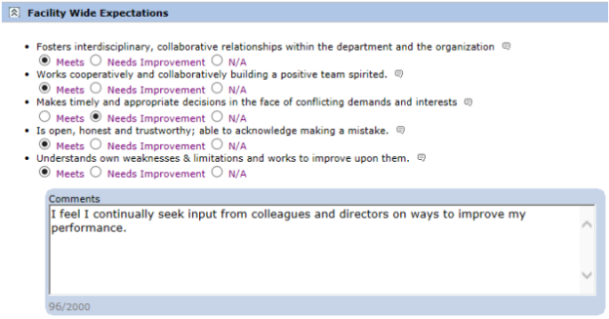
Note: If the notes area opens automatically when you select a rating for an item, it is required that you provide comments for that item.
- Provide any additional notes necessary in the Appraisal Comments area.
- Select Save and Send when finished.
Selecting Save and Send finalizes the appraisal and sends the form to your manager for review. You can no longer edit the appraisal after it is submitted.
You can access your appraisal form for review from the Appraisals page under the My Folder area.

Completing a multi-rater appraisal
Multi-rater appraisals allow managers to request employees to rate other employees on their performance.
Responses are viewable by the manager that assigned the appraisal and the HR department. The employee for the appraisal is able to view the ratings and comments left by multi-raters, but are unable to view which employee left those comments unless a name is indicated in the comments themselves.
When you are assigned a multi-rater appraisal, a MultiRater Appraisal task appears in your tasks list. There is often a due date listed by which you need to complete the appraisal.
These steps take place from the Tasks page under My Folder.
- In the Tasks table, locate and select the MultRater Appraisal task. This opens a confirmation page.
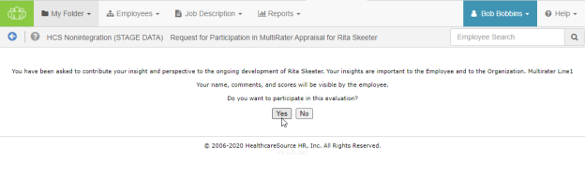
- Click Yes on the confirmation page to continue to the appraisal form.
Note: Clicking No indicates that you wish to opt out of the multi-rater appraisal. You are taken back to the Tasks page, and the MultiRater Appraisal task no longer appears in your task list.
- Review each item on the appraisal form and provide a rating based on your opinion of the employee's performance.
- You may provide notes on individual items in the form by clicking the notes icon () for an item. This opens a large text field for you to enter additional comments on the appraisal item. However please note that in order for your comments to be saved, you must choose or enter an evaluation option.
Note: If the notes area opens automatically when you select a rating for an item, it is required that you provide comments for that item.
- Provide any additional notes necessary in the Appraisal Comments area.
- Click the Save and Send button when finished.
Clicking Save and Send finalizes the appraisal and sends the form to the employee's manager for review. You can no longer edit the appraisal once it's submitted.

Reassigning Appraisals
Appraisal tasks can be reassigned to other users in the event the assigned user is unable to complete the appraisal due to being out of the office or other time constraints. Reassigning an appraisal creates a task for the selected user to complete the appraisal, and removes the task for the current user.
To reassign an appraisal, select the Reassign Appraisal option after clicking the desired appraisal task from the tasks list. A page opens that provides an area to search for and select a user for the reassigned appraisal task.

Rejecting Appraisals
At any point during the appraisal process (before a PDF document is generated), managers and routing users are able to reject appraisals. Rejecting an appraisal sends it back to a user (either the employee or the employee's manager) where it appears in their task list in order for them to make necessary changes.
Since rejecting an appraisal removes all existing signatures from the appraisal, it needs to be re-routed for approval.
To reject an appraisal, click the Reject button at the bottom of the appraisal form. You are required to add comments explaining why it was rejected so users can make necessary updates to the appraisal.

Recognition and Remarks
Recognition and Remarks is a commenting system that allows employees to send input to other employees about a recent exchange or behavioral observation at any time - not just when requested or during annual review periods. This 24/7 approach to input allows people to respond immediately and honestly while everything is fresh on their mind so they’re able to include specific details in their comments and help compile a more accurate view of employee performance.
Comments left for an employee can be associated with specific organizational and/or corporate values in order to provide even more context to the nature of the employee behaviors that inspired the unsolicited comments.
To help encourage employees to provide open and honest input regarding colleague activities, a feature setting provides an option to send input anonymously, which simply hides the name of the sender of the comments from the recipient.
Once the comments are sent, recipients are able to view the input left for them in Performance Manager. Recognition is saved in the employee profile, so both employees and managers are able to review the full history of received recognition.
Tip: If the Employee Journal is enabled, you can access your Journal page from its icon in the lower-right. Depending on your system's settings, it may either be grouped in with the Recognition and Remarks feedback options, or displayed independently.
Where can I find Recognition and Remarks?
Recognition and Remarks is located on the Tasks page as an icon in the bottom-right corner. Hovering your cursor over the icon expands the menu to show all the available options.
- My Recognition. Displays all of your received recognition.
- Recognition Approvals. For managers only; displays a list of recognition sent to your employees anonymously.
- Request Recognition. Allows you to send a request for input from specific employees.
- Received Requests. Lists any requests for input you have received from colleagues.
- Send Recognition. Opens the form used to send recognition to a colleague.
Note: Available options in the menu are controlled by system settings and permissions, so you may not have access to all the listed features.

About the Recognition form
The Recognition and Remarks form provides fields for selecting employees, associating specific values, and general comments for feedback.
Note: Due to the highly configurable nature of the Recognition and Remarks feature, you may notice differences in some verbiage and screenshots shown here.
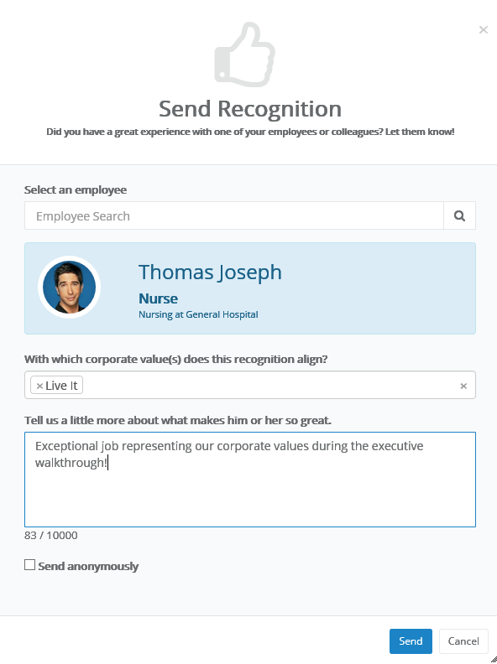
- Select an employee. Search field for locating the employee for your feedback. This is a type-ahead field that automatically displays employee names that match after three characters have been entered.
Tip: See an Advanced button in your employee search field? That means you can send recognition to multiple employees at once!
- Corporate values. Drop-down list that allows you to make multiple selections for any organizational/corporate values to assign to the feedback.
- Comments. Text field for entering your comments for the employee.
- Send anonymously. This option allows you to send your feedback anonymously, which simply hides name of the sender from the receiving employee. The recipient's manager must approve all anonymous feedback before it is shown to the employee.

Anonymous Recognition
Recognition and Remarks includes an option to send input to a colleague anonymously. This simply hides the name of the sender from the recipient. Anonymous recognition helps promote open and honest feedback amongst employees who otherwise might be hesitant to leave either positive or constructive comments for a fellow employee.
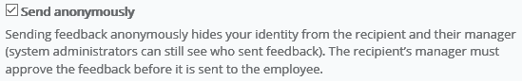
Anonymous recognition must be approved by the recipient’s manager (who is also unable to view the name of the sender) before it can be viewed by the recipient. Managers receive a notification via email and in the icon menu on the Tasks page on the Recognition Approvals option.
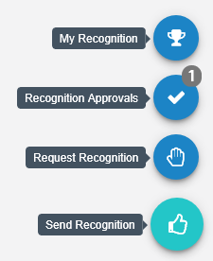
Managers can either Approve or Reject the anonymous recognition.
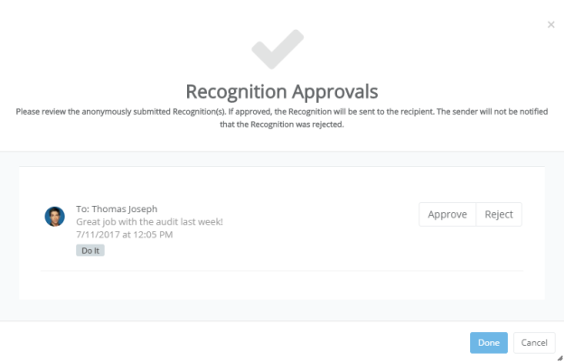

Batch Recognition
Recognition and Remarks helps build a complete, accurate profile of employee performance by allowing colleagues to leave feedback at any time about specific observed behaviors. But what about those times when a group of people go above and beyond to ensure organizational success?
Batch recognition has you covered. This allows you to select multiple employees or an entire department, facility, even job position for your comments. This sends your input to everyone at once, saving you time as you deliver recognition to the group.
Sending batch recognition is easy too: when enabled, you'll notice an Advanced button in the employee search field of the Send Recognition pop-up window. This indicates you can select multiple employees for your input.
There's two ways to add multiple employees:
- From the employee search field. As you begin typing into the search field, a list of matching employees is displayed. Clicking on an employee adds them to the recognition. Then just begin typing the next employee's name to add, and select them from the list. Repeat until all the desired employees have been added.
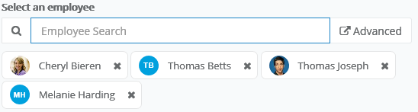
- Click the Advanced button. Clicking Advanced opens the employee picker, which allows you to browse employee lists as well as select specific facilities, departments, and/or positions. Simply check the desired areas, click Add Selected/All to move them to the Selected area, and click Confirm.
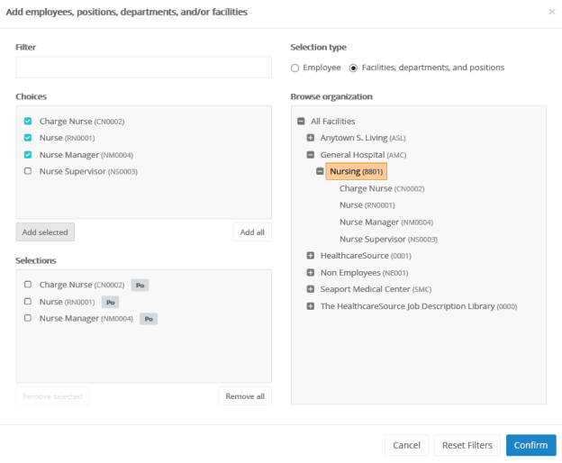
Batch recognition even allows you to include a combination of employees and facilities/departments/positions. The icons for each indicates their type.

Requesting Recognition
You can use Recognition and Remarks to request input from specific employees at any time. Employees receiving a request for input have the option to accept or decline the request.
- Select the Request Recognition option from the icon's menu on the Tasks page.
- Complete the form that opens in the pop-up window. You can select multiple employees for the request.
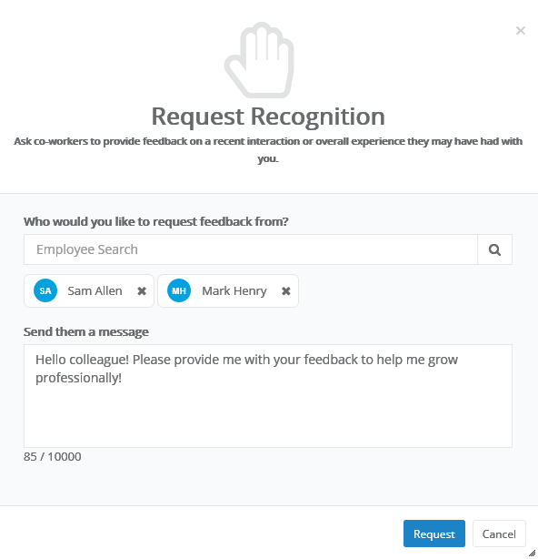
- Click Request.
Selected employees receive an email notification when the request is sent (if the email notification option is enabled), and the icon on their Tasks page displays a number to indicate they have a request waiting.

Responding to Recognition requests
Recognition and Remarks provides the ability to request input from specific employees. Employees receiving such requests are notified via email and on the Recognition icon on the Tasks page.
Clicking the Received Requests option from the menu opens a pop-up window that lists all the requests you have received from other employees.
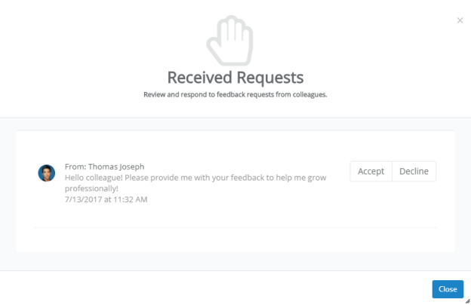
Each request has the option to Accept or Decline the request for input. Accepting a request opens the Send Recognition form for you to complete for the employee. Declining a request simply removes it from your list.

Sending Recognition
Sending recognition to a colleague is designed to be a quick and easy process to encourage employees to share thoughts and comments as often as possible.
- Select the Send Recognition option from the icon's menu on the Tasks page.
- Complete the send recognition form that opens in the pop-up window.
- Click Send.
The selected employee receives an email notification when the recognition is sent (if the email notification option is enabled), and the icon on their Tasks page displays a number to indicate they have new feedback.
Tip: Depending on how your Recognition and Remarks feature is configured, you may be able to send recognition to multiple employees at once.

Viewing Recognition
Comments from colleagues is only helpful if you're able to view their input, so we've made it easy to view all the recognition you've received from fellow employees.
When you receive new recognition, the icon on the Tasks page displays the number of new items for you to view.
Selecting the My Recognition option from the icon's menu opens a pop-up window that lists all your received recognition in chronological order.
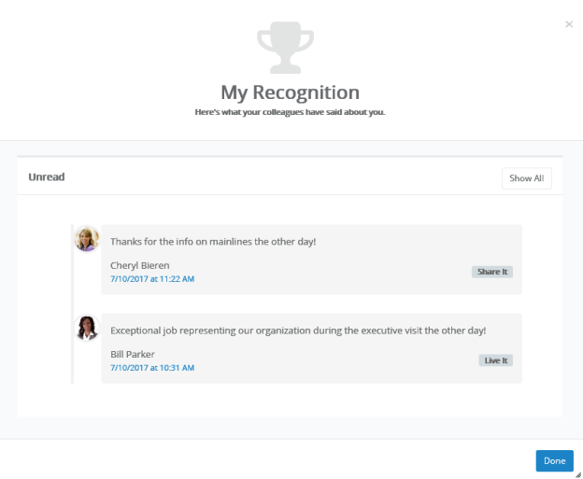
If you have new items to view, those are shown separately. Clicking Show All displays all of the recognition items you have received to date.
You can also access a listing of all your recognition items on the Feedback page under My Folder. The Recognition tab on this page shows the same list of received items.
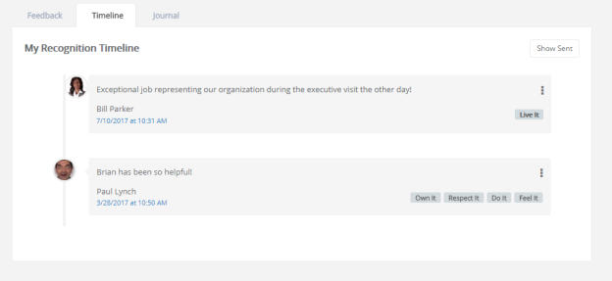
Additionally, the Show Sent button displays a list of all the recognition you sent to other employees.

Checklists
Checklists provide a way to assess employees on basic skills that relate to their positions in your organization. Whereas Assessments and 360 Reviews are intended to evaluate an employee's attitude, workplace contributions, and professional achievements, checklists are provided for the purpose of measuring the employee's skill level and ability in performing specific tasks such as drawing blood or inserting an IV line. Simply put, checklists assess to what degree they can or can not successfully perform a task.
Lists of specific skills is created and assigned to individual positions in Performance Manager. A checklist schedule is created (by an administrator) that assigns a checklist task to managers. This task requires them to evaluate their employees on the skills for their competency checklist.
Employees can also be assigned self-assessment tasks for checklists, allowing them to evaluate themselves on the necessary skills, and share the assessment with their manager.
Checklists can contain multiple skills, but not all skills on a checklist need to be completed at the same time. Checklist items can be evaluated when possible, and the checklist saved for completion at a later date.
Once all items on a checklist have been completed, the entire checklist can be closed. Closed checklists are stored as a PDF in the employee profile, and the employee is then assigned a sign-off task.
Users with a Validator role are able to complete individual skills for an employee, along with the employee's manager, but only the manager is able to close the entire checklist and complete the task.

About the Checklists form
The form used for checklists contains fields for evaluating employees on specific skills.
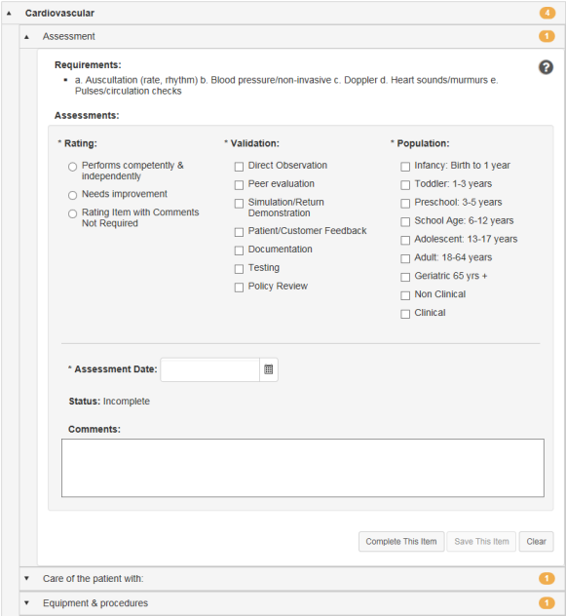
The form itself is organized in groups of skills. Each group heading contains a number that indicates how many skills require validation under that heading. When all the skills have been completed for a group, the number becomes a green checkmark.
Required fields on the form are indicated with an asterisk (*) next to the field name.
Rating | Rating scale used to evaluate the employee's performance of the selected skill. Rating scales may differ from skill to skill depending on how they are set up for your organization.
Validation | Determines how the skill was evaluated.
Population | Determines the population that was used to evaluate the skill.
Assessment Date | The date the skill evaluation was performed.
Comments | Text field for general comments about the employee's performance on the selected skill.

Completing skills
Skills are used to validate an employee's ability to perform skills necessary for their job positions. Checklists can contain many skills for evaluation, though not every skill needs to be evaluated at once.
Checklists can be completed by opening a Checklist task from the Tasks page, or by visiting the Validate page under Employees and selecting an employee to evaluate from the table.
Users in a Validator role are able to complete individual skills on a checklist (along with the employee's manager); however, only the manager is able to close the entire checklist and complete the task.
To complete a checklist once the checklist form is open:
- Locate the desired skill to evaluate from the list in the form. Skill group headings can be expanded to display the skills themselves, and clicking these sub-items opens that skill.
- Complete the skill evaluation form as necessary.
- When finished with the form, click the Complete This Item button to finalize your evaluation of the employee for that skill.
- Repeat steps 2 and 3 for other skills you wish to evaluate.
Clicking the Complete This Item button for individual skills marks selected skill as complete and closes it. While you can view closed skills, you are not able to make any further edits on a skill once it has been completed.
The Save This Item button saves your work on the current skill for completion at a later date.

Self assessments
Self assessments for checklists are exactly what you might think they are: a chance for employees to rate themselves on the skills contained within a checklist. Employees are assigned a Checklist - Self Assessment task that requires them to complete a checklist
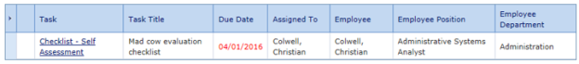
The employee view of the checklist is the same as managers and validators. They have the opportunity to select a Rating, Validation, and Population for each skill, and provide additional comments if desired.
Once completed, employee responses in the checklist are viewable by managers and validators working in the checklist. A little person icon next to the assessment fields indicates the employee’s selection, and their comments are shown at the bottom of the form as well.
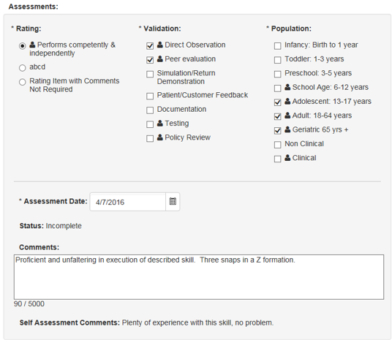

Completing a self assessment
Self assessments for checklists can be completed by opening the Checklist - Self Assessment task from the Tasks page
To complete a checklist once the checklist form is open:
- Locate the desired skill to evaluate from the list in the form. Skill group headings can be expanded to display the skills themselves, and clicking these sub-items opens that skill.
- Complete the skill evaluation form as necessary.
- When finished with the form, click the Complete This Item button to finalize your evaluation of the employee for that skill.
- Repeat steps 2 and 3 for other skills you wish to evaluate.
Clicking the Complete This Item button for individual skills marks selected skill as complete and closes it. While you can view closed skills, you are not able to make any further edits on a skill once it has been completed.
The Save This Item button saves your work on the current skill for completion at a later date.

Sign Off task
Checklist - Sign Off tasks are assigned to employees after their manager closes a checklist. This task provides employees the opportunity to review completed checklists and provide sign off.
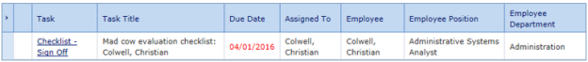
Launching the task opens a read-only view of the checklist, which displays both the employee’s self-assessment ratings (if one was assigned) – in the form of those little person icons again – along with the manager/validator responses. Comments from everyone are also shown for each skill in the checklist.
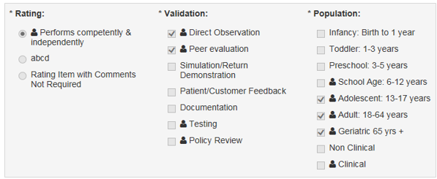
To complete the task, simply review the checklist and provide any additional comments in the available text box, then click Sign. A PDF of the checklist is created and saved to the employee profile. That PDF shows the same information as the form – feedback from both employee and manager/validator.

Refuse to Sign
A Refuse to Sign option is available that provides employees with the ability to refuse to sign off on a completed checklist.
When this option is enabled for an employee, an additional Refuse to Sign button is available at the bottom of the checklist form when performing their Checklist - Sign Off task. Clicking this button sends the checklist to the manager without signing off.
Employees can still leave Comments even if they refuse to sign off on the checklist. Any text entered into the Comments field is displayed to the manager.
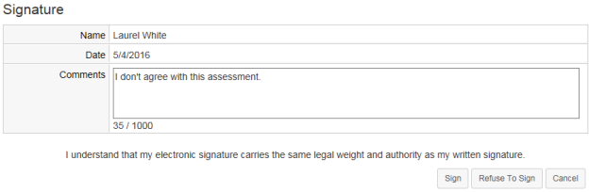
When an employee refuses to sign off on a checklist, the form is sent back to their manager as a Refused to Sign: Checklist task. Managers are required to review the form and sign off to complete the task. The Signature section of the form notes that the employee selected the Refuse to Sign option for the checklist, and displays any comments left by the employee.

Feedback
Feedback provides a way for managers to evaluate and inform employees of their performance and create action plans. Feedback is also a way to increase interaction between managers and employees, ensuring performance is on par with expectations and potential. The Feedback page is where you can send any praise, instruction, or warnings, via the Feedback form. Complete the form, then select the desired routing option to officially submit your feedback.
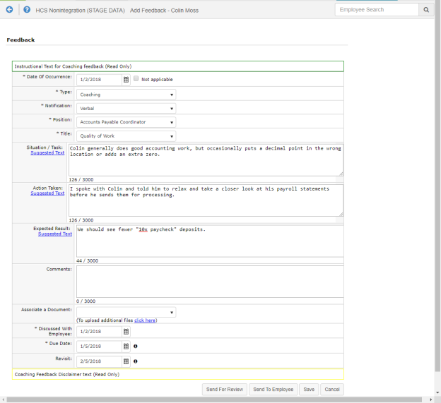
To access the Feedback form for a specific employee, navigate to your Employee List. Locate the desired employee in the list, then select Feedback, found under the Add drop-down menu. This displays the Feedback page.
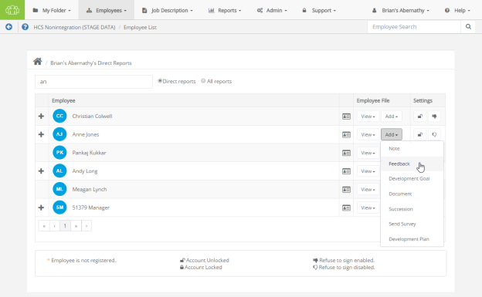
Feedback types
There are three types of feedback:
- Positive. Used to praise employees for quality work efforts.
- Coaching. For those occasions when an employee requires additional training or instruction. Coaching isn't necessarily negative feedback; rather, an opportunity to improve.
- Corrective. Used when an employee has performed poorly, disregarded policies, etc. Corrective feedback is required to be reviewed by Human Resources before it is sent to the employee.
Employees receiving feedback from their manager are assigned a task to review and comment on the feedback. Managers then review employee comments and sign off, at which point a PDF of the feedback is added to the employee's record.
Note: Employees may respond to feedback issued by their managers, but they can not initiate feedback to their managers.
Feedback status
The status of a feedback item helps identify where it is in the workflow process.
- Pending. Feedback has been created by manager, but not sent to employee or routed.
- Routed. Manager has sent the feedback to a routing user for approval.
- Routing Approved. Routing has been completed and the feedback is with the manager to complete the routing by sending it to the employee.
- Employee Review. Feedback has been sent to the employee for review.
- Manager Review. Employee has either signed the feedback with comments or rejected the feedback.
- Closed. Task/workflow is complete.
Feedback Routing Options
Send for Review. Submits the feedback to any applicable stakeholders (i.e. Managers) for their review and further action.
Send to Employee. Submits the feedback to the Employee for their own review and further action.
Save. Saves the feedback form as a draft, but does not submit it.

Refuse to Sign
A Refuse to Sign option is available that provides employees with the ability to refuse to sign off on feedback left by their manager.
When this option is enabled for an employee, an additional Refuse to Sign button is available at the bottom of the feedback form when performing their Review Feedback task. Clicking this button sends the feedback to the manager without signing off.
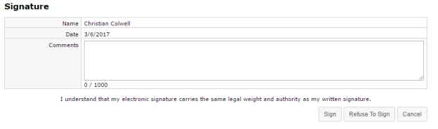
Employees can still leave Comments even if they refuse to sign off on the feedback. Any text entered into the Comments field is displayed to the manager.
When an employee refuses to sign off on feedback, the form is sent back to their manager as a Refused to Sign: Feedback task. Managers are required to review the feedback form and sign off to complete the task. The Signature section of the form notes that the employee selected the Refuse to Sign option for the feedback, and displays any comments left by the employee.
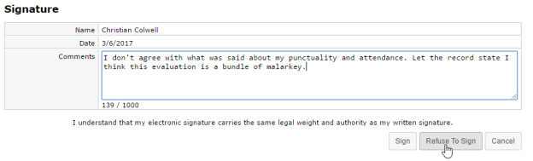

Reviewing Feedback (employee)
A Feedback task is created for employees receiving feedback from their manager. This task requires the employee to review, comment, and sign off on the feedback.
- Click the link for the feedback task in the Tasks table. The feedback form opens.
- Review the comments left by the manager.
- In the Signature section, enter any comments necessary into the Comments text box. These comments are visible to the manager that left the feedback.
- When finished review and commenting on the feedback, click the Sign button.
Clicking the Sign button signs off on the feedback and sends it back to the manager for review. Managers are then required to review any comments left by the employee and sign off on the form. Feedback is then added to the employee's record.

Reviewing Feedback (routing user)
A task is created for users that have been selected to review feedback left for an employee. This task requires the user to review, comment, and sign off on the feedback. It is then returned to the manager for review, then sent to the employee.
- Click the link for the feedback task in the Tasks table. The feedback form opens.
- Review the comments left by the manager.
- Make any necessary edits to the form.
Note: The ability to edit routed feedback forms is controlled by system-wide settings. You may not have the ability to edit the form, only comment and sign off.
- In the Correspondence section, review the manager comments and add any additional comments in the Response Comments field. Comments left in this field are only viewable by the manager, not the employee.
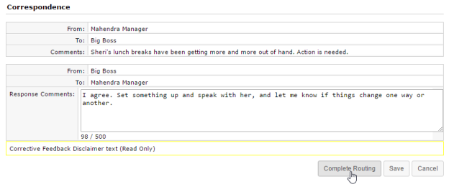
- When finished review and commenting on the feedback, click the Complete Routing button.
Clicking the Complete Routing button signs off on the feedback and sends it back to the manager for review. Managers can then send the feedback to the employee for review.

Document Sign Off
The Document Sign Off feature provides a way for organizations to route specific documents, such as organizational policies, to employees for review and acknowledgment.
The feature runs on schedules that assign tasks to employees, just like other performance activities like appraisals and 360 reviews. Once documents are reviewed and acknowledged by the employees, the signed documents are listed in the Signed Documents table on the Documents page in employee profiles.
Assigning documents to be signed must be handed by an Admin user, using Document Review Schedules to assign document review tasks to individual users, users in a particular role, new hires, or other applicable user groups. When a document review schedule has been assigned, it appears as a task on the user's Task List.

Signing off on Documents
When a Document Sign Off schedule activates, tasks are immediately sent out to the employees. Selecting this task from the Tasks table opens a new page that displays the document that requires review, along with a Signature area containing the employee’s name, the current date, and a Sign button.
Clicking Sign acknowledges that the employee has reviewed the document, and marks the task as complete. The document is then stored in the employee’s record under My Folder on the Documents page.
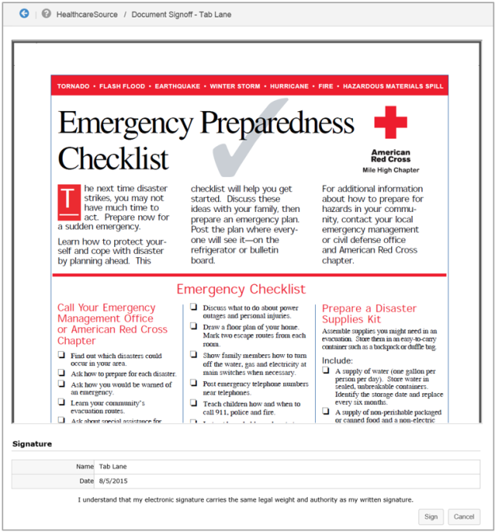
If you're a system administrator and need to schedule a document review task, please refer to the Document Schedule Administration page for additional details.

