Manager Guide
Performance Manager
Effective 2/14/2022

Contents
Getting Started 4
System requirements 4
Mobile Support 5
New user registration 6
Interface Basics 9
Navigation areas 10
Employee search 10
Help menu 12
Inline help 12
User menu 13
Tasks 15
About the Tasks page 15
Completing tasks 20
Employees 22
Employee List 22
Validate 23
Comparing employees 24
Performance Vitals 25
Job Descriptions 36
Reviewing a Job Description 37
Performance Goals 38
Adding goals 38
Copying goals 39
Distributing goals 41
Reviewing and approving goals 41
Assessing goals 42
Updating goals 42
More about Performance Goals 44
Notes 44
Adding notes to goals 45
Notifications 46
Weighting 46
Check in tasks 48
Department goal forms 48
Development Goals 49
About the Development Goal form 49
Adding Development Goals 50
Reviewing Development Goals 51
Refuse to Sign 52
Appraisals 53
Completing a manager appraisal 53
Assigning a multi-rater appraisal 55
Completing a multi-rater appraisal 57
Routing appraisals 58
Assigning a self appraisal 60
Completing a self appraisal 61
More about Appraisals 62
Reassigning Appraisals 62
Rejecting Appraisals 63
Routing Users 63
Recognition and Remarks 64
About the Recognition form 65
Anonymous Recognition 67
Approving Recognition 68
Batch Recognition 70
Requesting Recognition 71
Responding to Recognition requests 73
Sending Recognition 74
Viewing Recognition 76
Checklists 79
About the Checklists form 79
Completing skills 81
Closing checklists 81
Self assessments 82
Assigning a self assessment 83
Feedback 84
About the Feedback form 86
Adding Feedback 88
Reviewing Feedback (routing user) 91
Refuse to Sign 92
Notes 93
Compensation 95
About the compensation workflow 95
About the compensation worksheet 96
Completing a worksheet 100
Approving a worksheet 102
More about Compensation 102
Worksheet view options 102
Approvals 104
Batch actions 104
Notes 106
Reports 107
Available Reports 107
Viewing reports 109

Getting Started
Welcome to Performance Manager! Your company has chosen one of the most powerful, versatile, and easy-to-use performance management systems available for the healthcare industry today.
Before diving into Performance Manager, let's review system requirements and some basic concepts about general system use to help you understand system workflows, navigation, and functionality.
- System requirements. Make sure you have the latest and greatest browsers so you're able to take full advantage of all the features and functionality we offer.
- Interface basics. The navigation bar provides all the links and icons to features you need so you can locate information and get work done quickly.
- New user registration. You'll need to register before you can log in, so start here. It's done in a few simple steps.

System requirements
At HealthcareSource, our goal is to provide the best possible user experience across the wide range of desktop and smart device browsers. To achieve this goal, we prioritize supporting browsers with the most advanced technology. Our solutions are designed to function with the browser versions we’ve identified in the chart below as A-Grade — we actively test on these browsers to optimize user experience.
HealthcareSource recognizes that some legacy browsers, which we’ve identified as X-Grade, don’t provide the technology needed to deliver new features with a modern user experience. In order to continue providing the best solutions and support, we’ve decided to discontinue support for these X-Grade browsers.
In addition, there are browser versions for which we provide limited support, identified below as C-Grade. While we don’t regularly test this set of browser versions, customers have found them to work well with our software. Problems reported with these versions may be addressed, but we cannot make specific commitments as to if or when a fix will be available. In some cases, we know of select features or functionality that don’t work with these browsers. We do our best to document those cases and make this information available upon request.
By prioritizing A-Grade browsers and discontinuing the support of X-Grade browsers, HealthcareSource can release features more frequently, provide better support, and resolve issues faster.
Please contact support@healthcaresource.com if you have questions on browser support. We’re constantly upgrading our solutions to make them more browser agnostic. This work is ongoing and incremental, and we’ll notify customers when browser support changes.
A-Grade | C-Grade | X-Grade
Optimal user experience  HealthcareSource actively tests all A-Grade browsers and reported bugs are addressed with high priority. | Adequate user experience  HealthcareSource tests a sampling of C-Grade browsers periodically and reported bugs are addressed with high priority. | Not supported  HealthcareSource does not test X-Grade browsers or address reported bugs. There may be limited user experience.
Microsoft Edge*  Google Chrome* | Mozilla Firefox*  Apple Safari* (mobile only) | Microsoft IE 11 and below  (effective July 2021)  Browsers not listed are X-Grade

*Latest versions
Notes:
- HealthcareSource Hiring System supports Apple Safari (mobile only) as A-Grade across the application and explicitly blocks X-Grade browsers.
- HealthcareSource eLearning Library partner content varies by partner and isn’t implicitly compatible with the browsers listed above.
- Clients using reporting in Position Manager 11 will experience optimum performance using Chrome or Edge.
- The video conferencing feature in both HealthcareSource Hiring System and Position Manager does not work in IE11. Chrome or Edge is recommended.

Mobile Support
HealthcareSource supports mobile in many areas within our applications, notably throughout candidate workflows. The following table outlines specific areas within each product where mobile is supported.
Product | Areas where mobile is supported
Position Manager | Career Site, Profile Creation, Apply, Onboarding
HealthcareSource Hiring System | The application is mobile-responsive and any device using one of the supported browsers will work.
Job Board | The application is mobile-responsive for all areas except the administrative module.
Assessments (HSA, HLA, HRA) | The application is mobile-responsive and any device using one of the supported browsers will work.
HealthcareSource Recruitment Marketing – Source & CRM | Talent Network
HealthcareSource Recruitment Marketing – Career Site | Career Site
NetLearning | The learner experience is mobile-responsive. Course content may or may not be mobile-responsive depending on the course's design.
Performance Manager | Task List only

New user registration
As with most software solutions these days, Performance Manager requires a username and password in order to log in and access the site. But what if you’re a new user and don’t have either of those things yet? No worries. A quick registration process is all that’s needed for you to retrieve your username and create a password so you can log in and get stuff done.
Let’s dive in, shall we?
- Click the Register link on the main login page for Performance Manager.
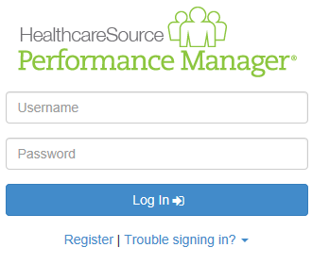
- The page reloads and asks for your First Name, Last Name, and Employee ID number. Enter these into the text fields and click Next.
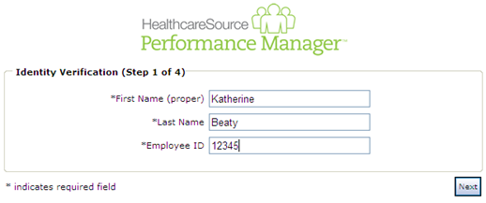
- The next form asks for your Username. Make sure to enter a username that follows the guidelines set by your organization. Click Next when finished.
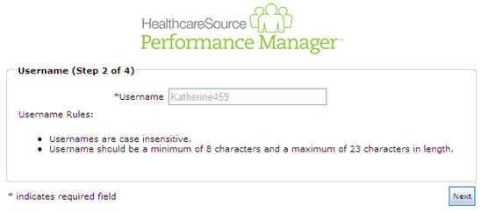
- Next up is the password. Enter a password for your account and confirm it, making sure to follow those guidelines again. Click Next when finished.
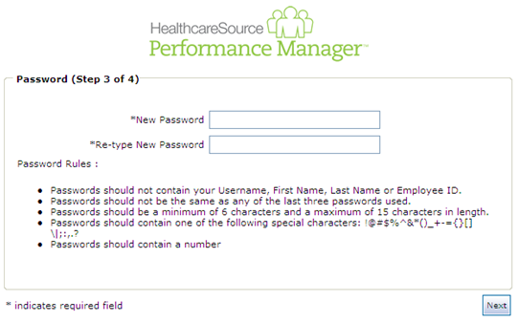
- Last step is the security questions. Security questions are used to help you retrieve your username and/or password in the future if you should ever have trouble remembering. Three default questions are selected, but you can choose different ones from the drop-down lists. Make sure to select questions and provide answers that you can remember!
When you’ve completed all the necessary fields, click Next to complete the registration process.
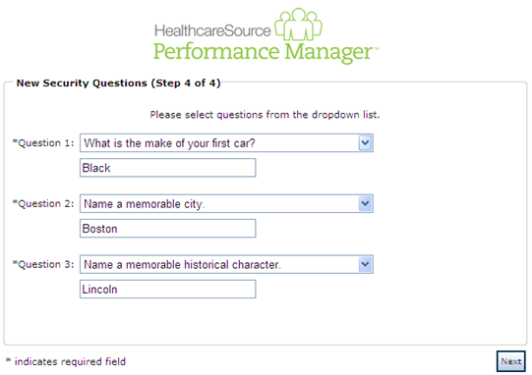
The page reloads again to display a message stating you have successfully registered. Nice job! You can now click the available Login button to return to the main login page and log in using the displayed username and password you just created.

Interface Basics
The navigation bar found at the top of the screen in Performance Manager contains all the links and icons for accessing the various areas and features of the system. From the drop-down menu items to the icons and breadcrumbs in the lower bar, this provides an easy way to get to the features you need.
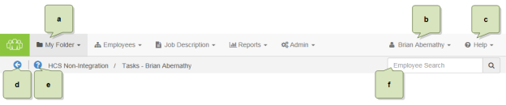
- Available areas. The main items in the navigation bar allow you to access different features throughout Performance Manager. Access to these items are controlled by system-wide permission sets, so you may not see all the options listed here. In fact, most employees only have access to the My Folder item.
- User menu. The user menu is the one that has your name on it - so hopefully it's pretty obvious which one we're referring to. This menu provides access to several Settings pages that control your account security and other system options, along with the system's Log Out link.
- Help menu. The Help and Release Notes options under this menu item launch the online help system in a new browser window or tab. The selected option determines which page of the online help system is displayed once opened. Clicking the Support option takes you to the HealthcareSource Community Support portal.
- Back button. This button merely takes you back to the previous page you were viewing. We recommend using this button instead of your browser's Back button when navigating around Performance Manager.
- Inline help. The icon opens the inline help window for the page you're currently viewing. These windows provide smaller chunks of help material so you can get past those sticking points without having to dive into the full help system for answers.

Navigation areas
The main navigation bar has several menu items containing the various functionality for Performance Manager. Access to the items is controlled by system-wide permissions, so chances are you won't see all the items listed unless you're an administrator for the system.
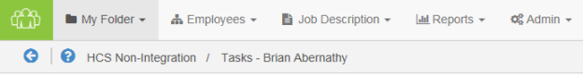
- My Folder. This is the one item that all users have. The pages under this area contain employee profile information and provide easy access to appraisals, checklists, feedback, and other items saved to your profile.

Employee search
The Employee Search field in the navigation bar provides a way for both managers and administrators to quickly locate and view employees. The field always appears in the navigation bar no matter which page you are currently viewing, and automatically begins displaying search results once three (3) characters have been entered.
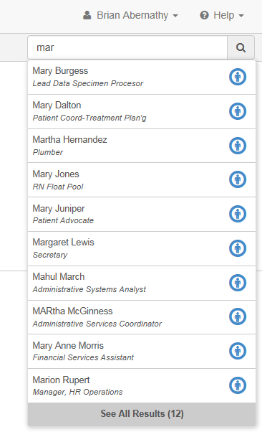
Searches are performed against employee names (first and last) as well as employee IDs. Clicking an entry from the list of results opens the Tasks page from the profile of the selected employee.
If your entered search criteria returns more than 10 matches, or you're looking for a terminated employee that does not appear in the drop-down list, the Additional Results link at the bottom of the list opens a new results page that lists all employees matching your criteria. This page includes an option to Include Inactive Users that, you guessed it, shows any inactive user that matches your search.

Help menu
The Help menu in the navigation bar provides quick access to pages found in the online help system. Clicking any of the available links launches the online help system in a new browser window or tab and displays the topic for the selected option.
- Help. Opens the help system to the home page, from which you can perform a search for topics, download user guides, or browse the available content.
- Release Notes. Opens the help system to the Release Notes topic, which lists feature enhancements and bug fixes we've delivered over the given time periods.
- Support. Takes you to the HealthcareSource Community Support portal, where you can search our knowledgebase of articles and submit support tickets.

Inline help
Inline help was created as a way to provide targeted bits of information that assist you in performing necessary tasks or functions within Performance Manager without having to dig through pages of information in online or printed user guides. Inline help delivers condensed chunks of user assistance that only relate to the page currently being viewed so you get the help you need now.
Clicking the icon next to the breadcrumbs in the navigation bar opens a pop-up window within Performance Manager itself - not a new browser window or tab - so you can view necessary information about features or procedures without having to switch back and forth between multiple windows. Viewing assistance information in the same window as the feature you're trying to use makes it easier to get past those sticking points.
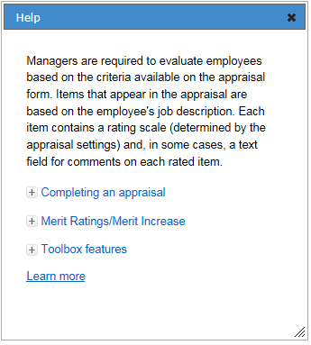
Another great thing about these inline help windows is that you can move them around the page and still interact with Performance Manager in the background. Open up an inline help window so you can see the steps necessary to complete your task, and click along in Performance Manager as you walk through the procedure. You can also resize the inline help window so it's never in the way.
Finally, if you're feeling particularly curious, clicking the Learn More link in the inline help window opens the full online help system for Performance Manager where you can view more detailed information about the feature(s) in question and all other areas of the system.

User menu
The user menu provides access to several settings pages that control security for your account and how certain features in Performance Manager operate. There's also a link for logging out of the system completely.
Selecting the Settings option opens the Change Password page by default. Additional pages can be viewed by selecting an option from the Settings drop-down list.
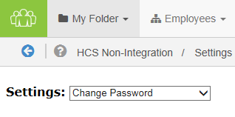
Change Password
Need to update your password? You're in the right spot. This page has the typical fields necessary for creating a new password for your account.
Make sure to review the rules listed when entering a new password, and definitely don't forget to click Save when you're done.
Note: Recovering a forgotten password (or username) is handled using a different process available on the system's Login page.
Change Security Questions
Another page to help beef up your account security. These security questions help you retrieve forgotten usernames and/or passwords should you ever forget and can't log into the system.
Each of the three questions uses a drop-down list of pre-set questions. Select one, provide an answer, and move on to the next.
Finished with picking and answering the questions? Click Save. All done.
Enable Appraisal Auto Save
Don't you just hate it when you're working on something and your computer decides it's time to freeze up on you and you lose the last hour or so of work? Who has time for that?
Fear not. Check the Enable Auto Save option on this page, and your appraisals will automatically save as you're working on them. So even if your computer takes a nap, you won't lose all your work.
Enter Email Address
People move all the time, so constantly need to update their mailing address. Well, same thing goes for email addresses. You probably don't change your email that often, but if you ever do, this page lets you update both your work and home (personal) email address.

Tasks
Performance Manager simplifies the employee performance management process by automating the workflow and content for performance appraisals, job descriptions, skills, goals, succession planning, and performance reporting. These automated processes are driven by specific tasks assigned to employees.
The Tasks page (found under the My Folder drop-down menu) lists all the tasks that have been assigned to you in Performance Manager. It provides a searchable, filterable, sortable table that makes it easy to browse, locate, and complete your various tasks and assignments.
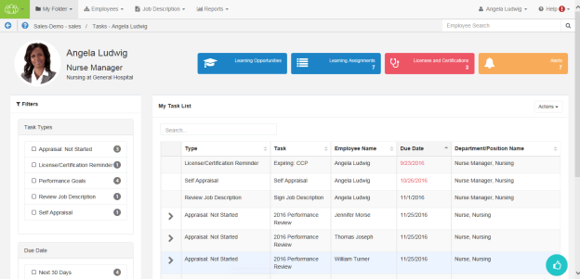
Most features of Performance Manager have associated tasks so employees know when they are required to complete work in the system. Notifications are also sent when tasks are assigned, so users don't need to continually log in to check for new assignments.

About the Tasks page
The Tasks page under My Folder displays a list of all the tasks you have been assigned. This table provides a way to easily locate and complete necessary tasks.
The interface provides information at a glance, and several ways to filter the Tasks table in order to locate specific items.
Employee Profile header
The Employee Profile header displays key information and provides quick links to take action on the listed items. A color-coding system for items delivers additional quick-view indicators so it’s easy to see when it’s time to review and update profile information.
Available areas in this header include:
- Employee and Position information. This area displays the employee name and position. Scroll arrows are available when an employee has multiple positions.
- Licenses and Certifications. This tile shows how many Licenses and Certifications reside in the employee’s profile. A green background indicates everything is up-to-date; red background means there’s items that have a renewal date upcoming or past due. Clicking the tile opens a table view that lists items under the header.
- Learning information. Available to clients with integrated NetLearning functionality, these areas provide access to NetLearning widgets for enrolled and available courses and classes. The Learning Assignments tile also displays the number of current assignments for the employee.
- Task Alerts. Displays the number of overdue tasks in the task list. Clicking this tile in the header opens a new page that lists the overdue tasks.
Filters and Search
The new Taskspage lists available filters in their own area to the left of the Tasks table. Filters include options forTask Type and Due Date.
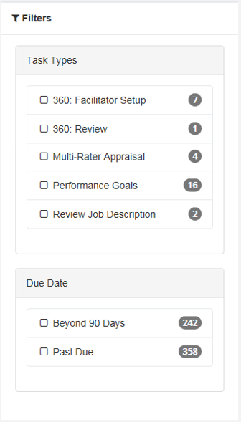
Managers also have access to anEmployee Statusfilter that allows them to view tasks for inactive employees.
The items listed in each set of filters displays a number that indicates how many tasks match that specific filter. Clicking the checkbox next to an item filters the results shown in the table.
Right above the table is a Search field that allows you to search for specific tasks in the list. This field is a type-ahead field, so the table automatically begins to filter down with each character entered into the field. This field searches across numerous fields for tasks.
Tasks table
Tasks are opened by clicking anywhere in their row. Tasks with associated sub-tasks display an arrow that, when clicked, expands the row to display the related sub-tasks.
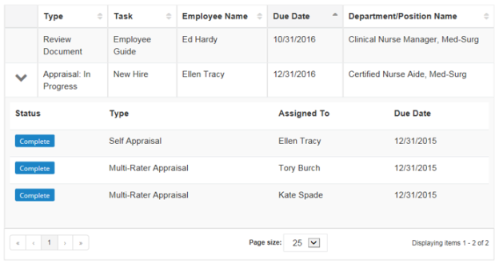
The tasks table can be sorted by almost any of the available columns to help you quickly locate tasks. Simply click on the column heading to toggle between Ascending, Descending, and Off.
The column currently being used for sorting is indicated with a gray background fill. By default, the table is sorted by Due Date.
Actions menu
The Actions menu contains options to Reassign Tasks, Send Self-appraisals, Send Multi-Rater Appraisals, and Assign Delegates. Selecting an option from the Actions menu opens a wizard that walks you through the steps necessary for the selected action.
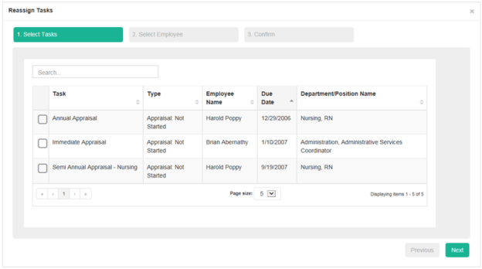
Note: Only managers have access to this Actions menu.
Recognition and Remarks
Recognition and Remarksis a commenting system that allows employees to send input to other employees about a recent exchange or behavioral observation at any time - not just when requested or during annual review periods. Its feedback form provides fields for selecting employees, associating specific values, and general comments for feedback.
Hovering your cursor over theRecognition and Remarksicon in the lower-right corner of the page displays additional feedback options, including:
- My Recognition. Displays all of your received recognition.
- Recognition Approvals. For managers only; displays a list of recognition sent to your employees anonymously.
- Request Recognition. Allows you to send a request for input from specific employees.
- Received Requests. Lists any requests for input you have received from colleagues.
- Send Recognition. Opens the form used to send recognition to a colleague.
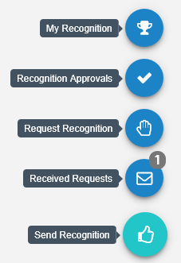
Note: Depending on your system's settings, theEmployee Journalmay also be included with these feedback options.
Employee Journal
TheEmployee Journal is a quick and easy way to keep your own written record of events and accomplishments that happen throughout the year. Using the journal allows you to quickly jot down a summary of events and activities, then reference them just as quickly whenever you need. Keep track of your training seminars, conference attendance, or any quick activities you want to remember, all within your own personal profile.
TheEmployee Journalicon is found in the lower-right corner of theTaskspage.
Note: Depending on your system's settings, theEmployee Journalmay either be grouped in with theRecognition and Remarksfeedback options, or displayed independently.

Completing tasks
The Tasks page in Performance Manager provides an way to quickly locate and complete necessary tasks.
- From the Tasks page, locate the desired task from the table.
- Click anywhere in the task's row. This opens the page necessary to complete the task.
The type of page that displays after clicking a task depends on the type of task selected. After completing the necessary actions for the task, it is marked as Complete and removed from your task list.

Employees
The Employees area in Performance Manager provides managers with quick access to information regarding their employees' professional development. This includes features such as goals, checklists, and learning. The information gleaned within these pages enables you to make data-driven decisions about how certain employees have been performing, and continue guiding them on the best path to success by adding and assigning new development goals as needed.
The available pages under the Employees tab include:
- Employee List. Lists employees you can access, such as direct reports. Provides links to view employee profile pages.
- Validate. Lists all checklists for employees that you can access and modify.
- Development. Provides views of available development goals, development plans, and assessments that can be assigned to employees.
- Performance Goals. Provides a way to add new goals and assign goals to multiple employees. Lists available performance goals, and also tracks and evaluates employee performance across the organization.

Employee List
The Employee List page under Employees provides managers with quick and easy access to the profile pages of their employees. Only managers and system administrators can access the Employee List page.
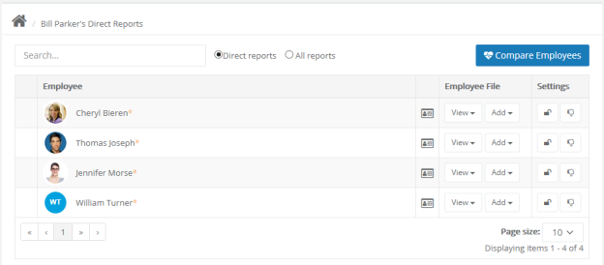
The table on the page displays all of your direct reports, as well as any of their direct reports as well. A plus sign icon () next to an employee indicates they have direct reports. Clicking this icon reloads the table to display all the direct reports for the selected employee.
A search field is available that provides a partial-word search on employee names. The table is automatically filtered based on each character that's entered into the search field. Additional options provide the ability to display only Direct reports, or show All reports (your direct reports AND their direct reports) listed together.
Employee File
Each employee in the row has an Employee File column, containing two drop-down menus:
- View. This split button provides two ways to view the available pages in the employees folder. Clicking View opens the employee's Performance Vitals page, while the down arrow opens a list other pages found in the employee's profile.
- Add. This menu provides a way to quickly add new items to an employee's profile without having to first visit that specific page. For example, selecting Feedback from the menu opens a blank feedback form. When completed, it is added to the employee's profile.
Settings
The Settings column contains two action buttons:
- Account locking ( ). This button toggles between locking and unlocking an employee's account. Employees cannot log into Performance Manager with a locked account.
- Refuse to sign ( ). This allows you to toggle the employee's refuse to sign privilege.

Validate
The Validate page under Employees provides a way for managers to view all checklists assign to employees that they can access. The table displays the name of the checklist and assigned employee, as well as a percentage complete for the individual checklists.
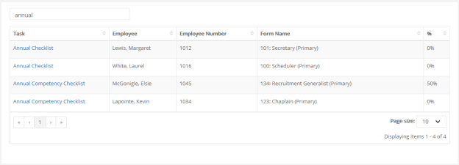
Selecting a checklist from the table opens that checklist form where you can then make any necessary edits.

Comparing employees
Comparing employees allows you to view their vital information side-by-side for easy evaluation. Up to 6 employees can be compared at a time.
These steps take place from the Employee List page.
- Click the Compare Employees button.
- Click the checkbox next to the employees you wish to compare. As you select employees, they are added to the Selected Employees area to the right of the table.
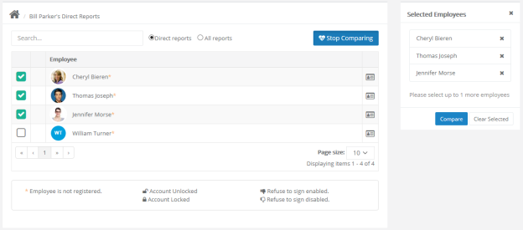
- Click Compare in the Selected Employees area when finished selecting employees.
The comparison view opens, showing the selected employees in a side-by-side format.
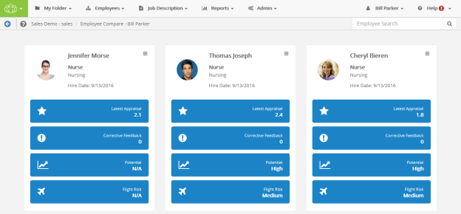
Employee cards can be re-ordered by dragging them to their desired position using the icon in the upper-right corner of the card.

Performance Vitals
Performance Vitals is a summary page that provides an overview of all performance-related information for an employee. Each area of an employee’s profile is represented with a summary card displaying pertinent data for that area, and a configurable set of tiles at the top of the page highlight the most relevant parts of their profile.
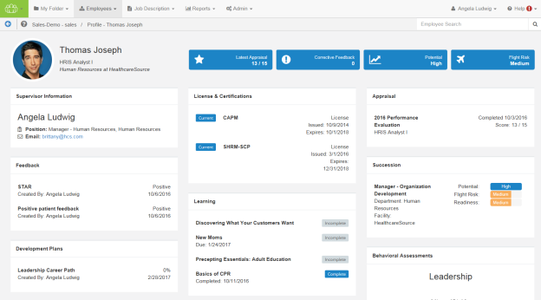
This single-page view for employee data includes informational cards for all the major features available within Performance Manager, as well as pertinent information from NetLearning for integrated clients.
Additional integrations with HealthcareSource solutions allows you to access Performance Vitals from within Position Manager as well. This allows necessary users, such as Hiring Managers, to easily access performance data on internal applicants, removing the need to contact managers for that information.
Accessing Performance Vitals
Performance Vitals is only available to Managers and Administrators.
The View menu on the Employee List page contains a Vitals option that opens the Performance Vitals page for the selected employee.
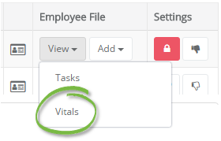
Administrators are also able to access Performance Vitals from the All Employees area under Admin. Once an employee has been selected and loaded, a Vitals option is available when viewing the employee profile.
Employee Profile header
The employee profile header at the top displays the employee name and picture (if available), as well as their current position, department, and company. (For employees with multiple positions, Performance Vitals shows their primary position at the organization.)
The tiles display key performance and profile information at a glance. Though only four tiles can display in the employee profile header at a time, there are several available tiles to choose from:
- Appraisals. Shows the results from the most recently completed appraisal. Depending on the evaluation method used, this tile displays the Merit Rating, Total Weighted Average, or Total Score.
- Development Plans. Displays the completion percentage from the most recent development plan.
- Feedback. Displays the number of corrective feedback items added to the employee’s profile.
- Flight Risk. Shows the employee’s flight risk rating from succession.
- Learning. Displays the number of incomplete learning assignments from NetLearning.
- Potential. Shows the employee’s potential rating from succession.
- Recognition and Remarks. Displays the number of feedback items left for the employee.
Informational Cards
The informational cards on the Performance Vitals page contain overview information for the various areas of an employee's profile. When cards have multiple entries, a scroll bar is added to the card so all the data can be viewed without having to increase the size of the card itself.
Cards appear on the page even if there is no information to display for that area. Instead of just showing a blank card, though, most cards include an option to jump to that specific page of the employee's profile to create and/or add content.
Informational cards are configurable, so you're able to determine which cards should appear on the Performance Vitals page for employees. There's no limit to the number of cards that can be included on the page.
Available cards include:
- Appraisal. Displays details from the latest appraisal for the employee, including the name of the appraisal, related position, completion date, and scoring results.
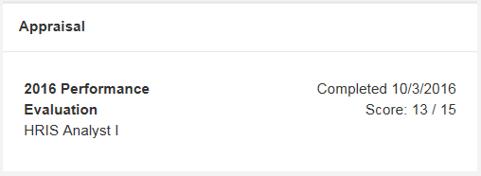
- Behavior Assessments. Displays the results of any assessment completed by the employee. A radar chart of the results helps define competencies for the employee, with overall scores available by hovering over the chart’s data points. Clicking the View Report link opens the PDF report from the assessment in a new browser window.
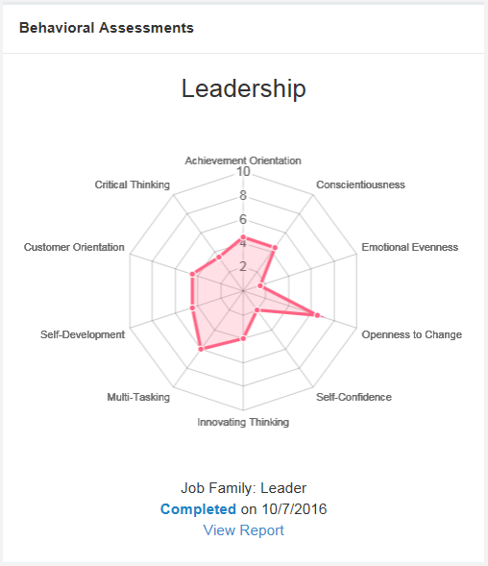
- Compensation. Shows all compensation cycles for the employee within the past year, along with a color-coded status of the cycle.
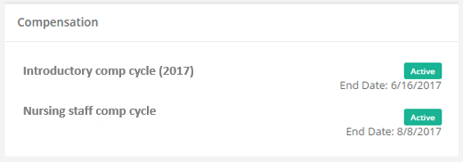
- Development Goals. Lists development goals the employee has completed within the past year, along with the goal's due date.
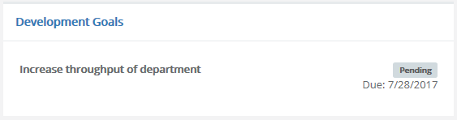
- Development Plans. Displays all development plans in the employee’s profile along with the overall completion percentage for each plan.
- Document. Lists documents that have been added to the employee's profile within the past year.
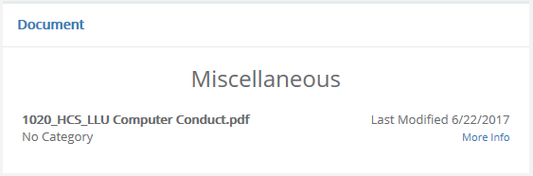
- Feedback. Displays all feedback items in the employee’s profile. Though tiles in the employee profile header only shows the number of corrective feedback items, this Feedback card shows details for all types of feedback left for the employee.
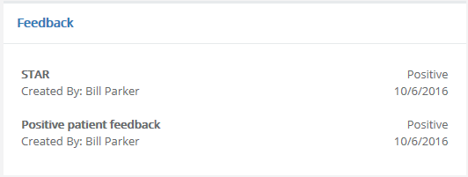
- Job Descriptions. Lists any job description the employee has signed within the past year and the date it was signed.
- Learning. Available for clients with integrated NetLearning solutions, this card displays a list of incomplete and complete learning assignments for the employee.
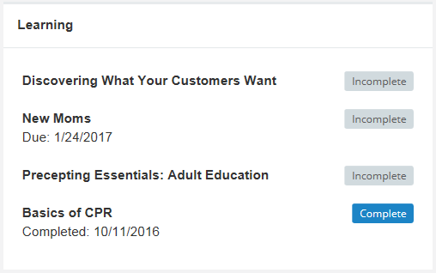
- License & Certifications. Shows the details of any licenses and certifications for the employee along with their current status.
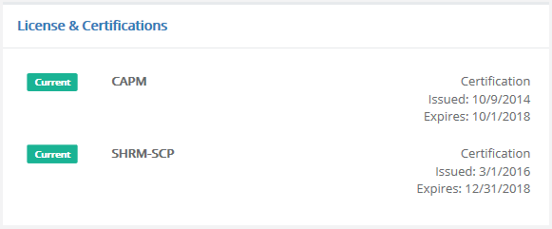
- Performance Goals. Lists performance goals the employee has completed within the past year, along with the goal's due date.
- Recognition and Remarks. Lists all the feedback left for the employee from the Recognition and Remarks feature.
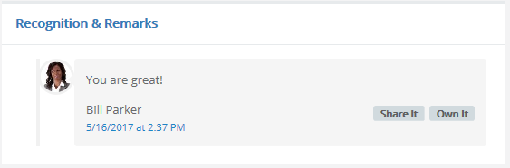
- Succession. Displays details from all available succession plans in the employee’s profile, including visual representations for Potential, Flight Risk, and Readiness for each plan.
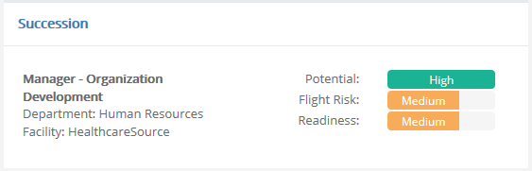
- Supervisor Information. Lists the employee’s manager and their position, department, and contact information (email and/or phone number). If an employee has multiple managers, they are all listed in this informational card.
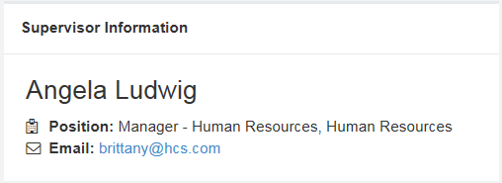
- Training & Assessments. Lists any training and assessment activities assigned to the employee within the past year, along with a color-coded status and any associated credit hours.
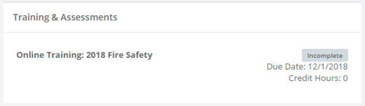
- 360 Review. This card displays any 360 reviews for the employee. The card includes the schedule title for the review, the applicable employee position, the status of the review, and a due date (if the review is still in progress).
Employee View
An Employee View option (found under the employee's name/position/location) provides a way to hide certain confidential informational cards when viewing the page with the employee present. This allows you to share necessary details of their file without disclosing sensitive data to the employee.
Enabling the Employee View option hides the following cards/information:
- 360 Reviews
- Assessments
- Compensation
- Flight Risk
- Potential
- Succession
- Removes Notes tasks from Feedback

Job Descriptions
Job descriptions in Performance Manager are detailed descriptions of positions at your organization. They typically include such information as duties and expectations for the job.
Every employee in Performance Manager is assigned to at least one job description, though it is also possible to be assigned to multiple job descriptions if necessary. Job descriptions are reviewed and signed off by both the employee and their manager. PDF versions of approved job descriptions are saved to employee profiles.
Managers can view job descriptions for employees using the Job Description area from the navigation bar.
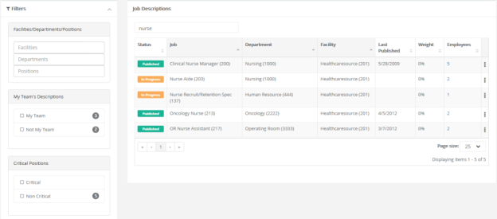
Employees are able to view their own job description from the Job Description page under My Folder. The table on this page lists all the job descriptions signed off by the employee and the date they were approved. Clicking the title of a job description displays its detailed description on a new page.
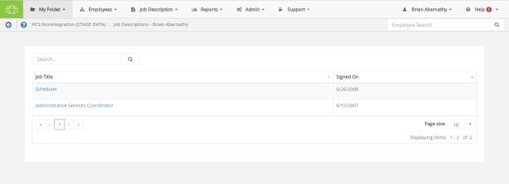
Only system administrators are able to manage positions and their related job descriptions, templates used to create job descriptions, and special forms used to populate job descriptions. In other words, if you need to draft a new job description, or edit an existing one, you'll need to work with your local administrators to set things up the way you need.

Reviewing a Job Description
Employees are required to review and sign off on all job descriptions they are assigned to in Performance Manager. Any time a new job description is assigned to an employee, they receive a task to review and approve that job description.
To review and approve a job description:
- Click anywhere within the Job Description task, in the table on the Tasks page under My Folder.
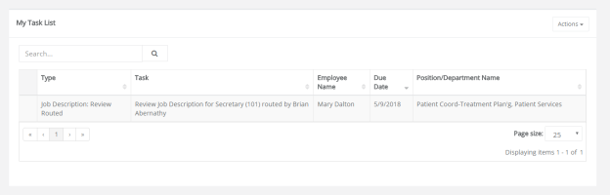
- Scroll down to review all the information contained in the job description.
- Click Sign button at the bottom to acknowledge your review of the job description.
Clicking Sign creates a read-only PDF file of the job description and places it in the employee electronic folder on the Job Description page.
Some employees may have the option to Refuse to Sign the job description based on their permissions. Refusing to sign a job description indicates that the employee has an issue with some information included in the description. Clicking Refuse to Sign allows the employee to send the job description back to their manager, with comments, for further review.

Performance Goals
Performance goals provide a way to track and evaluate employee performance across an organization. Corporate directives in the form of basic pillars are defined and subsequent goals for departments, facilities, and individual employees are aligned upwards.
Employees can view their performance goals on the Goals page under My Folder. Managers are able to view and assign goals to employees from the Performance Goals page under Employees.

Adding goals
Goals can be added by either a manager or an employee, depending on the options chosen when the appraisal is scheduled.
A Performance Goals task appears in the task list when you have been assigned a goal form to complete for the appraisal schedule. Clicking the link from the task list opens the Performance Goals page, where goals can be reviewed, added, and edited.
Goals can be created from scratch, or copied from previous goal forms. This topic covers creating goals from scratch.
Adding goals - Manager
For managers entering goals for their employees, the process is the same except for two additional fields found in the Add a goal pop-up window.
These steps take place from the Performance Goals page.
- Click Add option from the Actions menu above the Goals table. The Add a goal pop-up window opens.
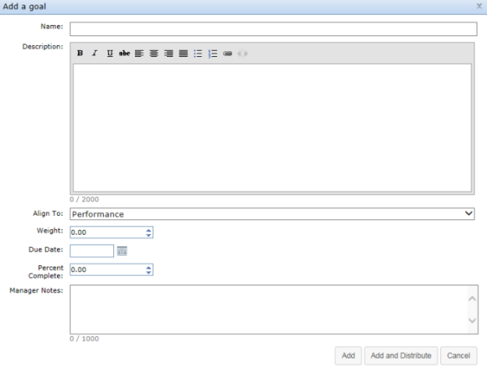
- Complete the fields in the Add a goal window as needed.
- Click the Add button when complete. The pop-up window closes and the new goal now appears in the list.
- Repeat steps 1 through 3 until all goals have been added to the table.
Once all the necessary goals have been added to the My Goals table, click the Send to Employee button under the table. The goals form is then sent to the employee for review.
Tip: Remember, if you are using weights for goals, the Total Weight for the goal form (shown in the upper right corner of the My Goals table) must equal 100%.

Copying goals
When adding goals, users have the option to create goals from scratch, or copy goals from previous goal forms.
Managers and employees can copy active, approved goals from previous goal forms. Only individual goals can be copied (no corporate goals).
Copying goals - Manager
These steps take place from the Performance Goals page.
- Click the Copy button above Goals table. The Select goals to copy pop-up window opens.
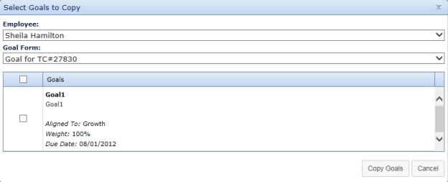
- Select an Employee from the drop-down menu. This determines which goal forms are available to copy goals.
- Select a Goal Form from the drop-down menu. A list of goals on the selected form loads in the table below.
- From the list of goals, check the box next to each goal you wish to copy.
- When a goal is selected, the Weight and Due Date field become editable. Make necessary edits to these fields.
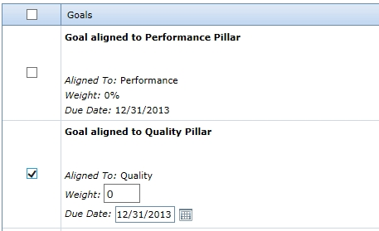
- Click the Copy Goals button at the bottom of the window when finished.
Clicking Copy Goals adds the selected goals to the goal form and closes the pop-up window. Additional goals can be created and/or copied to the goal form at this point.

Distributing goals
When creating new goals, the Add a goal pop-up window provides the option for managers to Add and Distribute the new goal to additional employees. Clicking this button opens a new Distribute Goal pop-up window where the manager can select individual employees and copy the goal to their forms.
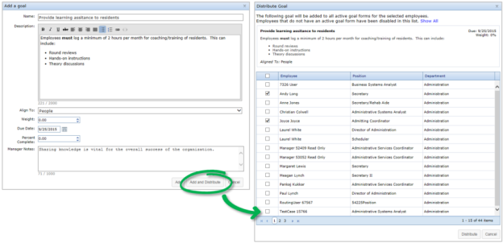
This Distribute option is also available from the main Goals form. Clicking this icon opens the same Distribute Goal pop-up window for selecting additional employees to assign the selected goal.
Note: Employees that do not have active Goal forms cannot be selected in the Distribute Goals pop-up window. Their rows are disabled. Disabled employees can be hidden from the table using the Hide Disabled link in the top of the window.

Reviewing and approving goals
After an employee submits their goal form, it is sent to their manager for review and approval. A Performance Goals task appears in the manager’s task list when they have been assigned a goals form to review for an employee.
Clicking the link from the task list opens the Performance Goals page, where goals can be reviewed, added, and edited.
The manager can make any edits they deem necessary to the employee’s goal form. This includes adding, removing, and editing goals.
Tip: Remember, if you are using weights for goals, the Total Weight for the goal form (shown in the upper right corner of the My Goals table) must equal 100%.
Managers also have the option to reject an employee’s submitted goals. When a manger rejects a goal form, it is sent back to the employee so they can make edits and re-submit the form.
When finished reviewing and revising the goals form, clicking the Approve button under the Individual Goals for [Employee name] table finalizes the process. The page reloads and displays the Tasks list, which no longer shows the task to review employee goals.

Assessing goals
Employee goals are evaluated and rated during scheduled assessments by managers. When managers complete assessment forms, a Goals section is included where they use the selected assessment scale to rate the employee against their defined goals.
No special steps are required to assess goals; simply select the ratings for the defined goals in the Goals section of the assessment form.
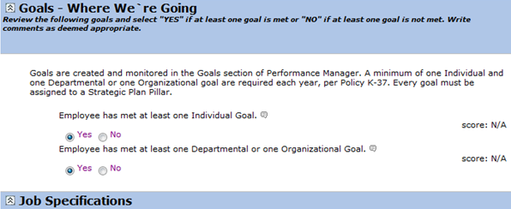

Updating goals
Updating a goal consists of either adding notes (both managers and employees) and/or changing the Percent Complete field for a goal (managers only).
Adding notes
Goal notes are added to individual goals from a goal form. Managers are able to add notes to employee goals, and employees can add notes to their own goals and respond to any manager notes.
An employee can reach their goal form by clicking the Goals link under the My Folder area in Performance Manager.
These steps take place from the goals form found on the Goals page.
- From the goal form, click the Show Notes link for the goal where you want to add a note. This expands the row and displays any previous notes that may have been left and provides a text box to add a new note.
- Type in text for the new note.
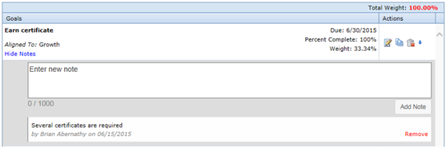
- Click the Add Note link under the text box when finished with the note.
The row reloads to show the new note has been added to the goal.
Updating Percent Complete
For a manager to update the Percent Complete field:
- From the Employees page, click the Goals link in the table for the desired employee. This opens the employee page.
- Click the link under the Performance Goals section. This opens the employee’s Performance Goals page.
- Locate the goal you wish to update and click the Edit icon. This opens the Edit a Goal pop-up window.
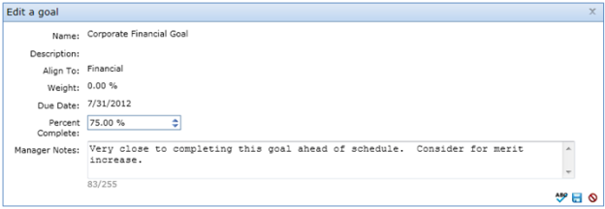
- Make the necessary changes to the Percent Complete field.
- Add any Manager Notes, if necessary.
- Click the Save icon when finished making changes.
Clicking Save updates the goal. Employees are able to view the updates made to their goals.

More about Performance Goals

Notes
Notes can be added to individual goals. Both managers and employees can add notes to a goal; only the person who created the note can delete it.
Notes can be used to keep track of important details regarding the goal, provide status information when updating completion percentages, or simply correspondence between an employee and a manager.
Notes are viewed by clicking the Show Notes link in the goal. The number of notes a goal has is indicated by the number in parenthesis next to the Show Notes link.
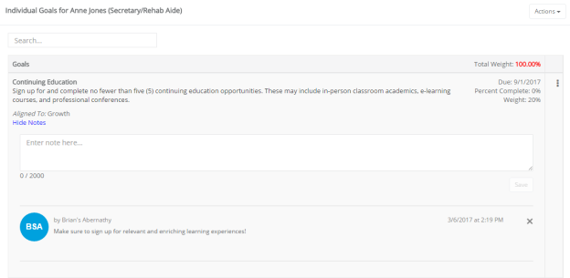
There are two types of notes that can be added to a goal:
- Manager notes. These are notes that are added to a goal when it is initially created, or when a manager returns to a goal form and edits an existing goal. Manager notes are not viewable by employees.
- Goal notes. Goal notes are notes added to individual goals that are viewable by anyone that has access to the employee goal form. Both managers and employees can create goal notes; only the person who created the goal note can delete it.

Adding notes to goals
Goal notes are added to individual goals from a goal form. Managers are able to add notes to employee goals, and employees can add notes to their own goals and respond to any manager notes.
An employee can reach their goal form by clicking the Goals link under the My Folder area in Performance Manager.
These steps take place from the goals form found on the Goals page.
- From the goal form, click the Show Notes link for the goal where you want to add a note. This expands the row and displays any previous notes that may have been left and provides a text box to add a new note.
- Type in text for the new note.
- Click the Add Note link under the text box when finished with the note.
The row reloads to show the new note has been added to the goal.

Notifications
In order to keep both employees and managers up to date with the progress of their goals in the system, automatic notifications are sent when certain actions take place.
- Manager approval of goals. When a manager approves an employee’s goal form, the employee is sent an email notification.
- Manager rejection of goals. Employees also receive a notification if a manager rejects their submitted goal form. This isn’t a notification of rejection; rather, when a manager rejects a goal form, the employee is re-assigned the task to enter their goals. Therefore, the employee receives a notification that they must enter their goals.

Weighting
The Goals module provides a weighting system for individual goals. This allows users to determine which goals hold more importance than others, or ones that may require additional effort to complete.
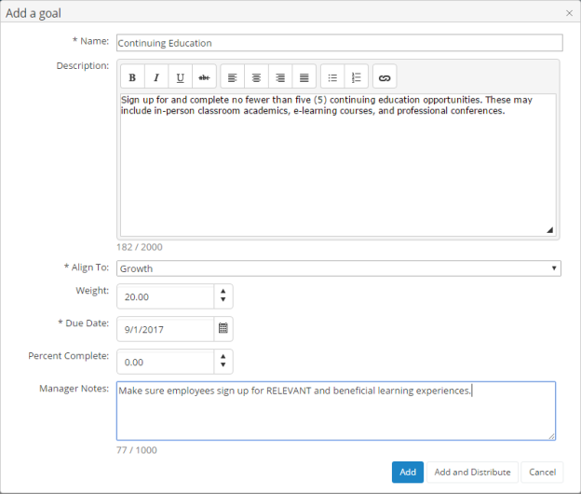
Individual goals can be assigned a weight when they are added to the system. When creating a set of goals for a user, the sum total of weight for all the combined goals must equal 100%. Users will not be able to submit their goals for approval unless the total weight equals 100%.
The Apply Weights Equally button allows you to quickly distribute weight evenly across the available individual goals.
It is not necessary to add weights to goals.
The weighting feature is an option for the Goals module. When the option is not activated, the “Weight” column does not appear in pop-up windows or goals tables. This option, labeled Show weights on Job Descriptions and Goals, can be found on the Settings page under the Admin area in the Choose Appraisal Options section.

Check in tasks
Check in tasks are reminders to review or update approved goals. They appear as tasks in a user’s My Tasks table in Performance Manager.
Check in tasks are created when setting up a new appraisal schedule, and are assigned before an employee's full appraisal. Employees are able to add notes to their list of goals when performing this task. Once finished, clicking the Dismiss button completes the task and removes it from the employee's task list.

Department goal forms
Goal forms are usually maintained by system administrators. However, managers have the ability to manage Department goal forms, providing them greater control over the goals set for their individual departments.
The Performance Goals page under the Employees area displays a table with all of the available department goal forms. Managers can add and edit goal forms from this table.
Clicking a link from the Name column opens the detail page for the selected form. Once a goal form reaches a Ready status, no more goals can be added to the form; however, existing goals can still be edited as needed.

Development Goals
Development goals are used by managers to encourage employees to improve and meet specific performance targets. These goals appear as tasks for employees to complete once the goal has been met.
Development goals can be found on the Goals page under My Folder. Updates to goals can be made by both employees and managers throughout the year.
Development Goals workflow
The basic workflow for development goals is as follows:
- A manager creates a development goal for an employee.
- The employee receives a task and completes the development goal.
- The manager reviews the employee's completion of the goal.

About the Development Goal form
The Development Goal form contains several fields for identifying and tracking the assigned goal.
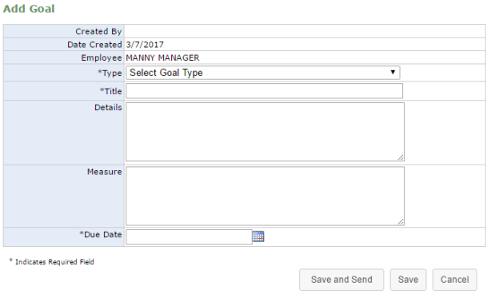
- Created By. The manager that created the goal for the employee.
- Date Created. The date the goal was added to the system.
- Employee. The employee assigned to the goal.
- Type. Drop-down menu with three selections for goal type:
  - Individual. These goals relate directly to the employee.
  - Departmental. These goals are related to goals set for the employee's specific department.
  - Organizational. These goals relate to the goals set for the overall organization. Selecting this option changes the Title field from a generic text field to a drop-down list that contains all available organizational goals.
- Title. Title of the goal. For Individual and Departmental goals, this field is a text box. However, when creating an Organizational goal, this becomes a drop-down field that lists all the available organizational goals, from which a selection must be made.
- Details. Details about the goal, which can include such information as why the goal has been created and what is hoped to be achieved.
- Measure. This details how success in meeting the goal is determined.
- Due Date. Sets the date by which the employee must complete the goal. It also serves as the due date for the task that is created for the employee.

Adding Development Goals
Managers can create development goals for employees at any time. There's no limit to the number of development goals that can be assigned to an employee.
These steps take place from the Employee List page under the Employees area.
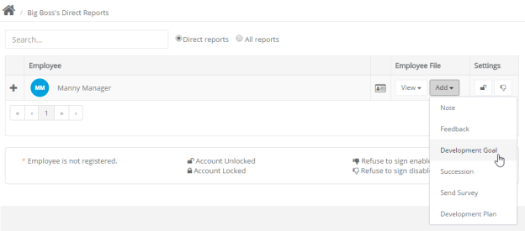
- Locate the desired employee from the list and click Add, from the Employee File column. This displays several options in a drop-down menu.
- Click the Development Goal option in the drop-down menu. The Add Goal page opens.
- Complete the form as necessary.
- When finished filling out the form, click the Save and Send button to send the development goal task to the employee for completion.
Clicking the Save button saves a draft of the goal and places the task in the manager's task list for completion at a later date.
Once the Save and Send button is selected, managers are only able to modify the Due Date for the goal.

Reviewing Development Goals
After an employee has completed a development goal task, the manager is assigned a task to review and finalize the task.
These steps take place from the Tasks page under My Folder.
- Click the link for the desired development goal task in the Tasks table. This opens the Goal page for the task.
- Review the information left by the employee in the Comments and Status areas of the goal form.
- In the Manager Evaluation area of the form, select a Status for the goal.
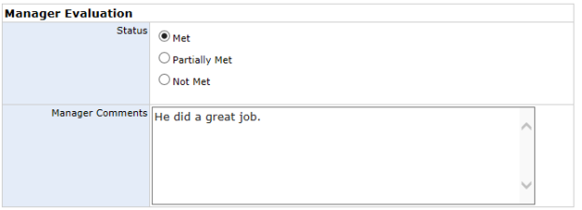
- Enter any additional Manager Comments as necessary.
- Click the Sign button.
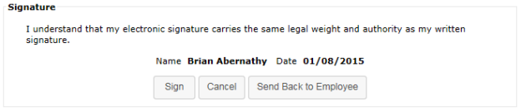
Clicking the Sign button completes the task. A PDF for the development goal is created and added to the employee's profile.
If the manager disagrees with the employee's evaluation of the task, clicking the Send Back to Employee button re-creates the goal task for the employee.

Refuse to Sign
A Refuse to Sign option is available that provides employees with the ability to refuse to sign off on developmental goals added by their manager.
When this option is enabled for an employee, an additional Refuse to Sign button is available at the bottom of the goal form when performing their Developmental Goal task. Clicking this button sends the feedback to the manager without signing off.
Employees can still leave Comments even if they refuse to sign off on the goal. Any text entered into the Comments field is displayed to the manager.
When an employee refuses to sign off on feedback, the form is sent back to their manager as a Refused to Sign: Goal task. Managers are required to review the goal form and sign off to complete the task. The Signature section of the form notes that the employee selected the Refuse to Sign option for the goal, and displays any comments left by the employee.
Managers have the option to Sign the goal form, which completes the task, or Send Back to Employee for further review and comment.

Appraisals
Appraisals in Performance Manager provide the ability for managers and employees to rate workplace performances based on the job description forms associated with their position. These appraisals are conducted on varying intervals depending on your company's own policy.
Appraisals provide a measurement of employee performance based on the benchmark criteria pre-established for their job. This differs from the 360 Review, which focuses more on the skills and contributions an employee provides to the workplace and their co-workers.
Manager appraisals are conducted to rate and comment on each of their individual employee's performance throughout the duration of the period. Employees conduct self appraisals and multi-rater appraisals to share their own beliefs and estimations on how their own— or their co-workers'— accomplishments stack up to what was expected of them throughout the evaluation period.
Appraisal types
There are three types of appraisals in Performance Manager:
- Manager appraisal. This is the basic employee appraisal form, based on a job description. Managers complete this evaluation form for all their direct-report employees.
- Self appraisal. Self appraisals are completed by employees in reference to their own performance. Self appraisals are reviewed with the employee's manager.
- Multi-rater appraisal. As part of 360-degree feedback in Performance Manager, multi-rater appraisals are completed by selected employees. Managers select which users conduct appraisals about their employees.

Completing a manager appraisal
As a manager, you are required to complete a Manager Appraisal for each of your employees. This allows you to rate and comment on employee performance throughout the appraisal period.
A Complete Appraisal task appears in your tasks list for each employee that requires an appraisal. There is often a due date listed by which you need to complete the appraisal.
These steps take place from the Tasks page under My Folder.
- In the Tasks table, locate and select the Complete Appraisal task. This opens the Appraisal type selection page.
- Select the Complete Manager Appraisal option and click Continue to open the appraisal form.
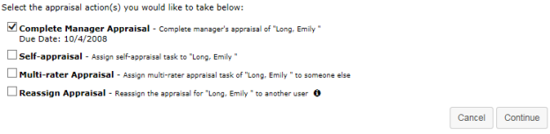
- Review each item on the appraisal form and provide a rating based on your opinion of the employee's performance.
Note: If self and multi-rater appraisals have been performed for the employee, feedback from those users (ratings and comments) appear for each item on the appraisal form.
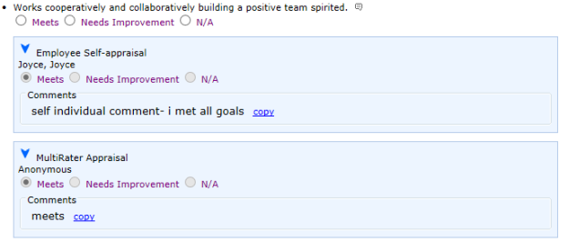
- You may be able to provide notes on individual items in the form by clicking the notes icon () for each item listed. This opens a large text field for you to enter additional comments on the appraisal item.
Note: If the notes area opens automatically when you select a rating for an item, it is required that you provide comments for that item.
- Select a Merit Increase for the employee.
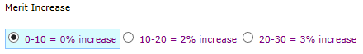
Note: When enabled, the system automatically recommends a merit increase based on the scores provided throughout the appraisal form. The recommended increase is highlighted, and managers may have the ability to override the recommendation.
- Provide any additional notes necessary in the Appraisal Comments area.
- Select a Date Reviewed with employee.
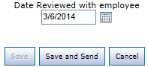
- Click the Save and Send button when finished.
Clicking Save and Send finalizes the appraisal. Depending on your company process, appraisals are either be sent directly to the employee for review and signature, or routed to other managers for review first.

Assigning a multi-rater appraisal
Multi-rater appraisals allow fellow employees to rate themselves. Employees selected for multi-rater appraisals are able to provide ratings and comments on items, which are reviewed by managers.
Multi-rater appraisals are assigned to employees by their manager, from the Tasks page under My Folder.
- Selecting Send Multi-Raters from a Task Actions menu displays the Assign MultiRater Task pop-up.
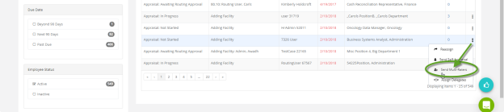
- Type the desired employee names in the Assign To: field, or select Advanced to browse and add employees by Organization and Department.
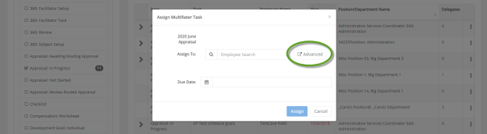
- When browsing for employees via the Add Employees page, selecting + expands an organization to show any departments underneath. Selecting one of these sub-departments displays any available employees to add in the Choices area.
- Find the desired employees within an organization or sub-department by entering a name in the Filter field. Any matches display in the Choices area.
- Selecting the checkbox beside their name(s) and clicking Add Selected adds them to the Selections area.
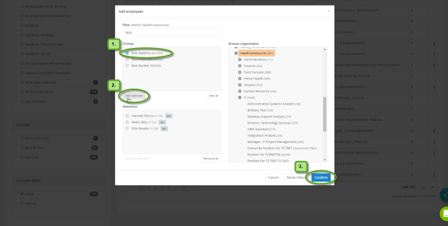
- Once you've added all the necessary employees, selecting Confirm displays the Assign MultiRater Task popup, with the employee names on display.
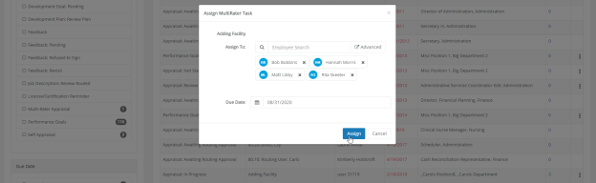
- Enter a Due Date in the field.
- Clicking the Assign button assigns the multi-rater appraisal to the chosen employees. Your Tasks page reloads, displaying a confirmation dialog in the upper-right corner of the page.
- The employees can now complete the multi-rater appraisal task from their own individual Tasks pages.
Once the assigned employees finish their appraisals, the task details update indicating the subtasks are complete.
Leaders can also reopen a previously declined multi-rater task. To reopen, the leader must select Resend the multi-rater from the Task Actions menu. This displays confirmation text stating the task has been reopened for the employee who declined it.

Completing a multi-rater appraisal
Multi-rater appraisals allow managers to request employees to rate other employees on their performance.
Responses are viewable by the manager that assigned the appraisal and the HR department. The employee for the appraisal is able to view the ratings and comments left by multi-raters, but are unable to view which employee left those comments unless a name is indicated in the comments themselves.
When you are assigned a multi-rater appraisal, a MultiRater Appraisal task appears in your tasks list. There is often a due date listed by which you need to complete the appraisal.
These steps take place from the Tasks page under My Folder.
- In the Tasks table, locate and select the MultRater Appraisal task. This opens a confirmation page.
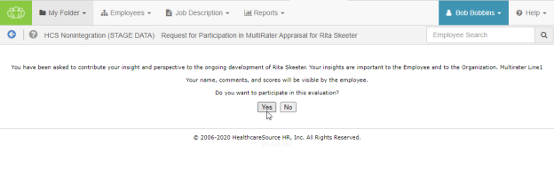
- Click Yes on the confirmation page to continue to the appraisal form.
Note: Clicking No indicates that you wish to opt out of the multi-rater appraisal. You are taken back to the Tasks page, and the MultiRater Appraisal task no longer appears in your task list.
- Review each item on the appraisal form and provide a rating based on your opinion of the employee's performance.
- You may provide notes on individual items in the form by clicking the notes icon () for an item. This opens a large text field for you to enter additional comments on the appraisal item. However please note that in order for your comments to be saved, you must choose or enter an evaluation option.
Note: If the notes area opens automatically when you select a rating for an item, it is required that you provide comments for that item.
- Provide any additional notes necessary in the Appraisal Comments area.
- Click the Save and Send button when finished.
Clicking Save and Send finalizes the appraisal and sends the form to the employee's manager for review. You can no longer edit the appraisal once it's submitted.

Routing appraisals
Routing an appraisal provides additional users the opportunity to review and approve appraisal details either before or after the manager performs the appraisal with the employee.
Note: The routing feature must be turned on by your HealthcareSource Account Manager. Discuss your routing/approval workflow with your HealthcareSource Account Manager to receive recommendations on how the system can be set up.
Routing an appraisal before the employee review
When routing an appraisal before reviewing it with the employee, the manager is presented with a pop-up window after clicking the Save and Send button on the appraisal form. This pop-up prompts the manager to select which user the appraisal should be routed to for approval.
If routing is not required, the manager also has the option to choose None – Complete Routing, which sends the appraisal directly to the employee.
The routing user selected by the manager has the option to Accept or Reject the appraisal.
- If the routing user Accepts the appraisal, they have the option of routing the appraisal to another user by picking a name from the drop-down list. They can also select None – Complete Routing and send the appraisal back to the manager.
Once the appraisal has received all necessary approvals, the manager cannot make any changes.
- If the routing user Rejects the appraisal, they are required to make a comment as to why it was rejected. The rejected appraisal is returned to the manager for the necessary changes, and the routing process is repeated.
Once the appraisal is accepted, the manager conducts the meeting with the employee and sends it to the employee for signature. After the employee signs the appraisal, the process is complete. The appraisal will have the employee’s signature, the manager’s signature and the routing user’s signature(s).
Routing an appraisal after the employee review
When routing an appraisal after reviewing with an employee, the manager is presented with a pop-up window after clicking the Save and Send button on the appraisal form. This pop-up prompts the manager to select which user the appraisal should be routed to for approval.
If routing is not required, the manager also has the option to choose None – Complete Routing, which sends the appraisal directly to the employee.
When a routing user is selected from the drop-down list, the employee is still the first to review the appraisal. Once the employee submits their appraisal, it is then sent to the routing user selected by the manager.
The routing user selected by the manager has the option to Accept or Reject the appraisal.
- If the routing user Accepts the appraisal, they have the option of routing the appraisal to another user by picking a name from the drop-down list. They can also select None – Complete Routing and send the appraisal back to the manager.
Once the appraisal has received all necessary approvals, the manager cannot make any changes. The approved appraisal appears in the employee's record as a PDF file.
- If the routing user Rejects the appraisal, they are required to make a comment as to why it was rejected. The rejected appraisal is returned to the manager for the necessary changes, and the routing process is repeated.

Assigning a self appraisal
Self appraisals allow employees the opportunity to evaluate themselves on their performance throughout the review period. They are able to provide ratings and comments on items, which is reviewed by their manager.
Self appraisals are assigned to employees by their manager, from the Tasks page under My Folder.
- Selecting Send Self-Appraisals from the Actions menu at the top-right corner of My Task List displays the Select Tasks page.
- Select the desired appraisal tasks to assign from the list.
- Set a new due date for the self appraisal by using the Change Due Date field, if necessary. This field may be left blank if you don't want to change this.
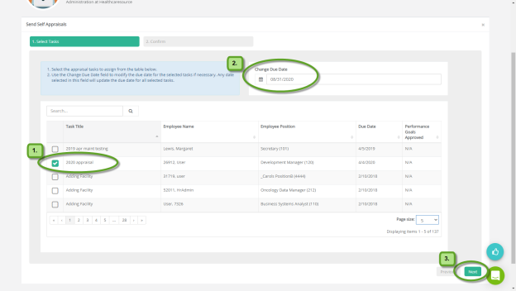
- Selecting Next displays the Confirm page.
- Selecting Finish here assigns the Self-Appraisal to the selected user.
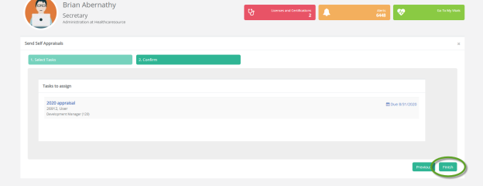
- Your Tasks page reloads, displaying a confirmation dialog in the upper-right corner of the page.
- The selected employee can now complete the self-appraisal task from their own Tasks page.
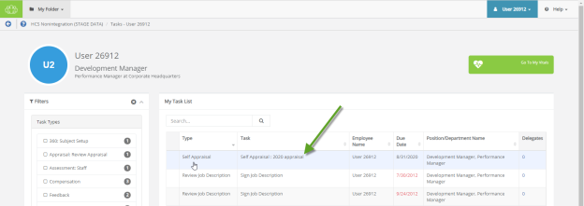
After the employee completes their self appraisal, the task in the manager's Task List updates to show it is complete.

Completing a self appraisal
As an employee, your manager can assign you a task to complete a self appraisal where you evaluate your own performance. This requires you to complete an appraisal form that lists performance criteria you are evaluated on based on your job description.
When you are assigned a self appraisal, a Self Appraisal task appears in your tasks list. There is often a due date listed by which you need to complete the appraisal.
These steps take place from the Tasks page under My Folder.
- In the Tasks table, locate and select the Self Appraisal task. This opens the appraisal form.
- Review each item on the appraisal form and provide a rating based on your performance.
- You may be able to provide notes on individual items in the form by clicking the notes icon () for each item listed. This opens a large text field for you to enter additional comments on the appraisal item. However please note that in order for your comments to be saved, you must select or enter an evaluation option.
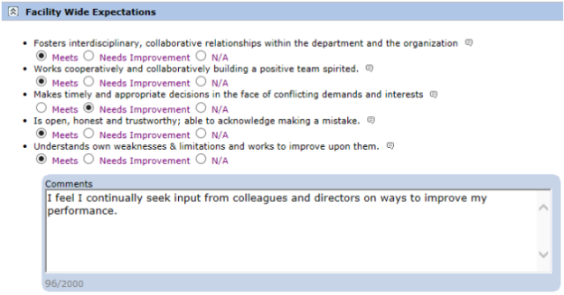
Note: If the notes area opens automatically when you select a rating for an item, it is required that you provide comments for that item.
- Provide any additional notes necessary in the Appraisal Comments area.
- Select Save and Send when finished.
Selecting Save and Send finalizes the appraisal and sends the form to your manager for review. You can no longer edit the appraisal after it is submitted.
You can access your appraisal form for review from the Appraisals page under the My Folder area.

More about Appraisals

Reassigning Appraisals
Appraisal tasks can be reassigned to other users in the event the assigned user is unable to complete the appraisal due to being out of the office or other time constraints. Reassigning an appraisal creates a task for the selected user to complete the appraisal, and removes the task for the current user.
To reassign an appraisal, select the Reassign Appraisal option after clicking the desired appraisal task from the tasks list. A page opens that provides an area to search for and select a user for the reassigned appraisal task.

Rejecting Appraisals
At any point during the appraisal process (before a PDF document is generated), managers and routing users are able to reject appraisals. Rejecting an appraisal sends it back to a user (either the employee or the employee's manager) where it appears in their task list in order for them to make necessary changes.
Since rejecting an appraisal removes all existing signatures from the appraisal, it needs to be re-routed for approval.
To reject an appraisal, click the Reject button at the bottom of the appraisal form. You are required to add comments explaining why it was rejected so users can make necessary updates to the appraisal.

Routing Users
Appraisals can be assigned to routing users to gather additional review and feedback. Performance Manager has both system-level routing users, which are available to everyone in the system, and personal routing users, which only appear for the individual users that have defined their own set of routing users.
System-level routing users are defined by system administrators. Personal routing users are defined by individual users.
Personal routing users are defined on the Personal Routing Users page under the My Folder area. Users added to this list appear in drop-down menus when routing items.

Recognition and Remarks
Recognition and Remarks is a commenting system that allows employees to send input to other employees about a recent exchange or behavioral observation at any time - not just when requested or during annual review periods. This 24/7 approach to input allows people to respond immediately and honestly while everything is fresh on their mind so they’re able to include specific details in their comments and help compile a more accurate view of employee performance.
Comments left for an employee can be associated with specific organizational and/or corporate values in order to provide even more context to the nature of the employee behaviors that inspired the unsolicited comments.
To help encourage employees to provide open and honest input regarding colleague activities, a feature setting provides an option to send input anonymously, which simply hides the name of the sender of the comments from the recipient.
Once the comments are sent, recipients are able to view the input left for them in Performance Manager. Recognition is saved in the employee profile, so both employees and managers are able to review the full history of received recognition.
Tip: If the Employee Journal is enabled, you can access your Journal page from its icon in the lower-right. Depending on your system's settings, it may either be grouped in with the Recognition and Remarks feedback options, or displayed independently.
Where can I find Recognition and Remarks?
Recognition and Remarks is located on the Tasks page as an icon in the bottom-right corner. Hovering your cursor over the icon expands the menu to show all the available options.
- My Recognition. Displays all of your received recognition.
- Recognition Approvals. For managers only; displays a list of recognition sent to your employees anonymously.
- Request Recognition. Allows you to send a request for input from specific employees.
- Received Requests. Lists any requests for input you have received from colleagues.
- Send Recognition. Opens the form used to send recognition to a colleague.
Note: Available options in the menu are controlled by system settings and permissions, so you may not have access to all the listed features.

About the Recognition form
The Recognition and Remarks form provides fields for selecting employees, associating specific values, and general comments for feedback.
Note: Due to the highly configurable nature of the Recognition and Remarks feature, you may notice differences in some verbiage and screenshots shown here.
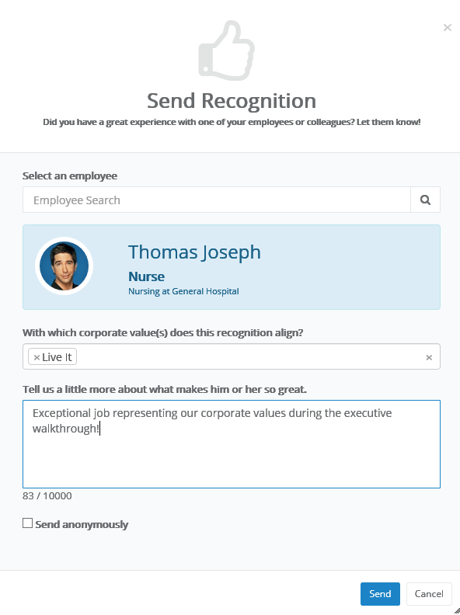
- Select an employee. Search field for locating the employee for your feedback. This is a type-ahead field that automatically displays employee names that match after three characters have been entered.
Tip: See an Advanced button in your employee search field? That means you can send recognition to multiple employees at once!
- Corporate values. Drop-down list that allows you to make multiple selections for any organizational/corporate values to assign to the feedback.
- Comments. Text field for entering your comments for the employee.
- Send anonymously. This option allows you to send your feedback anonymously, which simply hides name of the sender from the receiving employee. The recipient's manager must approve all anonymous feedback before it is shown to the employee.

Anonymous Recognition
Recognition and Remarks includes an option to send input to a colleague anonymously. This simply hides the name of the sender from the recipient. Anonymous recognition helps promote open and honest feedback amongst employees who otherwise might be hesitant to leave either positive or constructive comments for a fellow employee.
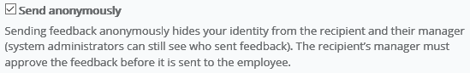
Anonymous recognition must be approved by the recipient’s manager (who is also unable to view the name of the sender) before it can be viewed by the recipient. Managers receive a notification via email and in the icon menu on the Tasks page on the Recognition Approvals option.
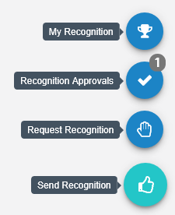
Managers can either Approve or Reject the anonymous recognition.
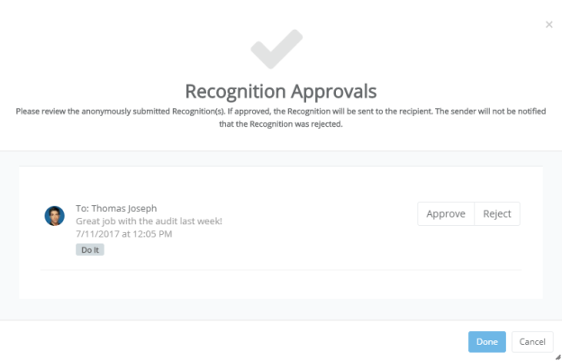

Approving Recognition
When an employee receives anonymous recognition, their manager must first review the input and decide if they want to approve or reject it. Only approved input is sent to the recipient.
Managers receive a notification via email and in the icon menu on the Tasks page on the Recognition Approvals option.
Clicking the Recognition Approvals item opens a new window the details of the anonymous input. Each item has the option to Approve or Reject the feedback. Select an option and click Done to finalize the review.

Batch Recognition
Recognition and Remarks helps build a complete, accurate profile of employee performance by allowing colleagues to leave feedback at any time about specific observed behaviors. But what about those times when a group of people go above and beyond to ensure organizational success?
Batch recognition has you covered. This allows you to select multiple employees or an entire department, facility, even job position for your comments. This sends your input to everyone at once, saving you time as you deliver recognition to the group.
Sending batch recognition is easy too: when enabled, you'll notice an Advanced button in the employee search field of the Send Recognition pop-up window. This indicates you can select multiple employees for your input.
There's two ways to add multiple employees:
- From the employee search field. As you begin typing into the search field, a list of matching employees is displayed. Clicking on an employee adds them to the recognition. Then just begin typing the next employee's name to add, and select them from the list. Repeat until all the desired employees have been added.
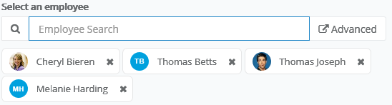
- Click the Advanced button. Clicking Advanced opens the employee picker, which allows you to browse employee lists as well as select specific facilities, departments, and/or positions. Simply check the desired areas, click Add Selected/All to move them to the Selected area, and click Confirm.
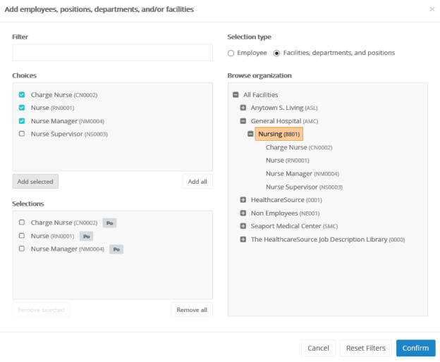
Batch recognition even allows you to include a combination of employees and facilities/departments/positions. The icons for each indicates their type.

Requesting Recognition
You can use Recognition and Remarks to request input from specific employees at any time. Employees receiving a request for input have the option to accept or decline the request.
- Select the Request Recognition option from the icon's menu on the Tasks page.
- Complete the form that opens in the pop-up window. You can select multiple employees for the request.
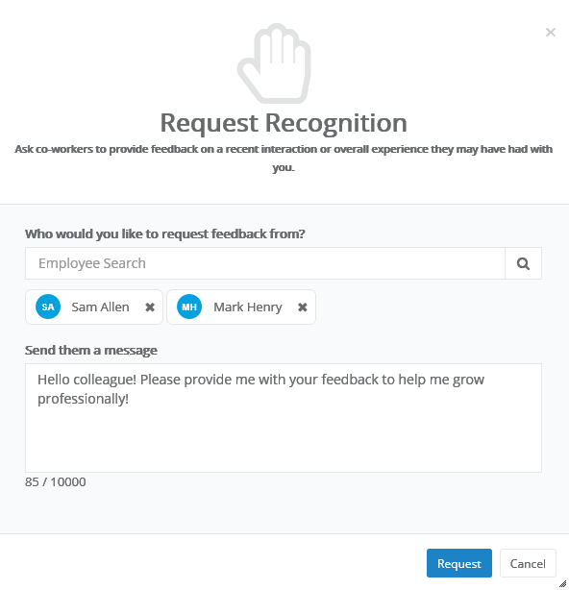
- Click Request.
Selected employees receive an email notification when the request is sent (if the email notification option is enabled), and the icon on their Tasks page displays a number to indicate they have a request waiting.

Responding to Recognition requests
Recognition and Remarks provides the ability to request input from specific employees. Employees receiving such requests are notified via email and on the Recognition icon on the Tasks page.
Clicking the Received Requests option from the menu opens a pop-up window that lists all the requests you have received from other employees.
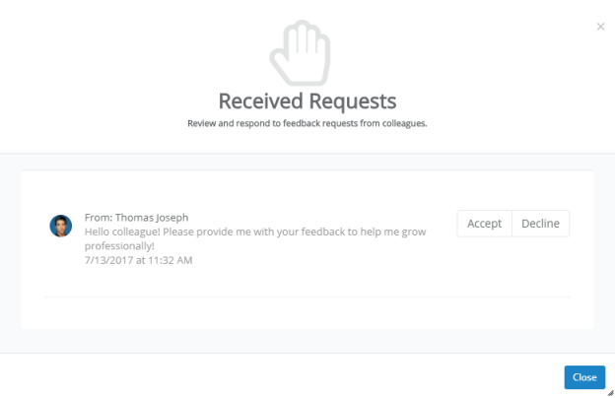
Each request has the option to Accept or Decline the request for input. Accepting a request opens the Send Recognition form for you to complete for the employee. Declining a request simply removes it from your list.

Sending Recognition
Sending recognition to a colleague is designed to be a quick and easy process to encourage employees to share thoughts and comments as often as possible.
- Select the Send Recognition option from the icon's menu on the Tasks page.
- Complete the send recognition form that opens in the pop-up window.
- Click Send.
The selected employee receives an email notification when the recognition is sent (if the email notification option is enabled), and the icon on their Tasks page displays a number to indicate they have new feedback.
Tip: Depending on how your Recognition and Remarks feature is configured, you may be able to send recognition to multiple employees at once.

Viewing Recognition
Comments from colleagues is only helpful if you're able to view their input, so we've made it easy to view all the recognition you've received from fellow employees.
When you receive new recognition, the icon on the Tasks page displays the number of new items for you to view.
Selecting the My Recognition option from the icon's menu opens a pop-up window that lists all your received recognition in chronological order.
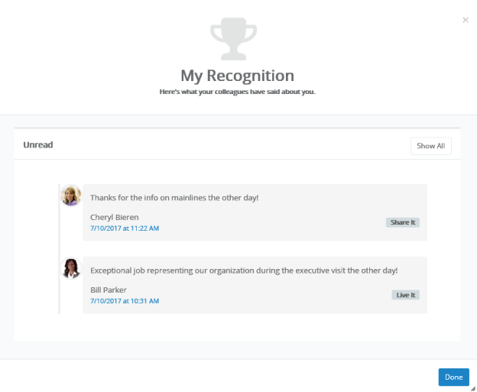
If you have new items to view, those are shown separately. Clicking Show All displays all of the recognition items you have received to date.
You can also access a listing of all your recognition items on the Feedback page under My Folder. The Recognition tab on this page shows the same list of received items.
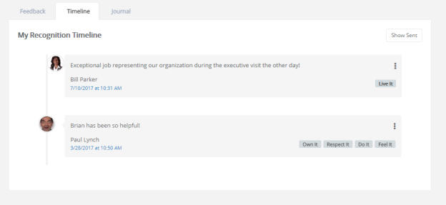
Additionally, the Show Sent button displays a list of all the recognition you sent to other employees.

Checklists
Checklists provide a way to assess employees on basic skills that relate to their positions in your organization. Whereas Assessments and 360 Reviews are intended to evaluate an employee's attitude, workplace contributions, and professional achievements, checklists are provided for the purpose of measuring the employee's skill level and ability in performing specific tasks such as drawing blood or inserting an IV line. Simply put, checklists assess to what degree they can or can not successfully perform a task.
Lists of specific skills is created and assigned to individual positions in Performance Manager. A checklist schedule is created (by an administrator) that assigns a checklist task to managers. This task requires them to evaluate their employees on the skills for their competency checklist.
Employees can also be assigned self-assessment tasks for checklists, allowing them to evaluate themselves on the necessary skills, and share the assessment with their manager.
Checklists can contain multiple skills, but not all skills on a checklist need to be completed at the same time. Checklist items can be evaluated when possible, and the checklist saved for completion at a later date.
Once all items on a checklist have been completed, the entire checklist can be closed. Closed checklists are stored as a PDF in the employee profile, and the employee is then assigned a sign-off task.
Users with a Validator role are able to complete individual skills for an employee, along with the employee's manager, but only the manager is able to close the entire checklist and complete the task.

About the Checklists form
The form used for checklists contains fields for evaluating employees on specific skills.
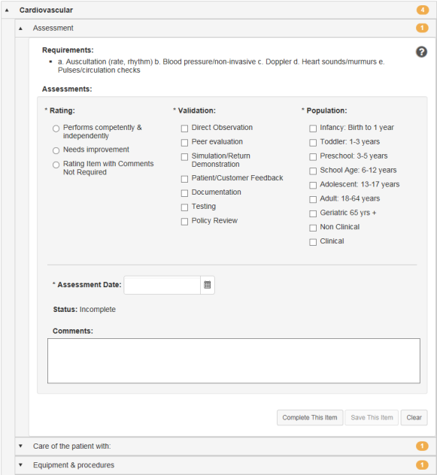
The form itself is organized in groups of skills. Each group heading contains a number that indicates how many skills require validation under that heading. When all the skills have been completed for a group, the number becomes a green checkmark.
Required fields on the form are indicated with an asterisk (*) next to the field name.
Rating | Rating scale used to evaluate the employee's performance of the selected skill. Rating scales may differ from skill to skill depending on how they are set up for your organization.
Validation | Determines how the skill was evaluated.
Population | Determines the population that was used to evaluate the skill.
Assessment Date | The date the skill evaluation was performed.
Comments | Text field for general comments about the employee's performance on the selected skill.

Completing skills
Skills are used to validate an employee's ability to perform skills necessary for their job positions. Checklists can contain many skills for evaluation, though not every skill needs to be evaluated at once.
Managers have the ability to close a checklist once all skills on a checklist have been completed.
Checklists can be completed by opening a Checklist task from the Tasks page, or by visiting the Validate page under Employees and selecting an employee to evaluate from the table.
Users in a Validator role are able to complete individual skills on a checklist (along with the employee's manager); however, only the manager is able to close the entire checklist and complete the task.
To complete a checklist once the checklist form is open:
- Locate the desired skill to evaluate from the list in the form. Skill group headings can be expanded to display the skills themselves, and clicking these sub-items opens that skill.
- Complete the skill evaluation form as necessary.
- When finished with the form, click the Complete This Item button to finalize your evaluation of the employee for that skill.
- Repeat steps 2 and 3 for other skills you wish to evaluate.
Clicking the Complete This Item button for individual skills marks selected skill as complete and closes it. While you can view closed skills, you are not able to make any further edits on a skill once it has been completed.
The Save This Item button saves your work on the current skill for completion at a later date.

Closing checklists
Managers complete checklists on employees to validate their ability to perform skills necessary for their job positions. Checklists can contain many skills for evaluation, though not every skill needs to be evaluated at once.
After all skills on a checklist have been completed, the entire checklist can be closed. Only the manager assigned the Checklist task is able to close the entire checklist.
To close a checklist:
- Ensure that all skills within the checklist have been completed.
- Click the Close Checklist button.
The Close Checklist button can only be selected once each skill on the form has been completed. A PDF copy of the completed checklist is added to the employee profile.

Self assessments
Self assessments for checklists are exactly what you might think they are: a chance for employees to rate themselves on the skills contained within a checklist. Employees are assigned a Checklist - Self Assessment task that requires them to complete a checklist
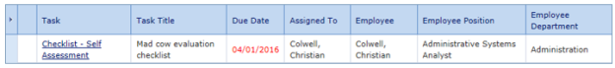
The employee view of the checklist is the same as managers and validators. They have the opportunity to select a Rating, Validation, and Population for each skill, and provide additional comments if desired.
Once completed, employee responses in the checklist are viewable by managers and validators working in the checklist. A little person icon next to the assessment fields indicates the employee’s selection, and their comments are shown at the bottom of the form as well.
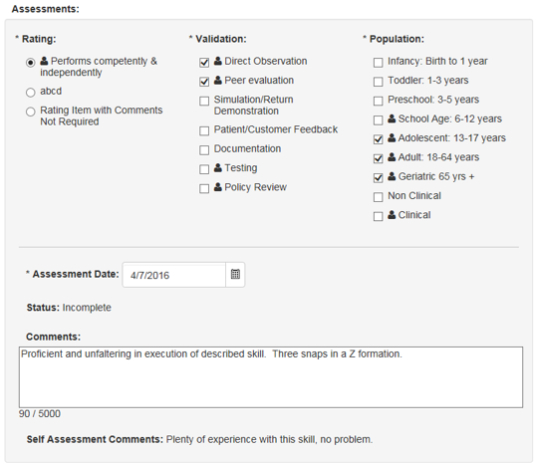

Assigning a self assessment
There are two ways to assign a self assessments task employees: automatically using a setting on the checklist schedule, or manually using a button on the checklist form itself.
Automatically via schedule
Automatically assigning self assessment tasks to employees is as easy as clicking a checkbox. The checklist schedule form contains an Auto-assign self-assessment option that, when enabled, automatically sends a self assessment task to the employee when the schedule becomes active.
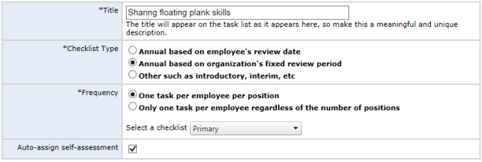
Manually via button
For the manual task assignment, all managers have to do is click the Send Self Assessment button at the top of a checklist. This fires off that self assessment task to the employee.
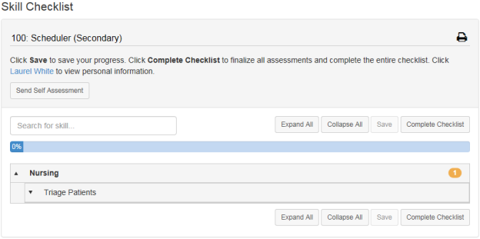

Feedback
Feedback provides a way for managers to evaluate and inform employees of their performance and create action plans. Feedback is also a way to increase interaction between managers and employees, ensuring performance is on par with expectations and potential. The Feedback page is where you can send any praise, instruction, or warnings, via the Feedback form. Complete the form, then select the desired routing option to officially submit your feedback.
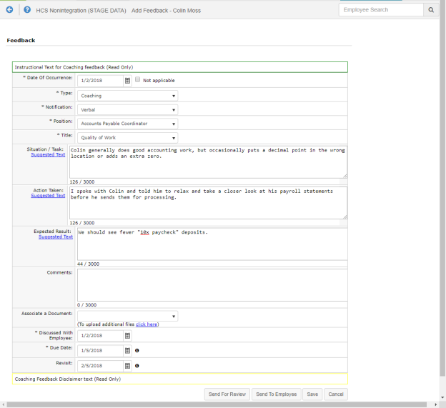
To access the Feedback form for a specific employee, navigate to your Employee List. Locate the desired employee in the list, then select Feedback, found under the Add drop-down menu. This displays the Feedback page.
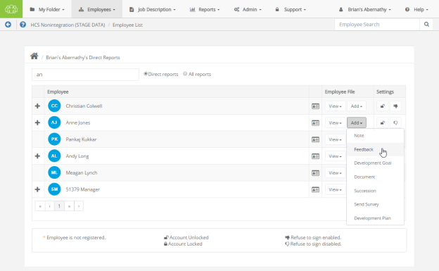
Feedback types
There are three types of feedback:
- Positive. Used to praise employees for quality work efforts.
- Coaching. For those occasions when an employee requires additional training or instruction. Coaching isn't necessarily negative feedback; rather, an opportunity to improve.
- Corrective. Used when an employee has performed poorly, disregarded policies, etc. Corrective feedback is required to be reviewed by Human Resources before it is sent to the employee.
Employees receiving feedback from their manager are assigned a task to review and comment on the feedback. Managers then review employee comments and sign off, at which point a PDF of the feedback is added to the employee's record.
Note: Employees may respond to feedback issued by their managers, but they can not initiate feedback to their managers.
Feedback status
The status of a feedback item helps identify where it is in the workflow process.
- Pending. Feedback has been created by manager, but not sent to employee or routed.
- Routed. Manager has sent the feedback to a routing user for approval.
- Routing Approved. Routing has been completed and the feedback is with the manager to complete the routing by sending it to the employee.
- Employee Review. Feedback has been sent to the employee for review.
- Manager Review. Employee has either signed the feedback with comments or rejected the feedback.
- Closed. Task/workflow is complete.
Feedback Routing Options
Send for Review. Submits the feedback to any applicable stakeholders (i.e. Managers) for their review and further action.
Send to Employee. Submits the feedback to the Employee for their own review and further action.
Save. Saves the feedback form as a draft, but does not submit it.

About the Feedback form
The Feedback form contains several fields to capture necessary information and desired action items for the employee.
Some text fields include a Suggested Text link under the field name. Clicking this link opens a pop-up window that contains standardized comments based on the field. It is not necessary to use any suggested text; comments can be directly entered into these fields.
Required fields on the form are indicated with an asterisk (*) next to the field name.
Feedback form details
- *Date of Occurrence. The date that the event occurred that led to the feedback. Check the Not Applicable option if no specific date is available.
- *Type. Drop-down list containing the different types of feedback (Positive, Coaching, Corrective).
- *Notification. Determines the type of notification the employee receives regarding the feedback.
- *Title. Drop-down list containing available titles for the feedback. The contents of this list is determined by the Type of feedback being left.
- Situation/Task. Describe the situation/task/event that led to the feedback being left for the employee.
- Action Taken. Describe the action taken after the situation/task/event occurred.
- Expected Result. Describe the desired outcome of the feedback. This includes potential training, disciplinary action, or accolades (depending on the type of feedback).
- Comments. Field for any additional comments necessary for the feedback item.
- Associate a Document. Documents can be associated with the feedback left for an employee. Documents can be added to the feedback by uploading from a local computer or selecting from the list of documents that exist in the employee's profile.
- *Discussed with Employee. The date the manager discussed the feedback item with the employee.
- *Due Date. The date by which the employee must address the item.
- Revisit. The date the manager wishes to readdress the issue.
- Created By. The user that created the feedback for the employee. This is an auto-populating read-only field.
- Created Date. The date the feedback was initially created. This is an auto-populating read-only field.
- Last Modified By. The user that last made any modification to the feedback, including sign-offs. This is an auto-populating read-only field.
- Signature. Lists those users that have reviewed and signed off on the feedback. This is an auto-populating read-only field.
- *Send To. Field used to select a user to route the feedback to for review before being sent to the employee.
- Comments. Field for any additional comments necessary for the feedback item, or special notes for the user the feedback is routed to before employee review.

Adding Feedback
Managers are able to add feedback to an employee's record at any time.
- Locate the desired employee from the Employees page and click the Feedback link in the table. The employee's Feedback page opens.
- Click the Add Feedback button. A blank feedback form opens.
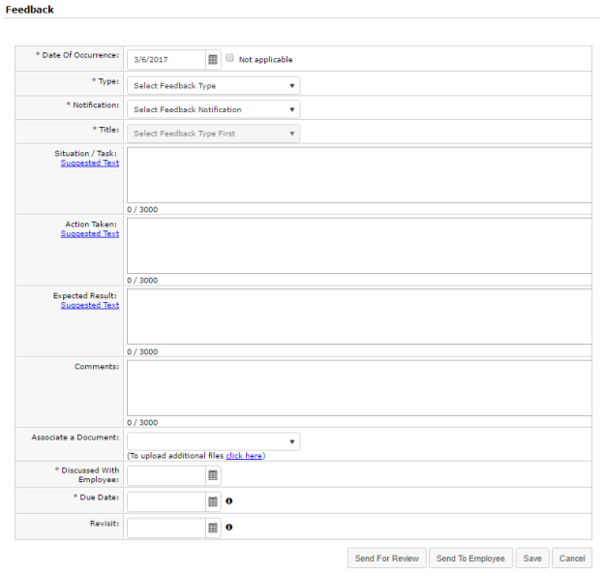
- Complete the form as necessary.
- Click the corresponding button for the action you wish to take.
  - Save. Saves a draft of the feedback; it is not sent for review or visible by the employee until further action is taken.
  - Send to employee. Saves the feedback and sends it to the employee for their review and signature.
  - Send for review. Saves the feedback and sends it for review. A pop-up window opens where a feedback routing user can be selected and additional comments can be added.
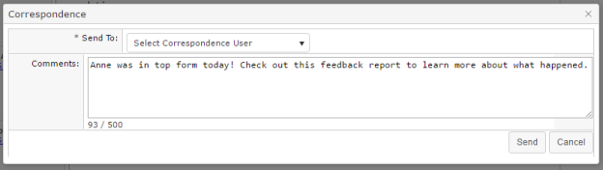
Clicking the Send to employee button creates a task for the employee to review and comment on the feedback. After an employee has signed off on the feedback, it is sent back to the manager for final review. Once the manager has signed off on the employee comments, the feedback is added to the employee's record.
Corrective feedback is required to be reviewed before it is sent to the employee; therefore, when corrective feedback is added, the Send to employee button is not available. The employee receives a task for the feedback after the selected routing user has reviewed and signed off.

Reviewing Feedback (routing user)
A task is created for users that have been selected to review feedback left for an employee. This task requires the user to review, comment, and sign off on the feedback. It is then returned to the manager for review, then sent to the employee.
- Click the link for the feedback task in the Tasks table. The feedback form opens.
- Review the comments left by the manager.
- Make any necessary edits to the form.
Note: The ability to edit routed feedback forms is controlled by system-wide settings. You may not have the ability to edit the form, only comment and sign off.
- In the Correspondence section, review the manager comments and add any additional comments in the Response Comments field. Comments left in this field are only viewable by the manager, not the employee.
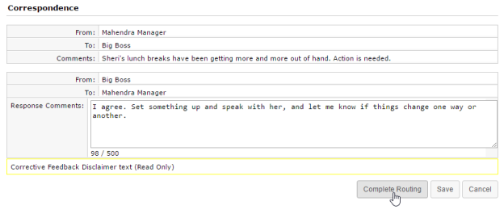
- When finished review and commenting on the feedback, click the Complete Routing button.
Clicking the Complete Routing button signs off on the feedback and sends it back to the manager for review. Managers can then send the feedback to the employee for review.

Refuse to Sign
A Refuse to Sign option is available that provides employees with the ability to refuse to sign off on feedback left by their manager.
When this option is enabled for an employee, an additional Refuse to Sign button is available at the bottom of the feedback form when performing their Review Feedback task. Clicking this button sends the feedback to the manager without signing off.
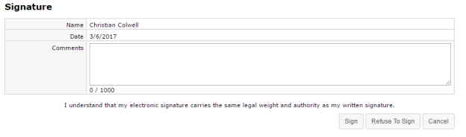
Employees can still leave Comments even if they refuse to sign off on the feedback. Any text entered into the Comments field is displayed to the manager.
When an employee refuses to sign off on feedback, the form is sent back to their manager as a Refused to Sign: Feedback task. Managers are required to review the feedback form and sign off to complete the task. The Signature section of the form notes that the employee selected the Refuse to Sign option for the feedback, and displays any comments left by the employee.
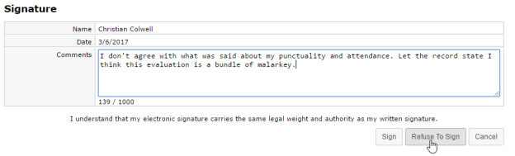

Notes
Notes are a watered-down version of Feedback and meant to serve as reference items for managers. Notes do not get routed to the employee or other users for comment; they are visible only to the manager that left the note for the employee. To create a new note, navigate to an employee's Feedback page, then click Add Note, found just under the Search bar. This displays the Add Manager Notes modal window.
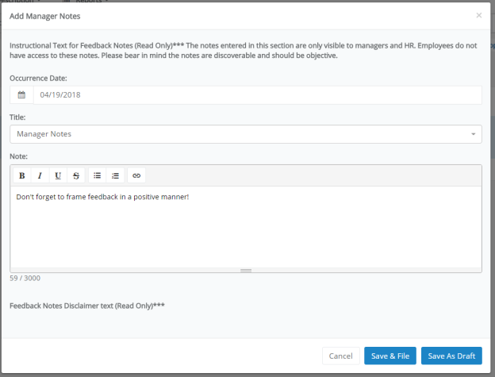
The Notes form only has three fields for capturing information.
- Date of Occurrence. The date that the event occurred that led to the note. Check the Not Applicable option if no specific date is available.
- Title. Drop-down list containing available titles for the note.
- Situation/Task. Describe the situation/event that led to the note being created for the employee.
The Save as Draft button saves a draft of the note, which can be found on the main Feedback page. Save and File adds the note to the employee's record. Once the note is filed, its status updates to Closed and it can no longer be edited or deleted.

Compensation
Compensation provides an easy way for organizations to compensate employees fairly and simplify the merit increase process. This powerful tool helps you prepare for your merit increase cycle quickly and accurately, and helps managers align compensation directly to employee performance.
Merit guidelines in the compensation worksheet take into account current performance, the employee’s place in the salary range, and/or their compa-ratio. Managers can quickly review past salary information and current performance ratings, and use this information to make accurate, objective adjustments to their employees' compensation.
After any merit adjustments have been made, the worksheet is routed to other managers and stakeholders for approval using the compensation workflow feature. Once the worksheet earns all its necessary approvals, the employee is ready for payroll processing.
Note: Access to the compensation worksheet is controlled by system settings and user permissions. If you don't see the Compensation option, then your system may not be enabled with the compensation module, or you may not have the necessary permissions to access the worksheet.

About the compensation workflow
Compensation workflow is basically a worksheet routing feature that triggers tasks along the way. At certain stages in the compensation process, users receive tasks for them to perform various functions on the worksheet itself – from completing it, to reviewing it, and finally signing off.
- A compensation cycle becomes active, creating a Compensation – Worksheet task for the compensation manager. This task launches the compensation worksheet that they must complete for the included employees.
- When the manager is finished updating the worksheet, they route it to another user for approval. They have the option of sending it to their direct manager, who always appears in the Route To drop-down list, or another compensation approval user that’s available in the list.
- After the manager has selected a user and routed the worksheet, that user receives a Compensation – Approval task. This task requires them to review the worksheet and provide approval before it is completed. When the review of the worksheet is done, the user can either route the worksheet to another user for further review using the available Send for Approval button, or Complete the workflow and send the worksheet to HR for final processing.
- The final step in the compensation workflow is a signoff task for employees on the completed worksheet. They receive a Sign Compensation Summary task that only requires them to review their compensation and provide signoff. Once an employee signs off on their summary task, the compensation worksheet is saved to their employee profile (Compensation page under My Folder) in a read-only view.

About the compensation worksheet
The Compensation page can be found by clicking the Compensation link under My Folder. A Compensation Worksheets table displays all available worksheets for open compensation cycles.
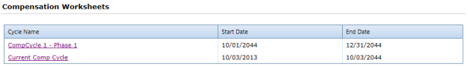
Worksheets can also be accessed using tasks that are assigned during the compensation workflow.
On the Compensation Worksheet page, cycle and budget information is displayed at the top of the page, and the actual compensation worksheet is shown in a table format.
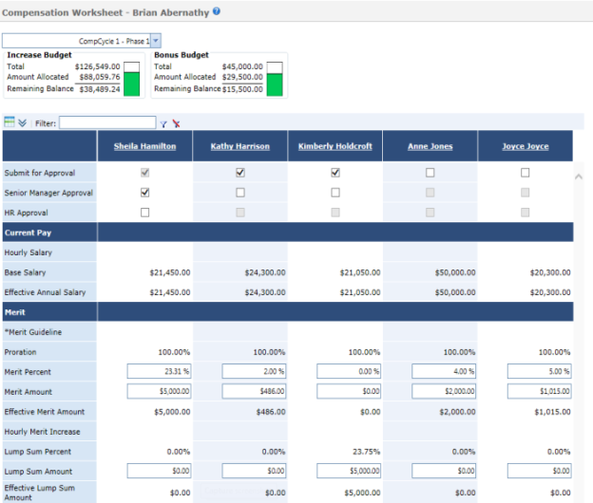
Cycles
The Cycle drop-down list at the top of the Compensation page allows you to select a compensation cycle for the worksheet. Only those employees that fall under the selected cycle are displayed in the worksheet.
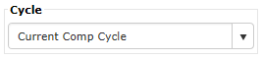
The system displays a message if a cycle is selected that has already closed, or if the current user does not have any employees that fall under the selected cycle.
Budgets
There are two budget sections available for compensation worksheets: Increase Budget and Bonus Budget.
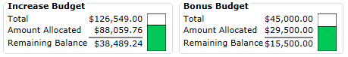
- The Increase Budget section displays the total budget available to you for your employee merit increases, the total amount you have currently allocated in the worksheet, and the remaining balance available for additional increases.
- The Bonus Budget section displays the total budget available for one-time bonus payouts to employees on your worksheet. This section also tracks total, allocated, and remaining amounts.
Note: Bonus budgets are an optional feature for compensation worksheets, and may not be available depending on your system configuration.
These areas automatically update in real-time as you make adjustments in the worksheet. If you allocate increases that exceed your overall budget in either area, the system displays a warning and does not let you save the worksheet until necessary adjustments are made.
Worksheet table
The compensation worksheet itself is displayed in a table that allows easy access to information and fields for increases. The table itself is broken up into different sections.
Approvals
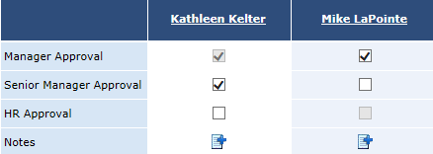
The top of the worksheet contains several checkboxes that are used when managers have reviewed and approved changes for an individual. When all necessary approvals are received, the employee is ready for payroll processing.
Also in this area is the Notes feature, which allows managers to add new and view existing notes to employee compensation records.
Employee Data
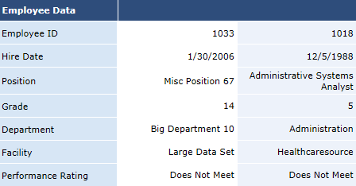
This section of the worksheet contains basic employee information, such as Hire Date, Position, Department, etc. The Performance Rating field shows how the employee performed during the last appraisal period.
Current Pay
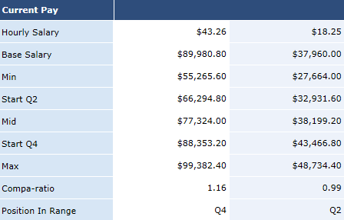
This is a display-only section of the worksheet (meaning it contains no input fields) that shows current salary information for employees, as well as salary range information for that position in your organization.
The Compa-ratio field is calculated using the employee’s current salary and the midpoint of their salary range. Salaries above their midpoint have compa-ratios above 1.0; salaries below the midpoint are below 1.0. Position in Range simply shows where the employee’s current base salary falls in relation to the displayed salary range information for their position.
Merit
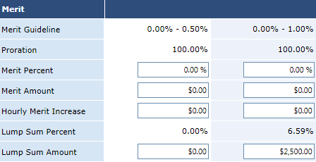
This section of the worksheet is where merit adjustments are made for employees. Fields allow you to adjust employee compensation through percentage increases, specific amounts, or lump-sum payouts.
The Merit Guideline field displays the system-recommended merit increase range based on the employee’s rating and salary information.
Updates made in this area affect the amounts in the Budget section above the worksheet and the Proposed Pay section.
Depending on system configuration settings, error messages are displayed if increases made in this area are outside the guidelines or if the resulting salary is outside the salary range for the position.
Tip: When working in the Merit section of the table, it is recommended that you use either the Merit Percent or Merit Amount field for employees (as opposed to completing both fields for each employee). This consistency helps with tracking total budget expenditure.
Note: When working with fields in the Merit section of the worksheet, changes to fields automatically trigger real-time recalculations of other fields - such as those found in the Increase Budget and Proposed Pay sections of the worksheet.
Proposed Pay
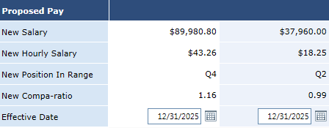
This area displays the resulting salary information for the employee when updates are made in the Merit section of the worksheet. Updated in real-time, it shows the New Salary, Hourly Salary, Position in Range, Compa-ratio, and Effective Date for a given employee.
Bonus
The Bonus area of the worksheet allows you to distribute one-time bonus payouts to employees. The Bonus Budget section above the worksheet automatically updates in real-time when these fields are changed.

Completing a worksheet
Managers with direct reports need to complete the compensation worksheet in order to provide necessary merit increases for their employees. Completed worksheets can then be submitted for review and approval.
Managers receive a Compensation - Worksheet task when a cycle becomes active. Worksheets can also be opened from the Compensation page under My Folder.
- Locate the employee(s) to review in the table. You can use available filters and sorting to narrow the results displayed in the table.
- Make necessary adjustments to the Merit section of the worksheet for the desired employees. Make sure to check the Increase Budget area to ensure you’re within the budget limits.
- Click the Send for Approval button. This opens the Send for Approval pop-up window.
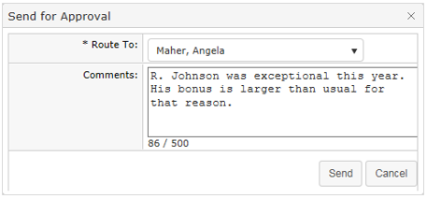
- Select a user to route the worksheet to for approval and add any additional Comments as necessary. Click Send when finished.
After sending the worksheet, the Manager Approval option on the worksheet is automatically checked, and the worksheet is sent to the selected routing user as a Compensation - Approval task.
You can also click the Save button at any point when working on the worksheet to save your current progress without submitting it for approval.

Approving a worksheet
After a manager has completed a compensation worksheet, it is routed to additional users for review and approval. These employees, usually senior managers and HR, receive a Compensation - Approval task that requires them to review the worksheet to determine if it meets all applicable company guidelines and/or requirements.
- Click the Compensation - Approval task form your task list. This opens the worksheet.
- Review the worksheet to determine if it falls within the guidelines set for merit increases for your company. Make any necessary edits to the worksheet.
Once you have finished reviewing the worksheet, you have a few different options for your next step. Depending on how your compensation system is configured, the following action buttons may be available under the worksheet:
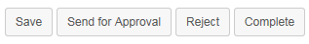
- Save. This saves your current progress on the worksheet if you made any edits. This does not submit the worksheet for any approval.
- Send for Approval. Allows you to route the worksheet to another user for review and approval before final processing. The Senior Manager Approval option on the worksheet is automatically checked once sent if you are the manager of the worksheet's compensation manager.
- Reject. Rejecting a worksheet sends it back to the compensation manager for further edits. Rejecting a worksheet requires you to enter comments.
- Complete. Users with necessary permissions can complete the review and approval process with the Complete button, which finalizes the worksheet. The employee receives a Sign Compensation Summary task that only requires them to review their compensation and provide signoff.

More about Compensation

Worksheet view options
The compensation worksheet offers several options to modify how data in the table is displayed, enabling you to quickly locate information and complete the worksheet.
Column/row view
The column/row viewing option toggles the layout of the worksheet between columns and rows. Using the toggle button () located above the worksheet, you can switch between having the employees listed across the top of the table (the default view) and having them listed down the first column of the table. This allows you to view more records at once if you have multiple employees on your worksheet.
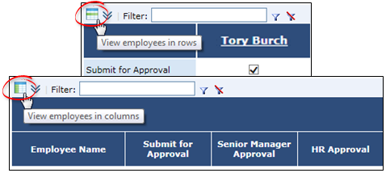
Filter
A filter field above the table performs partial-word searches to help narrow the results displayed in the table. The filter searches against Employee Name, Employee ID, Position, Department, and Facility.
Enter a search string into the text box above the compensation worksheet and click the filter icon (). The table then shows only those employees that match the text entered in the filter.
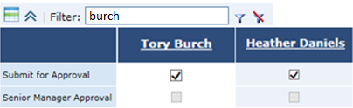
Clicking the clear filter icon () removes the filter and returns to the default view of all employees.
Hide/Show Details
Clicking the hide/show details button () in the upper left of the compensation worksheet toggles the view of many static rows of the table. This allows you to view just those fields necessary to make adjustments and the ones that are automatically updated when changes are made.
When details are hidden, the many fields from the Current Pay section are not displayed, and the entire Employee Data section is removed from the table as well.
Paging
Options for paging are available at the bottom of the table. The drop-down menu allows you to set how many employees are displayed in the table at one time. You can also select a page number to jump directly to that page of employees.

Approvals
The approvals feature for compensation worksheets allows Managers, Senior Managers, and HR to review submitted worksheets.
- Manager approvals are conducted either by the direct manager of the employee, or by a designated compensation manager at your organization.
- The Senior Manager approval provides the ability to approve submitted worksheets after upper management has completed their review. Once the Senior Manager checks the approval option, the worksheet is available for final review by HR.
- The HR approval occurs after a worksheet owner has submitted the worksheet for review and has been approved by a Senior Manager. HR approvals indicate the worksheet is ready for payroll processing.
Administrators are the only user role that can “unapprove” a Senior Manager approval and “unsubmit” the worksheet, allowing the worksheet owner to make edits.
HR approval must be removed before Senior Manager approval can be removed. Likewise, Senior Manager approval must be removed before Manager Approval can be unchecked.

Batch actions
Batch actions for compensation provide a way to apply changes to all employees that appear in a worksheet. This provides a way to quickly populate fields across the worksheet in one action as opposed to completing fields for each individual employee.
Batch actions include the ability to apply approvals across the worksheet, as well as set a merit increase for all employees. A Batch Apply button above the worksheet lists the available batch actions when selected.
Batch approvals
Approvals can be applied to compensation worksheets as a batch action across multiple worksheet entries. This allows users to quickly select approval for large worksheets without the need to manually select for each entry.
The Batch Apply drop-down allows users to select an approval level to be applied to all entries in the worksheet (provided they haven’t already received that level of approval or higher). Available approval levels include Manager, Senior Manager, and HR Approval. Users only have access to the levels of approval they normally are able to provide for worksheets.
Selecting an approval level opens a confirmation window to verify the batch action. Once confirmed, the selected level of approval is applied to all qualifying entries in the worksheet. Users can then manually un-check approval for individual employees if needed. Approved entries are not submitted to the next level of approval until the entire worksheet is saved.
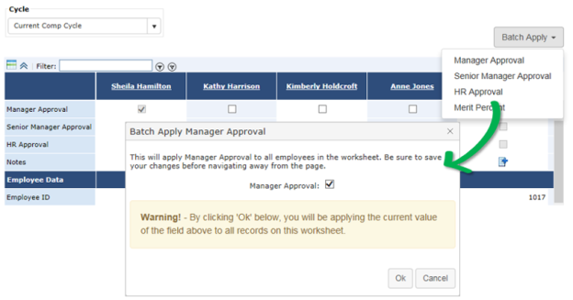
Batch merit increase
Along with batch approvals, Merit Percent can be applied across all entries in a worksheet as a batch action as well.
Selecting the Merit Percent option from the Batch Apply drop-down opens a confirmation window where users enter the percentage of merit increase to be applied to worksheet entries. The value entered here overwrites any values currently in the worksheet.
Once confirmed, the value is applied to all entries in the worksheet. Users can then manually adjust the merit percent for individual employees as needed. The worksheet must be saved in order to apply the merit percent.
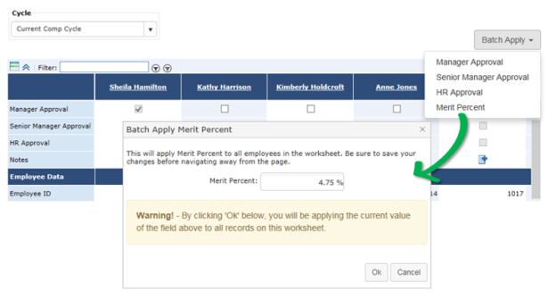

Notes
The Notes feature on the compensation worksheet, located in the Approvals section, provides an area to leave notes about an employee. These notes are viewable by approving managers, so can be used to provide justification for submitted employee merit levels.
The icon displayed in the Notes field indicates if a note has been created for that employee. An add icon () means no note is available, while a notes icon () means a note currently exists.
Hovering the cursor over the notes icon displays the note text in a tooltip. Clicking the add icon opens a notes window where you can enter text for the employee note and save it to the worksheet.
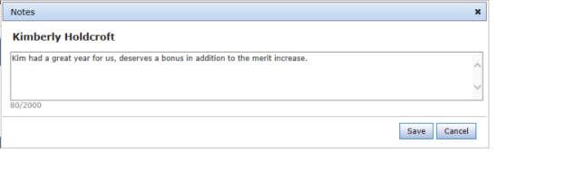

Reports
The Reports area provides access to all the system reporting tools available for viewing and extracting defined data in Performance Manager.
Performance Manager provides a wide range of reports so you can easily gather and examine the data you need to ensure your employee management is efficient and successful. Each report provides several data filters, allowing you to manipulate your results without the need of sifting through records you don't need.
The Reports area contains several sub-pages:
- Standard. Standard reports include all the pre-packaged reports offered in Performance Manager. The reports found on this page are diverse and address many of the data needs for users.
- Appraisal Status Reporting. This report displays the status of appraisals throughout your organization to help track where deficiencies exist in the appraisal process. This is similar to the Appraisal Status Standard Report, but the version of the report on this page allows a greater degree of flexibility and customization of data views, filters, and other details.
- Checklist Status Reporting. This report displays the status of checklists throughout your organization to help track where deficiencies exist in the checklist process. This is similar to the Checklist Status Standard Report, but the version of the report on this page allows a greater degree of flexibility and customization of data views, filters, and other details.

Available Reports
The Standard Reports page lists the reports available down the left-hand side of the page. Clicking a link opens the search filters for that report and allow you to run the report.
The list is organized by category, with related reports shown under each heading.
Appraisals
- Appraisal and Goal Status. Displays the completion status and summary information for all the appraisals and goals in a given date range.
- Annual Appraisal Review Date. Lists employees and their annual review due date.
- Appraisal Status. Displays the overdue or completion status and summary information for all appraisals in a given date range.
- Employees Without Appraisals. Lists employees who have not had an appraisal within a given date range.
- Performance Distribution. Displays distribution of performance scores along with the list of relevant employees and performance score information.
- Self-Appraisal. Lists self-appraisals and completion dates for employees and managers within a given date range.
Checklist
- Employee Checklist Status. Displays all the training competencies that have been completed by employees in a department or group of departments. This report can be filtered based on departments or date range.
Compensation
- Compensation Approval Status. Displays employees and whether or not compensation changes have been submitted for approval.
- Compensation Detail. Displays employee-level detail for selected compensation cycles within facilities and departments.
Feedback
- Feedback Detail. Displays employees who have received feedback within a given date range, along with feedback details such as type, notification, and action taken.
- Recognition and Remarks Detail. Displays employees who have received recognition within a given date range, along with details such as facility, manager, department, approval status, and organizational values exemplified.
Feeds
- Feed Detail. Displays details on feed files processed within a given date range and lists errors for easy troubleshooting.
Miscellaneous
- 360 Summary Report. Displays an employee's detailed responses to a selected 360 Review survey.
- Development Plan Status. Displays the details of development plan tasks that are either pending, open, or completed, within a given date range.
- Document Status. Displays the details of review document tasks that are either completed or outstanding, within a given date range.
- Employee Census. Provides a list and totals of positions, employees, and FTE's.
- License and Certification. Displays employees who have licenses and/or certifications on record for a given date range.
Performance Goals
- Goal Completion Status. Displays a rollup of goal status for a given date range, along with details on individual goals.
- Goal Task Status. Displays status of goal tasks for a given date range.
Succession Planning
- 9 Box Succession Planning. Displays performance vs. potential for a given date range, including details for each employee.
- Succession Planning Detail. Displays succession planning details for each employee within a given date range.
Tasks
- Non-Appraisal Task Status. A filterable report capable of delivering a wide range of task information.

Viewing reports
Viewing reports in Performance Manager is a simple matter of selecting the desired report and setting available filters for your data.
- Locate the report you wish to view from the list on the left side of the page.
- Click the link for the name of the desired report. The page will load the available filters for the report.
- Select the desired filters for the report using the available fields.
Note: Available filters may vary from report to report based on the type of report you are running.
- Click the Generate Report button.
Clicking the Generate Report button loads the report in the main viewing area where the filters were displayed.
If you wish to update the filters for a custom report, click the Back button under the report. This re-opens the Filters page. Make any necessary adjustments to the filters then click Generate Report to re-run the report.
Report Graphs
All reports in Performance Manager provide a table view of the requested data. In addition to this table view of your data, some reports may also offer a graphical view of the information.
Graphs are automatically available on a select set of reports. If the report you are running is able to produce a graphical representation of your data, you will see an Expand for Graph link above your report results table. Clicking this link displays the graph view of your report results.
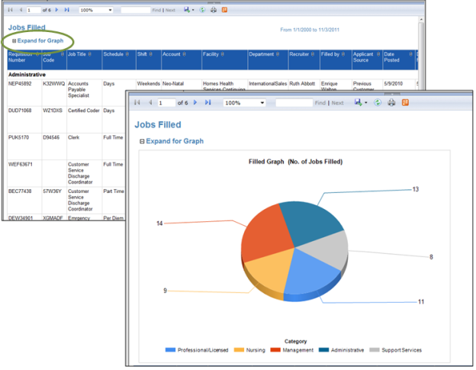
Tip: If you want to include the graph of your data when exporting the report to a file, make sure the graph is expanded and visible in your screen view. If the graph is not expanded, it will not be included in your export.
Report Data Latency
In an effort to increase the overall responsiveness of Performance Manager, reports are actually run against a copy of the databases that hold your data. Using a copy of the database allows better optimization of the reporting application, provides greater system stability, and develops a software foundation necessary for effective custom report building.
So what does this mean for your reports?
Since information isn't being pulled directly from the working databases, it must be copied to the reporting database at set intervals (every 15 minutes, in this case). That means the information you are seeing in your reports will never be more than 15 minutes behind what's actually in the system.
If you want to see just how recent your report data is, you need look no further than the footer of the report. There you will find a line that states:
"Data current as of MM/DD/YYYY HH:MM:SS"
The date and time displayed in this line indicates the last time data was copied to the reporting database - or, how recent your report data is.

